WORKING AT HEIGHT

GUIDANCE FOR SCHOOLS
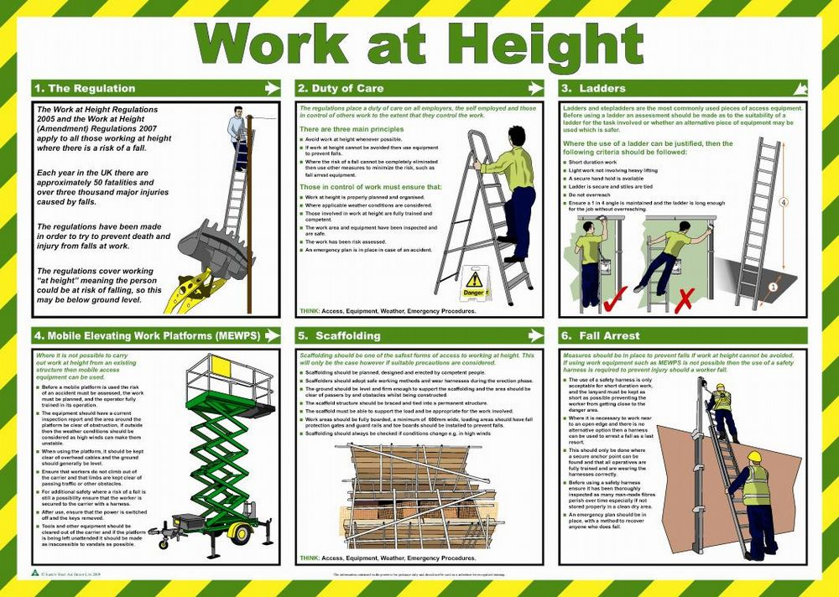

LEGISLATION
- Health and Safety at Work etc Act 1974
- Management of Health and Safety at Work Regulations 1999
- Work at Height Regulations 2005

WHAT YOU NEED TO DO
- Ensure that all work at height is properly planned and organized
- Identify and assess the risks from work at height
- Ensure the most appropriate work equipment is selected, used, maintained and inspected
- Ensure staff members are capable of using the equipment
- Ensure that the risks from fragile surfaces are properly controlled
- Ensure that the risks from falling objects are properly controlled
- Where temporary ladders, tower scaffolds etc. are regularly used to access an area, consider more permanent access arrangements if possible.
- Ensure equipment is inspected regularly to an agreed schedule and that suitable records are kept.

INTRODUCTION
Most major injuries in schools are caused by ‘low’ falls (below two metres) and involve falls from desks/chairs while putting up displays and falls from ladders, for example, while putting up stage lighting.
Work at height is defined as being work in any place, including a place at or below ground level where, if measures required by the Regulations were not taken, a person could fall a distance liable to cause personal injury.
The Work at Height Regulations sets out a hierarchy of control for determining how to work at height safely. The hierarchy has to be followed systematically and only when one level is not reasonably practicable may the next level be considered.
Duty holders must:
- Avoid work at height where they can
- Use work equipment to prevent falls when work at height cannot be avoided
- When the risk of falls cannot be eliminated use work equipment to minimise the distance and consequences of any fall.
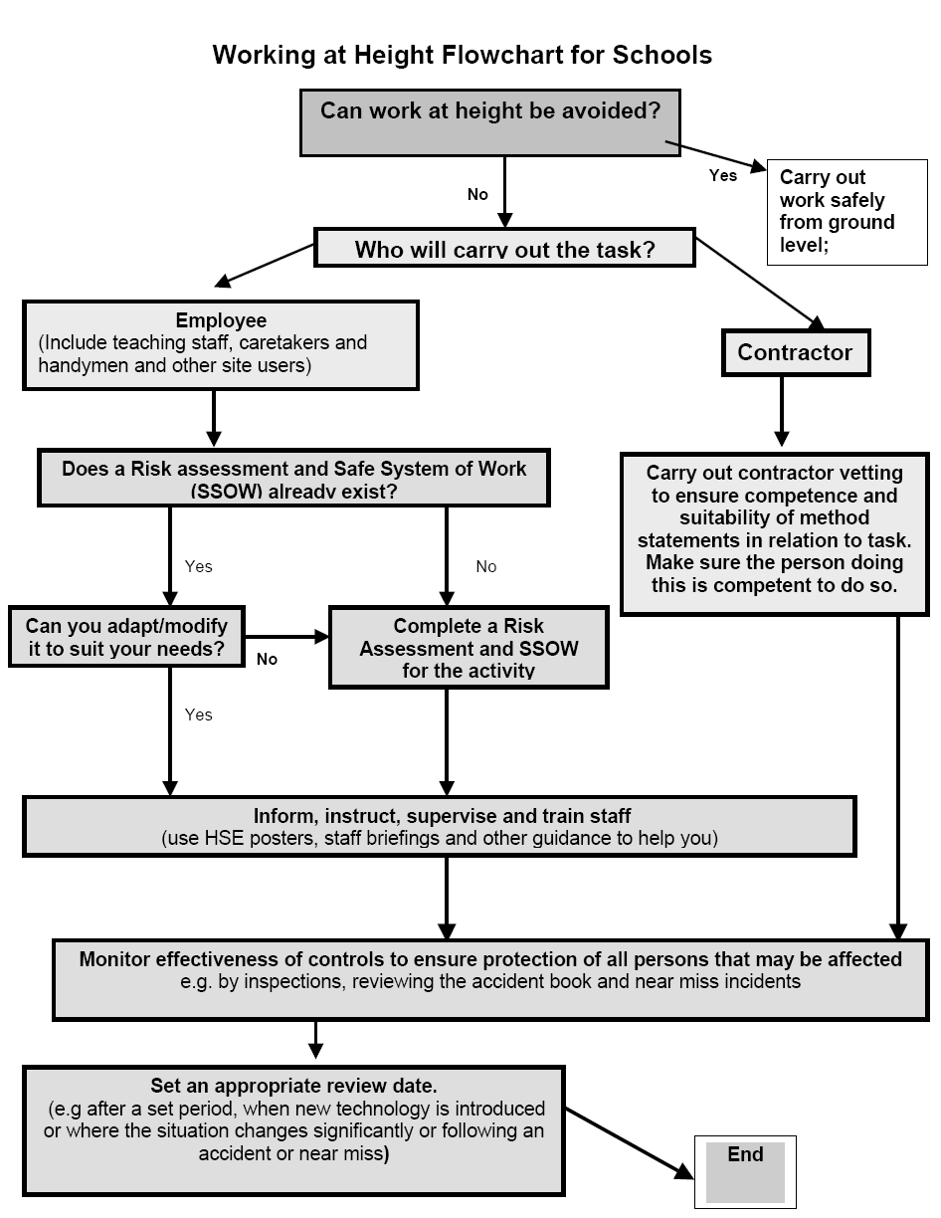

RISK ASSESSING
The factors to be considered in such a risk assessment will include the following:
- The work activity (ie the proposed work at height)
- The equipment to be used (ladders, MEWP etc)
- The duration of the work
- The location of the work activity (to determine the presence of hazards)
- The work environment (including weather conditions, lighting, space etc)
- The condition and stability of existing work surfaces
- The physical capabilities (and competency) of the workers
- Emergency procedures required in the event of an incident or accident

EQUIPMENT SELECTION, USE AND MAINTENANCE
When selecting work equipment the Regulations require the following be considered:
- The working environment (ground conditions, space constraints, presence of the public etc)
- The duration and frequency of work
- Emergency and rescue procedures
- The distance and consequences of any potential fall
- The distance to be overcome in terms of access and egress
- Risks posed by the installation, use, dismantling and removal of the equipment
- The potential loadings persons, equipment and materials
- Is it appropriate for the nature of the work
Equipment must be inspected by the user before each use and also more thoroughly by a nominated competent person at least once every six months (termly in schools).
In the case of ladders and step ladders more often if frequently used by many different people.
In the case of tower scaffolds a competent person must inspect before first use and then, if it remains erected, every seven days that it remains in the same place thereafter.
Ladders should never be hung from the stile or rung but should be securely stored on suitable racks. Materials should not be placed on stored ladders or stepladders. Timber ladders should be protected from the weather and stored away from radiators, steam pipes or other areas of excessive heat or dampness.

STAFF COMPETENCE
Employees required to work at height must receive general training in the risks of working at height and specific training in the equipment that they will be using. Any person using a ladder must be competent to do so.
A suitable qualification for the use of tower scaffolds would be the PASMA (Prefabricated Access Suppliers and Manufacturers Association) Certificate.
Suitable training for the use of powered access equipment and mobile elevating work platforms (MEWP’s) may be arranged with or provided by the manufacturers or suppliers of the equipment.

LADDERS
The Work at Height Regulations do not ban the use of ladders but do require consideration to be given to their use as ladders will not prevent falls and will not limit the distance or consequences of a fall. The causes of falls from ladders include:
- The ladder slipping
- Overstretching
- Ladder fault
- Slipping or loosing footing
- Stepladder being used side on to work-task
Where ladders are to be employed, the requirements of Schedule 6 to the Regulations must be met which can be summarized as follows:
- Ladders should only be used if a risk assessment has demonstrated that the use of more suitable equipment is not justified (taking into account the short duration of the work and site features that cannot be altered)
- Surfaces upon which ladders rest must be stable, firm and of sufficient strength
- Ladders must be positioned so as to ensure stability
- Suspended ladders must be attached in a secure manner to prevent displacement and swinging
- Slipping of portable ladders is to be prevented by securing the ladder, by the use of anti-slip devices (or similar arrangements)
- Access ladders are to protrude sufficiently above the place of landing (to ensure a firm handhold)
- Interlocking and extension ladders should be prevented from moving relative to each other whilst in use
- Mobile ladders should be prevented from moving before being stepped on
- Where practicable, landing or rest areas should be provided when a ladders rises 9 metres above the vertical
- All ladders should be used in a way that allows a secure handhold, secure support and allows a safe handhold to be maintained when carrying a load (unless impracticable when using a stepladder).
Where work at height is necessary you need to justify whether a ladder or stepladder is the most suitable access equipment compared to other access equipment options. You do this by using risk assessment and the hierarchy of controls. When considering whether it could be appropriate to use a ladder or stepladder, you need to consider the following factors.
As a guide, only use a ladder or stepladder:
- In one position for a maximum of 30 minutes
- For ‘light work’. If a task involves a worker carrying more than 10 kg up the ladder or steps it will need to be justified by a detailed manual handling assessment
- Where a handhold is available on the ladder or stepladder;
- Where you can maintain three points of contact (hands and feet) at the working position.
When buying a new ladder, think about the worst type of surface conditions you come across (eg smooth, wet floor tiles). Manufacturers should be able to indicate the types of surfaces their products are intended to be used on when they are unsecured (untied). Only buy the ladder and associated stability devices that suppliers/manufacturers can confirm will be stable enough to be used unsecured in your worse-case scenario, otherwise you will need to take additional measures to secure it. There are two types that can be used:
- Industrial Duty (Class 1) ladders which are designed for a Maximum Static Vertical Load of 175kg (27.5 stones). This will sometimes be referred to as "safe working load". These will be marked as BS2037 Class 1 Metal Ladders or BS 1129 Class 1 Timber.
- BS EN 131 (previously Trade Duty Class 2, but now BS EN 131) ladders, which are designed for a Maximum Static Vertical Load of 150kg (23.5 stones). These may be of metal or timber construction and will be marked simply as complying with BS EN 131.
Only ladders/stepladders complying with the above and so marked are recommended for use in council work. Unmarked ladders must not be purchased or used under any circumstances.
BS 2037 and BS 1129 Class 3 ladders of metal and timber construction are Domestic Duty ladders which are designed for a Maximum Static Vertical Load 125kg (19.5 stones).
These ladders are not designed for heavy use in a working environment. As such therefore, they are not recommended for council work unless a risk assessment indicates they are suitable for the task for which they are to be used.
Any existing domestic ladders or ladders where their type and load bearing can be determined, either by markings, or by the manufacturers, and that are still in serviceable condition, may continue to be used if appropriate for the task. When due for replacement or if there is a doubt as to their loading or suitability, they should be replaced with the appropriate class of ladder detailed above.

Ladder Do’s and Do Not’s
- Do not use a ladder if you have a medical condition, or are taking medication that could affect your safety, or you are under the influence of drugs or alcohol.
- Do make sure you have the right footwear, ie clean, in good condition and without dangling laces.
- When going up or down a ladder, take each rung one at a time and don’t rush. Use both hands to grip the ladder whenever possible.
- Don’t use the top three rungs of a ladder
- Don’t use the top two steps of a stepladder, unless a suitable handrail is available on the stepladder
- On nearing the bottom, watch where you place your feet
- Make sure you do not miss the lower rungs as you step off.
- When working from a ladder, try and maintain three points of contact with it at all times (eg both feet and one hand).
- Don’t carry heavy or awkward shaped objects on a ladder. Never carry loads heavier than 25 kg - any over 10 kg should be avoided if possible. This includes long lengths of lightweight material such as plastic guttering, which can be passed up by a second person instead.

TOWER SCAFFOLDS
Mobile access towers are widely used and can provide an effective and safe means of gaining access to work at height. However, inappropriate erection and misuse of towers are the cause of numerous accidents each year.
Aluminium and thin-wall steel towers are light and can easily overturn if used incorrectly. Towers rely on all parts being in place to ensure adequate strength. They can collapse if sections are left out. Before selecting or specifying a tower, you must be satisfied that it is the most suitable item of equipment for the job.
Towers should only be erected by trained and competent people. There are a number of organisations that provide training for the safe erection and use of tower scaffolds.
Towers should be erected following a safe method of work. There are two approved methods recommended by the Prefabricated Access Suppliers’ and Manufacturers’ Association (PASMA), which have been developed in co-operation with the Health and Safety Executive.
To prevent the use of incorrectly erected or damaged mobile access towers, they must be inspected by a competent person. This is someone with the experience, knowledge and appropriate qualifications to enable them to identify any risks that are present and decide upon the measures required to control the risks.
The requirement for inspection is different for small towers under 2 m, and for towers of 2 m and above. If the working platform is less than 2 m in height, the tower must be inspected:
- after assembly in any position
- after any event liable to have affected its stability
- at suitable intervals depending on frequency and conditions of use.
If the working platform is 2 m or more in height, it must be inspected:
- after assembly in any position
- after any event liable to have affected its stability
- at intervals not exceeding seven days.
A new inspection and report is not required every time a mobile access tower is moved to a new location on the same site. However, if guard rails or other components have to be removed to enable the tower to be moved past an obstruction, then a pre-use check should be undertaken by a trained and competent user to make sure the tower has been reinstated correctly.

PRACTICAL GUIDANCE

PUTTING UP DISPLAYS
What could go wrong | Best practice
- Whilst using wrong equipment (Table/desk/chair/books) gives way when teacher stands on it.  - Person using ladder/step ladder over reaches causing ladder to topple over  - Pupil walks into ladder causing it to topple over  - Person drops display on a teaching assistant | - Install washing line style assembly, using pulleys which can be raised and lowered from ground level  - Restrict displays to head height  - Consider room layout to ensure that display boards are easily accessible  - Displays are prepared as far as possible before putting them up  - Staff and persons instructed not to climb on chairs/tables or other furniture to access display boards  - Provide equipment which is suitable for users to enable safe access to display areas (e.g. kick step type stools and properly designed low steps with hand rails).  - All access equipment is suitable for purpose, checked before use and readily available.  - The use of ladders and other access equipment is restricted to those trained and competent in its safe use.  - Encourage staff to wear appropriate footwear (heel-less or low heeled shoes with non/slip soles).

PLACING OR RETRIEVING ITEMS FROM HEIGHT
What could go wrong | Best practice
- Staff knocked on head by falling items when replacing trays on high shelf  - Shelf collapses causing items to fall on person  - Use of wrong equipment as above | - Implement a ‘heavy box low shelf’ policy  - Review storage so that frequently needed items are easily accessible  - Loose items must not to be stored in high places.  - Display HSE leaflets and posters on working at height in staff rooms  - Provide proper equipment for the task i.e. step ladders with handrails  - Train people in the safe use of equipment

OPENING & CLOSING WINDOWS
What could go wrong | Best practice
- Person falls off ledge whilst opening window  - Pupil falls from unprotected window  - Poorly maintained window falls out of frame striking person standing underneath | - Install remote means of opening high windows (e.g. long handled poles or mechanical openers)  - Fit window opening limiters to all windows above ground floor  - Ensure windows and doors are maintained in a safe condition

DRAMA LESSON
What could go wrong | Best practice
- Pupil falls from mobile tower scaffold when changing stage lights  - Item falls from gantry area onto audience  - Stage light falls during adjusting and strikes another person  - Person climbs up outside of tower scaffold which overturns and injures them  - Scaffold collapses during use due to unsafe erection  - Person falls through open trap door  - Fall from stage during production | - Pupils should not change stage lights  - Consideration of installing lighting rigs which can be lowered to ground level to reduce the need for working at height.  - Teaching staff & volunteers trained in safe use of access equipment through recognised training providers.  - Provide equipment which is suitable to the users to enable safe access to theatre/studio areas (e.g. mobile tower access scaffold, stepladders, ladders and mobile elevated working platforms).  - Frequent documented checks take place to ensure the safe working condition of access equipment.  - Access equipment is restricted to those competent in its safe use.  - Access to backstage/gantry and other areas are restricted at all times and especially when stage is set for production.  - Gantry areas scaffolds etc have appropriate edge protection and handrails which are subject to frequent documented checks.  - Create an exclusion zone where necessary beneath areas where work is taking place.

CARETAKING DUTIES
What could go wrong | Best practice
- Caretaker falls when standing on wheelie bin to access guttering  - Handyman overreaches and falls off a ladder which is not footed or tied during use  - Caretaker blown off edge of flat roof when retrieving football  - Caretaker falls through roof void when walking on joists  - Cleaner falls from desk when standing on it to access light diffuser.  - Caretaker drops a hammer whilst fixing a loose gutter striking a person below  - Ladder placed on uneven ground slips and cleaner falls.  - Caretaker falls from ladder when carrying a tin of paint to first storey  - Caretaker falls through fragile roof  - Ladder rung breaks when handyman steps onto it.  - Whilst cleaning air vents cleaner falls from workbench they are standing on  - Caretaker electrocuted when fixing window from an aluminium ladder when he came into contact with overhead power cable | - All access equipment is suitable for purpose, checked before use and readily available.  - Consideration should be given to hiring suitable equipment for specific jobs (e.g. mobile elevated work platforms, mobile access tower scaffolds) with staff trained in safe use by equipment supplier.  - Frequent documented checks take place to ensure the safe working condition of access equipment.  - Procedures are in place for damaged access equipment to be removed and further use prohibited.  - Access equipment is restricted to those competent in its safe use.  - Consider use of fall arrest systems depending on nature of task, equipment and duration.  - Where persons have pre-existing medical conditions or other factors which may affect their ability to use such equipment a separate risk assessment is in place.  - Adequate and appropriate signs are in place to warn of hazards below work area.  - Ground level area where access route is located is cordoned off to prevent contact with any persons who may be on the premises  - Work scheduled to take place when persons/others are not in the immediate area.  - Caretakers are aware of site specific risks including fragile roofs.  - All fragile roof areas are clearly labelled.  - Access equipment is removed and secured when not in use to prevent unauthorised use.  - Appropriate footwear is worn.
- Accompanying tools and equipment carried on person are in tool belts or secured appropriately.
- Items are lifted using the appropriate equipment (e.g. pulleys) and appropriate safe system of work
- Use only battery powered tools when working at height.
- When working on roof, caretakers to maintain safe distance from roof edge.

