VOICE LOSS IN STAFF

GUIDANCE FOR SCHOOLS

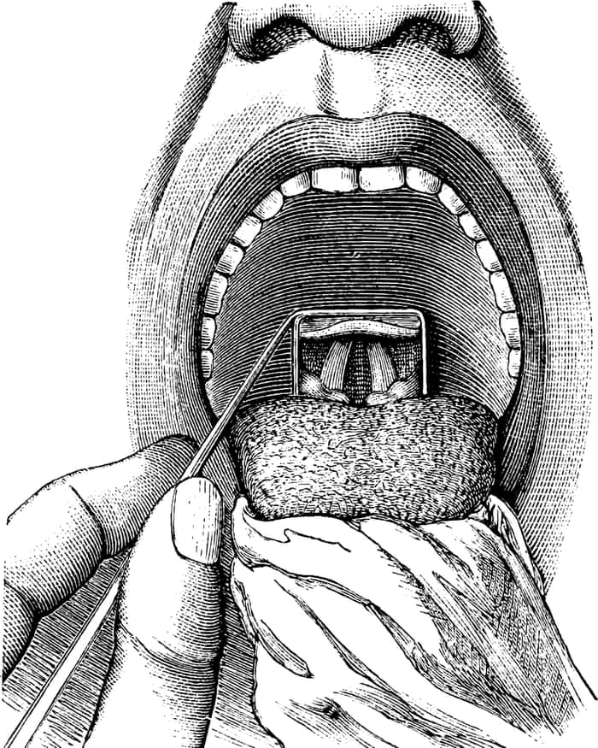

LEGISLATION

- Management of Health and Safety at Work Regulations 1999

INTRODUCTION

Voice care is an issue of increasing concern to teachers. The nature of the job means that teachers are at greater risk than most other groups of employees of experiencing vocal problems at some point in their careers.

The DfE has recognised, in its advice on teachers’ occupational health problems, ‘Fitness to Teach’, that teachers are more likely than most other occupational groups to be obliged to consult their doctors about voice disorders.

The voice is a ‘bag of muscles’. The larynx is the hollow muscular organ forming an air passage to the lungs, and contains the vocal cords. These muscles can also suffer from repetitive strain injury.

In severe cases, vocal strain can produce inflammation of the larynx, swelling of the vocal chords or the appearance of vocal nodules, tumours or ulcers.

VOICE LOSS CONTRIBUTORY FACTORS

Common contributory factors to the development of voice problems include ineffective projection and breathing techniques. Other key factors that can lead to occupational voice loss are:

- Overuse Voices are not designed to talk continually without breaks, and cannot cope with prolonged heavy use without breaks.
- Noise In most of the workplaces with a high risk, there tends to be little thought given to acoustics because there is not usually an occupational deafness risk. However, voices are raised causing vocal strain when the background noise level gets about 40dB
- Humidity and temperature Low humidity, particularly prevalent in winter, is bad for the vocal cords and leads to an increased risk of throat irritation and infections.
- Stress The throat is affected by stress - hence, the telltale ‘lump in the throat’. In extreme cases, this can cause ‘hysterical aphonia’, stress-induced voice loss.
- Fatigue As the voice gets tired, it falls off, so extra effort is needed to be heard. This can be the start of damaging cycle of overuse.
- Infections Colds and flu must be taken seriously - a sore throat is a warning sign that the larynx is inflamed and needs a break.
- Air quality Poor workplace air can cause irritation - mould spores in damp environments, airborne dusts like glass fibre, aluminium, wood dust, silica, lime.
- Chemicals Some common workplace exposures - chlorine, nitrogen oxides, aromatic nitro-compounds, organic solvents, bitumen fumes - can affect the voice.
- Work methods Large classrooms, long scripts and too few breaks are among the management causes of workplace voice loss.

SIGNS OF VOCAL DIFFICULTIES

Most teachers will from time to time experience hoarseness or discomfort from upper respiratory infections such as colds and flu. Early signs of a problem might not seem too worrying or unusual - discomfort speaking, a lower pitch to the voice, breaking voice, a loss of vocal range, a tickling in the throat, or an urge to cough or clear the throat, or a voice that becomes harsh, raspy, shrill or thin.

This will normally sort itself after a break - a night’s sleep or a weekend off. But if the symptoms persist, this could be the early signs of a long-term and potentially irreversible problem. The onset may be gradual, so it is important to be vigilant for signs the symptoms that are becoming more frequent or more troublesome. These include:

- Regular and/or unexplained voice loss.
- A change in voice quality (e.g. hoarseness or croakiness) for more than 10 days.
- A weak and tired sounding voice.
- A voice and/or throat that feels consistently painful or as if there is a lump in the throat.
- Frequent throat clearing.
- Loss of vocal power or ability to project.

Where teachers experience such problems, it is sensible for them to see their GP.

PREVENTING VOICE LOSS

Attention to voice care techniques can be of substantial benefit to teachers. Teachers whose initial training included advice on care of their voice appear to have fewer voice problems during their careers than their peers.

Set out below is a brief summary of points to consider about the way teachers use their voices, possible problems which they may be causing for themselves and the way in which their working environment may contribute to these.

Voice and Speech Patterns

It is important for teachers to:

- warm up their voice at the start of the day
- focus their thoughts and make good use of key words
- consider the effect their voice needs to have on the listener and aim for flexibility to reflect the changing moods they wish to convey
- make use of pauses and silences to emphasise their meaning
- be aware of the symptoms of vocal fatigue and consult their doctor accordingly

Relaxation

Teachers may find it helpful to:

- practise relaxation techniques to ease whole body tension
- before lessons, stretch and relax their facial muscles to release tension from their face and jaw
- take time to relax and let their voice recover after prolonged speaking, use ‘cooling down’ exercises and have a warm drink.

Posture

Teachers should be aware of their posture when speaking and consider how their postural alignment and degree of muscular tension affect the tone and resonance of their voice.

Breathing

Shallow ‘upper chest breathing’ can affect the tone and resonance of the voice.
Teachers may find it useful to practice slower ‘centred breathing’ using the diaphragm, which will help their vocal quality and also release tension and recharge energy.

Pitch

- It is a useful exercise for teachers to seek to find their optimum or natural pitch. By making a sound of agreement in their most relaxed state (“hm, hm”). The second sound is most likely to be very close to their optimum pitch. Practicing speaking flexibly on and around this level can be helpful.
- Although this may be hard to achieve, teachers should try not to pitch outside their comfortable range or shout to get attention. Instead, they should try using agreed signals and develop “getting attention” routines using sound, visual and vocal signals.

Working Environment (Acoustics, Layout and Air Quality)

- Teachers need to be aware of acoustics, space and classroom layout and how these can impact upon their voice and should consider how best to group their class for the task they are undertaking with regard to the acoustics and layout of the room.
- Wood, stone, ceramics, pottery, brick, metal and glass all reflect sound, while some large spaces produce echoes. Teachers should aim to speak more slowly with clear pronunciation rather than increasing the volume in such surroundings.
- A heavily furnished room with low ceilings and containing many people will absorb sound, meaning that voices have to work much harder, so teachers will need to maintain good posture and articulate words using the front of the mouth.
- Dust and fumes or dry atmospheres can affect the voice as well. Poor standards of cleaning, particularly in areas such as art or D&T rooms where particular materials such as clay, solvent-based glues etc are used, can affect air quality. Rooms need to be well ventilated. Humidity can be increased by introducing a few houseplants or by placing bowls of water near radiators.

Self Help for Vocal Fatigue

- It is important to drink water frequently. Drinking six or eight glasses a day will help to keep the larynx moist, especially in hot dry atmospheres. Keeping a glass of water to hand during lessons will help as will a reduction in caffeine intake.
- For a mild sore throat, sucking fruit pastilles can help. Strong throat sprays, lozenges etc, which dry the larynx, should be avoided. It is important to rest the voice as much as possible and avoid whispering, as it is stressful for the larynx.
- Breathing steam rising from hot – but not boiling! – water can also be of benefit.

