HEALTH & SAFETY RISK REGISTER

GUIDANCE FOR SCHOOLS
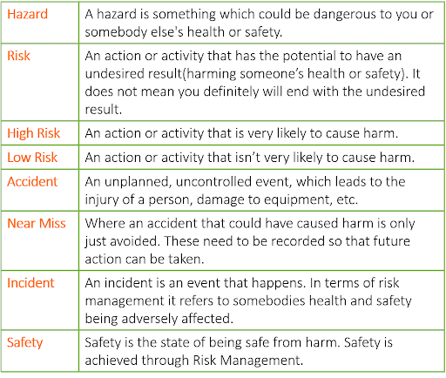

INTRODUCTION
Before senior managers can commit resources to risk control activities, the risks requiring control must be identified and assessed and the control measures deemed necessary selected. Risk assessments are the normal tool used to achieve this objective. Although a legal requirement, completing a risk assessment will not ensure legal compliance unless the control measures needed to treat the risk are acted upon.
A well-developed health and safety risk register can be a useful tool that will enable Head or school managers to identify, commit resources to and monitor the control of the most significant risks the establishment faces. A Risk Register should be developed detailing the risk assessments that have been completed. This has a number of purposes:
- It will provide documentary evidence that the school is identifying and managing risks
- It will act as a control document to ensure risk assessments are being completed and reviewed as necessary
- It will identify who owns the risk assessments
- It will identify any significant risks that are not being reduced to as low as reasonably practicable
- It will identify any further control measures that are required to be taken
It is recommended that the Governing Body, as part of the overview of health and safety within the establishment, review the risk register at least once a term.

WHAT HAS TO BE RISK ASSESSED?
There are no fixed rules on what has to be risk assessed. It can be aimed at general work activities, specific work activities (for example, manual handling), specific persons (for example lone workers or pregnant employees), pieces of equipment (for example, woodworking machinery) or environmental factors (such as noise).
The following is a list of core risk assessments that establishments could develop:
PREMISES RELATED | PERSON RELATED | CURRICULUM RELATED | NON-CURRICULUM
General premises and grounds risk assessment | Teachers/Teaching Assistants | Design and technology lessons | Breakfast or after school clubs
Playground and outdoor play equipment risk assessment | Site Care staff | Art and craft lessons | School events such as plays, firework displays, fetes etc
Fire risk assessment | SEN or medical needs children | Food technology lessons | Blank cell
Classroom risk assessment | New or expectant mothers | Physical education lessons | Blank cell
Asbestos risk assessment | Blank cell | Educational visits/learning outside the classroom | Blank cell
Legionella risk assessment | Blank cell | Primary school curriculum | Blank cell
Premises security risk assessment | Blank cell | Blank cell | Blank cell
Kitchen risk assessment | Blank cell | Blank cell | Blank cell

SCHOOL RISK REGISTER
There is no set format for a risk register but the following example may assist establishments in developing a register. The recommended contents are as follows:
- Risk assessment-this is a simple explanation of what has been risk assessed
- Owner-this is details of who was responsible for completing the risk assessment
- Review date-all risk assessments require review either periodically or when significant change has occurred
- Significant risks-this is a summary of any significant risks that remain that are not currently being controlled
- Action-this is a summary of any recommended actions that are to be taken as a result of the risk assessment. This may include details of the action to be taken, who is responsible for this and when the recommended action is to be completed
NAME OF ESTABLISHMENT:
OWNER OF REGISTER:
DATE OF NEXT REVIEW:
RISK ASSESSMENT | OWNER | REVIEW DATE | SIGNIFICANT RISKS
Blank cell | Blank cell | Blank cell | Blank cell
Blank cell | Blank cell | Blank cell | Blank cell
Blank cell | Blank cell | Blank cell | Blank cell
Blank cell | Blank cell | Blank cell | Blank cell
Blank cell | Blank cell | Blank cell | Blank cell
Blank cell | Blank cell | Blank cell | Blank cell
Blank cell | Blank cell | Blank cell | Blank cell
Blank cell | Blank cell | Blank cell | Blank cell
Blank cell | Blank cell | Blank cell | Blank cell
Blank cell | Blank cell | Blank cell | Blank cell
Blank cell | Blank cell | Blank cell | Blank cell
Blank cell | Blank cell | Blank cell | Blank cell

