NOISE AT WORK

GUIDANCE FOR SCHOOLS
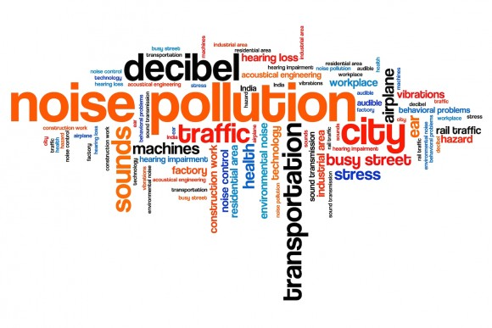

LEGISLATION
- Control of Noise at Work Regulations 2005

WHAT YOU NEED TO DO
- Identify those work activities that may generate excessive noise levels
- Control exposure levels as required by the Control of Noise at Work Regulations 2005
- Purchase equipment with noise reduction in mind
- Provide employees and pupils with adequate hearing protectors
- Ensure that hearing protectors are worn and maintained
- Provide employees and pupils with adequate information, instruction and training
- Provide health surveillance when this is necessary

INTRODUCTION
Noise has been described as unwanted sound, which may be distracting, annoying or cause physical damage to the body (e.g. temporary or permanent hearing damage).
The damaging effects of noise are related to the ‘dose’ that the ear receives and this depends on the duration of the exposure and the noise level. Equal doses will cause the same amount of damage. Therefore short exposure to high levels of noise will cause similar damage to lower levels of noise exposure that are of longer duration.
The Control of Noise at Work Regulations 2005 are intended to protect against risks to health and safety from exposure to noise, risk of hearing damage and other risks such as interference with the employee’s ability to hear instructions or warnings.
All schools and other establishments, to meet the requirements of the legislation must take the following action:
- Identify noisy areas during H&S inspections
- Identify those likely to be at risk from noise exposure
- Identify any employees or groups of employees whose health may be at particular risk from noise exposure
- Obtain a reliable estimate of noise exposure (e.g. from manufacturers’ and suppliers data) and compare the exposure to the action values and limit value

EXPOSURE LIMTS AND ACTION VALUES
Noise is measured in decibels (dB). The annotation dB(A) means ‘A-weighted’, a measure of noise levels in the audible range for humans. A ‘C-weighting’, written as dB(C), is used to measure peak, impact or explosive noises. Both measures are important in relation to the exposure limits and action values.
The Regulations require action at specific values relating to the levels of noise exposure averaged over a working day or week, and the maximum noise (peak sound pressure) to which employees are exposed over a working day.
Lower exposure action values are:
- daily or weekly exposure of 80dB (A)
- peak sound pressure of 135dB(C)
Upper exposure action values are:
- daily or weekly exposure of 85dB(A)
- peak sound pressure of 137dB(C)
Use of a weekly exposure, rather than a daily exposure, may be appropriate where exposure to noise varies from day to day (e.g. the use of power tools on one day but not on others). No allowance should be made for the effects of hearing protection when determining an employee’s noise exposure in relation to the upper or lower action values.
Exposure limits have also been set which must not be exceeded:
- daily or weekly exposure of 87dB(A)
- peak sound pressure of 140dB(C)
In this case, account may be taken of the reduction in noise exposure afforded by hearing protection. However if an employee is exposed to noise at or above the exposure limit values then establishments must take immediate action to bring exposure down below this level.

ASSESSMENT OF EXPOSURE
"Noisy" areas, work activities or processes where there is likely to be risk from noise exposure must be assessed by a competent person. The findings of the assessment should be compared to the action and exposure limit values detailed above.
The type of exposure will depend on how loud the noise is and how long people are exposed to it. As a simple guide you will probably need to do something about the noise if any of the following apply:
- Is the noise intrusive – like a busy street, a vacuum cleaner or a crowded restaurant – for most of the working day?
- Do employees have to raise their voices to carry out a normal conversation when about 2 m apart for at least part of the day?
- Do employees use noisy powered tools or machinery for more than half an hour each day?
- Do employees work in a noisy industry, eg woodworking; plastics processing; engineering
- Are there noises due to impacts (such as hammering, drop forging, pneumatic impact tools etc), explosive sources such as cartridge operated tools?
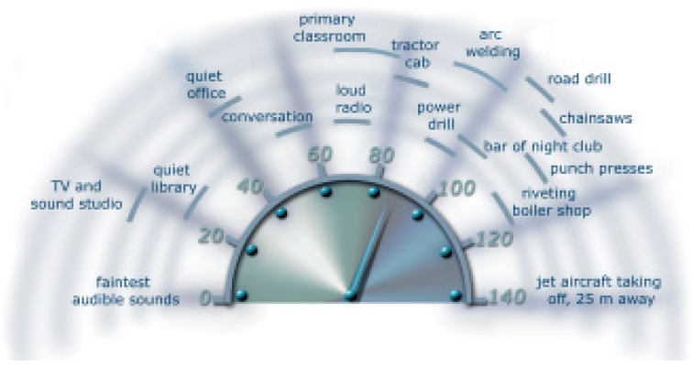
The aim of the risk assessment is to help to decide what is needed to be done to ensure the health and safety of employees who are exposed to noise. The risk assessment should:
- identify where there may be a risk from noise and who is likely to be affected;
- contain a reliable estimate of your employees’ exposures, and compare the exposure with the exposure action values and limit values;
- identify what you need to do to comply with the law, eg whether noise-control measures or hearing protection are needed, and, if so, where and what type; and
- identify any employees who need to be provided with health surveillance and whether any are at particular risk.
In many cases noise measurements will not be necessary and sufficient information about noise emissions may be obtained from equipment manufacturers and suppliers.
It is essential that the assessment is representative of the work that employees do. It needs to take account of:
- the work they do or are likely to do
- the ways in which they do the work
- how it might vary from one day to the next.
Assessment should be by means of observation of specific working practices, reference to relevant information on the probable levels of noise corresponding to any equipment used in the particular working conditions and if necessary, measurement of the level of noise to which his employees are likely to be exposed.
The risk assessment shall include consideration of —
- the level, type and duration of exposure, including any exposure to peak sound pressure
- the effects of exposure to noise on employees or groups of employees whose health is at particular risk from such exposure
- so far as is practicable, any effects on the health and safety of employees resulting from the interaction between noise and the use of ototoxic substances at work, or between noise and vibration
- any indirect effects on the health and safety of employees resulting from the interaction between noise and audible warning signals or other sounds that need to be audible in order to reduce risk at work
- any information provided by the manufacturers of work equipment
- the availability of alternative equipment designed to reduce the emission of noise
- any extension of exposure to noise at the workplace beyond normal working hours, including exposure in rest facilities supervised by the employer
- appropriate information obtained following health surveillance, including, where possible, published information
- the availability of personal hearing protectors with adequate attenuation characteristics.
Where necessary, further assistance in carrying out the risk assessment should be sought from the Health & Safety Manager.
The assessment should be recorded and reviewed at least every two years, or when there is a significant change that may invalidate the original assessment.

CONTROL OF EXPOSURE
If the assessor is satisfied that noise levels are below the first action value of 80dB(A) then this should be recorded. No further action is required other than to ensure that there are no changes to the area, process or activity, or to take action if changes do arise.
Where employees or others are exposed at or above the second action value, i.e. 85dB(A), establishments must draw up a planned programme of noise control measures. The immediate risk can be managed by the provision of hearing protection. However, establishments should identify short and long term targets to reduce noise exposure, draft a timetable for implementation of the noise control measures and assign responsibilities to individuals to deliver relevant parts of the plan.
The purpose of the Noise Regulations 2005 is to make sure that people do not suffer damage to their hearing– so controlling noise risks and noise exposure should be where efforts are concentrated. The basic principles are to:

- tackle the immediate risk, eg by providing hearing protection;
- identify what is possible to control noise, how much reduction could be achieved and what is reasonably practicable;
- establish priorities for action and a timetable (eg consider where there could be immediate benefits, what changes may need to be phased in over a longer period of time and the number of people exposed to the noise in each case)
- assign responsibilities to people to deliver the various parts of the plan
- ensure the work on noise control is carried out
- check that what you have done has worked.
Wherever there is noise at work employers should be looking for alternative processes, equipment and/or working methods which would make the work quieter or mean people are exposed for shorter times. Where there are things that can be done to reduce risks from noise, that are reasonably practicable, they should be done.
However, where noise exposures are below the lower exposure action values, risks are low and so you would only be expected to take actions which are relatively inexpensive and simple to carry out.

PURCHASING EQUIPMENT
Introducing a positive purchasing and hire policy can be the most cost-effective long-term measure to take to reduce noise at work. Choosing quieter equipment and machinery, whether it is bought or hired, from the start can save the cost of introducing noise-reduction measures once it is installed or in use. The following can be done:
- Consider at an early stage how new or replacement machinery could reduce noise levels in the workplace – set a target to reduce the noise levels if possible.
- Ensure that a realistic noise output level is specified for all new machinery, and check that tenderers and suppliers are aware of their legal duties.
- Ask the suppliers about the likely noise levels under the particular conditions in which the machinery will operate, as well as under standard test conditions.
- Try to purchase or hire only from suppliers who can demonstrate a low-noise design, with noise control as a standard part of the machine, not as a costly optional extra.
- Keep a record of the decision process, to help show that legal duties have been met to reduce workplace noise.
Remember to ask suppliers about:
- installation arrangements, eg methods of mounting and location, to ensure machinery operates as quietly as possible;
- anything about how the machine operates which could affect the noise it produces;
- maintenance arrangements to ensure the machine continues to operate properly and does not get louder over time.

HEARING PROTECTION
Hearing protection should be issued to employees:
- where extra protection is needed above what can been achieved using noise control
- as a short-term measure while other methods of controlling noise are being developed
You should not use hearing protection as an alternative to controlling noise by technical and organisational means.
Employers have a legal duty to:
- provide employees with hearing protectors if they ask for it and their noise exposure is between the lower and upper exposure action values (above 80dB(A) but below 85dB(A))
- provide employees with hearing protectors and make sure they use them properly when
- their noise exposure exceeds the upper exposure action values
- identify hearing protection zones, ie areas where the use of hearing protection is compulsory, and mark them with signs if possible;
- provide employees with training and information on how to use and care for the hearing protectors;
- ensure that the hearing protectors are properly used and maintained.
Hearing protectors must be suitable for the environment, comfortable for the wearer and compatible with other personal protective equipment such as hard hats, respirators or eye protection.
Hearing protection zones should be designated in any area for which hearing protection is required, i.e. in areas where exposure to noise is above the upper action value of 85dB(A). The area must be clearly marked "Ear Protection Zone" and suitable signs posted to indicate that hearing protection is mandatory in these areas.

INFORMATION, INSTRUCTION AND TRAINING
The importance of training cannot be understated and in many cases the employee’s exposure to noise will be determined by their diligence in using control measures and adhering to good practice. Employees at risk from exposure to noise must understand the risk to their health, the control measures in place to control exposure and the importance of using these appropriately. Training records should be maintained.
It is important that employees understand the risks they may be exposed to. Where they are exposed above the lower exposure action values you should at least tell them:
- the likely noise exposure and the risk to hearing this noise creates;
- what the employer is doing to control risks and exposures;
- where and how people can obtain hearing protection;
- how to report defects in hearing protection and noise-control equipment;
- what their duties are under the Noise Regulations 2005;
- what they should do to minimise the risk, such as the proper way to use hearing protection and other noise-control equipment, how to look after it and store it, and where to use it
- the health surveillance systems.
Make sure information is given in a way the employees can be expected to understand (for example you might need to make special arrangements if the employee does not understand English or cannot read).

HEALTH SURVEILLANCE
Employers must provide health surveillance (hearing checks) for all employees who are likely to be regularly exposed above the upper exposure action values, or are at risk for any reason, eg they already suffer from hearing loss or are particularly sensitive to damage. The purpose of health surveillance is to:
- warn the employer when employees might be suffering from early signs of hearing damage
- give the employer an opportunity to do something to prevent the damage getting worse
- check that control measures are working
The hearing checks need to be carried out by someone who has the appropriate training. The whole health surveillance programme needs to be under the control of an occupational health professional (for example a doctor or a nurse with appropriate training and experience).

