HEALTH & SAFETY - schools first aid training for schoOLS



# MANUAL HANDLING RISK ASSESSMENT

# GUIDANCE FOR SCHOOLS

[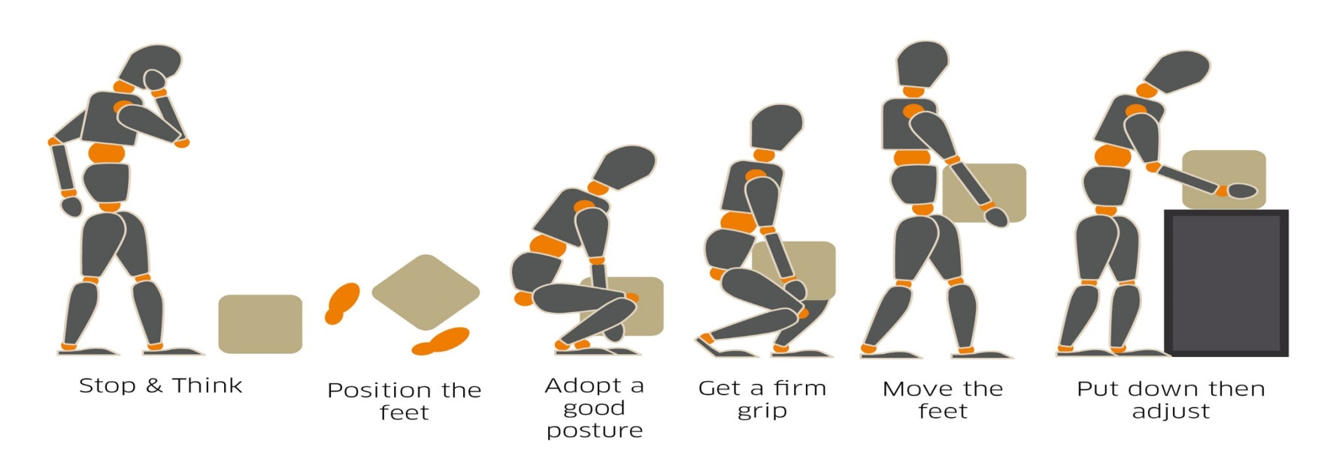](https://www.google.co.uk/url?sa=i&url=https://www.mclarengroup.com/sheq-case-study-manual-handling/&psig=AOvVaw1Uh8b6uO7wzUGU7EZ8fhXU&ust=1588233750073000&source=images&cd=vfe&ved=0CAIQjRxqFwoTCIjqs_aVjekCFQAAAAAdAAAAABAE)

## INTRODUCTION

Where manual handling operations cannot be avoided, employers have a duty to make a suitable and sufficient assessment of the risks to health.

Assessment may best be carried out by members of staff who are familiar with the operations in question, as long as they have the competencies to do so. It may be necessary to call in outside expertise where, for example, the manual handling operation being carried out is complex.

Before in-house personnel are allowed to act as assessors, suitable checks should be made during and after training to ensure that the individuals have understood the information given to them and have reached an adequate level of competence.

## RISK ASSESSMENT FILTER

The filter is in several parts, covering lifting and lowering, frequent lifting, carrying, twisting, carrying, pushing and pulling and handling when seated. Use the guideline figures in each part to help you assess the task. You will need to carry out a more detailed assessment if using the filter shows the activity exceeds the guideline figures.

## LIFTING AND LOWERING

In the diagram below, each box contains a guideline weight for lifting and lowering in that zone. The guideline weights are reduced if handling is done with arms extended, or at high or low levels, as that is where injuries are most likely to occur.). Decide which box or boxes the lifter’s hands pass through when moving the load. Then, assess the maximum weight being handled. If it is less than the figure given in the box, the operation is within the guidelines.

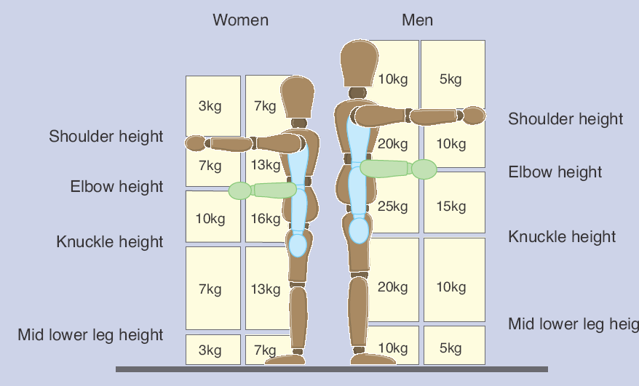

If the lifter’s hands enter more than one box during the operation, use the smallest weight. Use an in-between weight if the hands are close to a boundary between boxes. The guideline weights assume that the load is readily grasped with both hands and that the operation takes place in reasonable working conditions, with the lifter in a stable body position.

## TWISTING

Reduce the guideline weights if the handler twists to the side during the operation. As a rough guide, reduce them by 10% if the handler twists beyond 45o, and by 20% if the handler twists beyond 90o.

## FREQUENT LIFTING AND LOWERING

The guideline weights are for infrequent operations - up to about 30 operations per hour - where the pace of work is not forced, adequate pauses to rest or use different muscles are possible, and the load is not supported by the handler for any length of time. Reduce the weights if the operation is repeated more often. As a rough guide, reduce the weights by 30% if the operation is repeated once or twice per minute, by 50% if the operation is repeated five to eight times a minute, and by 80% where the operation is repeated more than 12 times a minute.

## PUSHING AND PULLING

The task is within the guidelines if the following figures are not exceeded:

|  |  |  |
| --- | --- | --- |
|  | Men | Women |
| Force to stop or start the load | 20kg | 15kg |
| Sustained force to keep the load in motion | 10kg | 7kg |

You will need to make a more detailed assessment if:

* the conditions given for using the guidelines (eg that the load can be readily grasped with both hands) are not met;
* the person doing the lifting has reduced capacity, eg through ill health or pregnancy;
* the handling operation must take place with the hands beyond the boxes in the diagram; or
* the guideline figures in the diagram are exceeded.

For pushing and pulling, you should make a more detailed assessment if:

* there are extra risk factors like uneven floors or confined spaces;
* the worker can’t push or pull the load with their hands between knuckle and shoulder height;
* the load has to be moved for more than about 20 m without a break; or
* the guideline figures in the table are likely to be exceeded.

## CARRYING A DISTANCE

The guideline figures for lifting and lowering apply to carrying operations where the load is held against the body and is carried no further than about 10 m without resting. A more detailed assessment should be made for all carrying operations if:

* The load is carried over a longer distance without resting; or
* The hands are below knuckle height or above elbow height (due to static loading on arm muscles).

## HANDLING AND LIFTING WHILST SEATED

5 kg for men, 3 kg for women.

These are the guideline figures for handling and lifting whilst seated.

## REMEMBER

**The use of these guidelines does not affect the employer's duty to avoid or reduce the risk of injury where this is reasonably practicable. The guideline figures, therefore, should not be regarded as weight limits or approved figures for safe lifting. They are an aid to highlight where detailed risk assessments are most needed. Where doubt remains, a more detailed risk assessment should always be made.**

## MANUAL HANDLING OF LOADS: RISK ASSESSMENT CHECKLIST

### APPLICATION OF GUIDELINES

|  |  |  |  |
| --- | --- | --- | --- |
| Task: | | Load Weight: | |
| Activity | For each activity, does the task fall outside the guidelines?  (Yes/No) | Are there any other considerations that indicate a problem? | Is a more detailed assessment required? |
| Lifting and Lowering | **Blank cell** | **Blank cell** | **Blank cell** |
| Twisting | **Blank cell** | **Blank cell** | **Blank cell** |
| Frequency | **Blank cell** | **Blank cell** | **Blank cell** |
| Pushing and Pulling* | **Blank cell** | **Blank cell** | **Blank cell** |
| Carrying a Distance | **Blank cell** | **Blank cell** | **Blank cell** |
| Seated Lifting and Lowering | **Blank cell** | **Blank cell** | **Blank cell** |

## IF YOU ANSWER YES TO ANY OF THE ABOVE A FULL ASSESSMENT SHOULD BE COMPLETED

Operations covered by this assessment: Diagrams and other information

Location/s:

Personnel involved:

Date of Assessment:

Has assessment been discussed with employees or safety representatives

|  |  |  |  |  |  |
| --- | --- | --- | --- | --- | --- |
| **Section b – More detailed assessment, where necessary:** | | | | | |
| Questions to consider | If yes, tick appropriate level of risk | | | Problems occurring from the task  (Make rough notes in this column in preparation for the possible remedial action to be taken) | Possible remedial action  (Possible changes to be made to system/task, load, workplace/space, environment. Communication that is needed) |
|  | Low | Med | Hi |  |  |
| **The tasks** – do they involve:   * Holding loads away from trunk? * Twisting? * Stooping? * Reaching upwards? * Large vertical movement? * Long carrying distances/ * Strenuous pushing or pulling? * Unpredictable movement of loads? * Repetitive handling? * Insufficient rest or recovery? * A work rate imposed by a process? | **Blank cell** | **Blank cell** | **Blank cell** | **Blank cell** | **Blank cell** |
| **The loads –** are they:   * Heavy? * Bulky/unwieldy? * Difficult to grasp? * Unstable/unpredictable? * Intrinsically harmful (eg. sharp/hot)? | **Blank cell** | **Blank cell** | **Blank cell** | **Blank cell** | **Blank cell** |
| **The working environment –** are there:   * Constraints on posture? * Poor floors? * Variations in levels? * Hot/cold/humid conditions? * Strong air movements? * Poor lighting conditions? | **Blank cell** | **Blank cell** | **Blank cell** | **Blank cell** | **Blank cell** |
| **Individual capability –** does the job:   * Require unusual capability? * Hazard those with a health problem or physical/learning dificulty? * Hazard those who are pregnant? * Call for special information/training? | **Blank cell** | **Blank cell** | **Blank cell** | **Blank cell** | **Blank cell** |
| **Other Factors:**   * Is movement or posture hindered by clothing or personal protective equipment? * Are there sudden or seasonal changes to the workload? * Have workers been given sufficient training and information? * Have workers been involved in the process of planning workloads? * Are communications between management and workers good? | Yes/No  **Blank cell** | | | **Blank cell** | **Blank cell** |

**Overall assessment of the risk: LOW/MEDIUM/HIGH**

(Circle as appropriate)