MANAGEMENT OF TREES

GUIDANCE FOR SCHOOLS
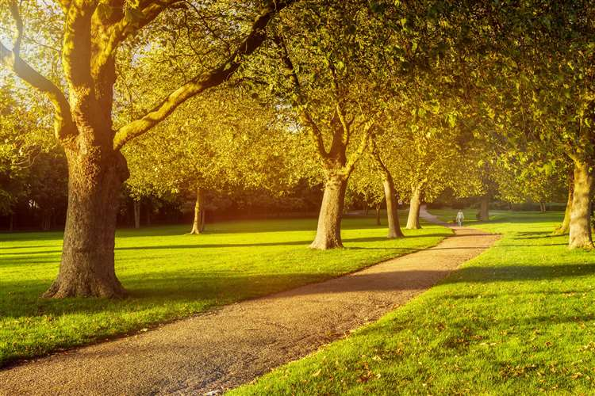

WHAT YOU NEED TO DO
- Recognise that trees within school grounds should be subject to appropriate management
- Seek advice from a competent person (arboriculturalist) to undertake an initial review
- Complete a risk assessment for trees in conjunction with the competent person
- Take any necessary action resulting from the risk assessment process to ensure risks are reduced to as low as reasonably practicable
- Put in place an appropriate regime for the on-going care, inspection and maintenance of trees

LEGISLATION
Health and Safety at Work etc Act 1974
Management of Health and Safety at Work Regulations 1999
Workplace (Health, Safety and Welfare) Regulations 1992
Occupiers Liability Acts 1957/1984

WHY MANAGE TREES
Latest figures from the Forestry Commission suggest that in the UK there are around 3.8 billion trees. Taking into account this significant figure, the number of serious or fatal accidents involving tree failures is extremely low.
However, as the National Tree Safety Group highlights, when such events do occur they become newsworthy because of their very infrequency and that “naturally and rightly, fatal and serious accidents are investigated and can result in litigation”.
As well as direct risks to persons from failures, trees that are not appropriately managed may also cause indirect hazards to people and premises, for example, through unwanted root growth.
As such, schools should take reasonable steps to identify trees, which represent a significant risk to people or property, assess the risk from those trees and take any necessary action to manage the risks in a proportionate way.
Good tree management will have a significant role in:
- avoidance of harm to those occupying or visiting premises
- avoidance of harm to buildings (particularly to foundations) including neighbouring buildings
- avoidance of harm to those on the public highway or in neighbouring buildings
- regulation of tree felling particularly in conservation areas
- protection of trees of special amenity value
- protection of wildlife species and their habitats

MANAGEMENT RESPONSIBILITY
All landowners have a common duty of care under the Occupier’s Liability Act 1957 to take all reasonably practicable precautions to ensure the safety of those who are on their land.
In addition, the Health and Safety at Work etc Act 1974 requires employers to conduct their undertaking in such a way so as to ensure people are not exposed to risk to their health and safety.
Where a tree is hazardous because of decay or structural weakness and shows external signs of being in such a condition, the occupier of the land on which it stands is normally liable under UK laws for any personal injury or other damage it causes by breaking or falling.
This liability arises from provisions by which the occupier has a common duty of care to others who enter the land or its vicinity. The occupier is defined as the person ‘occupying or having control of the premises’.
Community schools and nurseries, under local management of schools and the division of responsibility for maintenance, are responsible for ensuring that all trees are managed in an appropriate manner, following best practice and guidelines.

MANAGEMENT OF TREES
All establishments should ensure they have an effective system for managing trees to meet the requirements set out in the Management of Health and Safety at Work Regulations 1999 and the associated Approved Code of Practice. This will involve:
- instructing specialist competent persons to assist in the management of trees
- setting an appropriate Policy (including determination of responsibilities)
- assessing the risks associated with trees
- taking appropriate action to manage trees so as to achieve an acceptable level of risk
- defining a monitoring and inspection cycle
- keeping records of risk assessments, action, monitoring and inspections

COMPETENT ADVICE
Case law and good practice has identified a number of levels of competency in relation to the management of trees.
It is recommended that the initial specialist assessment be undertaken by an individual with Level 3 competence (e.g. arboriculturalist).
Those trees that are determined as higher risk should be inspected by a professionally trained arboriculturalist at intervals determined by the risk assessment.
Any recommendations for remedial work must also come from an appropriately qualified arboriculturalist.
Staff undertaking regular monitoring of trees should have some experience and/or knowledge so as to be able to identify obvious, visible failure or disease and take the necessary action (e.g. contacting arboriculturalist).
Any external consultants should normally be registered as consultants by the Arboricultural Association.

RISK ASSESSMENT
Establishments are required to consider the level of risk associated with trees and whether it is reasonable to protect against that risk. This will enable the risks associated with tree stocks to be prioritised and help identify any checks or inspections needed.
A tree risk assessment process will require the following steps to be undertaken:
- assess target(s) that may be vulnerable (e.g playgrounds, neighbouring premises, buildings)
- assign target zones to target areas as appropriate
- determine tree inspection type and priority
- assess trees for hazard (identify trees needing more detailed inspection)
- make tree risk assessment (assess the probability that a hazard may result in harm)
- assign risk categories to trees and prioritise management
- implement management system including remedial action, monitoring and inspection regime

TAKING MANAGEMENT ACTION
Once a tree has been identified that presents an elevated risk, action should be planned and taken to manage the risk. Any management regime adopted should identify appropriate measures to maintain trees at an acceptable level of safety, whilst balancing landscape and wildlife considerations.
In general terms, this can be based upon either managing the target or managing the tree itself.
Target management can be undertaken by various actions including:
- Target separation, for example by moving pathways away from the risk zone
- Preventing access to the risk zone, for example by the use of barriers and signs
- Strengthening or protecting the target from impact damage
Tree management may involve some form of tree surgery which could have environmental implications such as loss of habitat for wildlife.
Any arboricultural work required should be carried out by a competent arboriculturist. Any such work should also be kept to a minimum so as to reduce environmental impacts.

ON-GOING INSPECTION AND MONITORING
The need for a particular tree or group of trees to be inspected by a competent person depends on the usage of the area within their potential falling distance.
Inspection is unquestionably necessary within zones where people, or high-value items of property, are continuously or frequently present close to trees which are capable of being hazardous.
Inspections should also be made immediately after any exceptionally severe weather event that might have caused damage to trees. Also, on the basis of expert advice, it may be necessary to make detailed inspections of particular trees at prescribed intervals if they have been found to show signs of progressive deterioration in their condition.
Local monitoring may also be undertaken. It is possible to recognise signs of possible weakness without detailed training, but establishments are expected to seek expert advice if they themselves are not able to recognise all these signs.
Staff should be encouraged to report any defects, near misses and accidents relating to trees so that remedial action can be taken if required.
Key to any inspection regime is competency with useful guidance on competency being found in both the NTSG and English Nature documents detailed below.

RECORD KEEPING
Establishments should keep the following records:
- Details of service level agreements with contractors in relation to tree management
- Copies of risk assessments and any subsequent reports
- Details of any remedial work undertaken
- Copies of any inspection or monitoring reports
- Details of any training undertaken of staff in relation to monitoring

FURTHER INFORMATION
National Tree Safety Group: Common sense risk management of trees- Guidance on trees and public safety in the UK for owners, managers and advisers www.ntsg.org.uk
Forestry Commission: Hazards from Trees-A general guide www.forestry.gov.uk
English Nature: Veteran Trees-A Guide to Risk and Responsibility www.english-nature.org.uk
Health and Safety Executive: LAC2/23: Management of the risk from falling trees or branches www.hse.gov.uk

