LEGIONNAIRES DISEASE

GUIDANCE FOR SCHOOLS
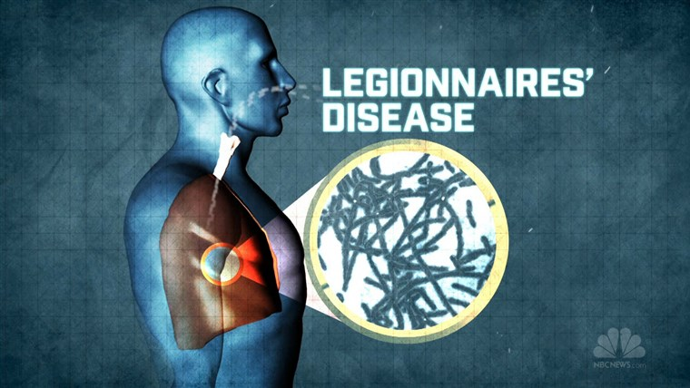

LEGISLATION

- Control of Substances Hazardous to Health Regulations 2002

WHAT YOU NEED TO DO

- Appoint an individual to be the ‘responsible person’
- Identify and assess risks of legionellosis
- Avoid the use of systems that give rise to a reasonably foreseeable risk of legionellosis
- Where this is not reasonably practicable, prepare a written scheme for minimising the risk from exposure
- Implement and manage the scheme of precautions
- Keep appropriate records (risk assessment, treatment etc)

INTRODUCTION

Legionnaires’ disease is a type of pneumonia caused by a bacterium called Legionella pneumophila. People catch Legionnaires’ disease by inhaling small droplets of water suspended in the air which contain the Legionella bacterium.

Experience has shown that cooling towers, evaporative condensers and hot and cold water systems in a wide variety of workplaces present a risk of exposure to legionella bacteria.
To prevent the occurrence of Legionnaires disease, schools and other Children’s Services establishments which operate these systems must comply with regulations requiring them to manage, maintain and treat them properly.

RISK ASSESSMENT

Establishments will need to find out if water systems (including the equipment associated with the system such as pumps, heat exchangers, showers etc) are likely to create a risk. A reasonably foreseeable risk of exposure to legionella bacteria exists in:

- water systems incorporating a cooling tower
- water systems incorporating an evaporative condenser
- hot and cold water systems
- other plant and systems containing water which is likely to exceed 20°C and which may release a spray or aerosol

The following questions may assist in determining the need for a risk assessment:

- Are conditions present which will encourage bacteria to multiply? For example - is the water temperature between 20-45°C ?
- Is it possible that water droplets will be produced and, if so, could they be dispersed over a wide area? For example, consider showers and aerosols from cooling towers;
- Is it likely that anyone particularly susceptible will come into contact with the contaminated water droplets?

In conducting the assessment, the person on whom the duty falls is required to have access to competent help to assess the risks of exposure to legionella bacteria in the water systems present in the premises and the necessary control measures.

This source of advice is most likely to be from a consultancy, water treatment company or a person experienced in carrying out legionella risk assessments.

If a risk is identified which cannot be prevented, establishments must introduce proper controls.

If an establishment has a cooling tower or evaporative condenser on site the establishment must, under the Notification of Cooling Towers and Evaporative Condensers Regulations, notify the local authority in writing with details of where it is located.

CONTROL

Establishments need to prepare a written scheme which sets out how it is intended to control the risk from legionella. The scheme should describe:

- The water system including up-to-date plan or schematic diagrams are sufficient
- Who is responsible for carrying out the assessment and managing its implementation
- The safe and correct operation of your system
- What control methods and other precautions will be used
- The checks that will be carried out on the control scheme and how often these checks will be carried out.

Establishments should appoint someone to take responsibility for managing the control scheme. The ‘responsible person’ needs to be competent - that is, they need to have sufficient knowledge and experience of the water system to enable them to manage and control the scheme effectively.

If an establishment employs contractors to carry out water treatment or other work, it is still the responsibility of the appointed person to ensure that the treatment is carried out to the required standards.

In general, proliferation of legionella bacteria may be prevented by:

- avoiding water temperatures between 20°C and 45°C - water temperature is a particularly important factor in controlling the risks;
- avoiding water stagnation, which may encourage the growth of biofilm;
- avoiding the use of materials in the system that can harbour or provide nutrients for bacteria and other organisms;
- keeping the system clean to avoid the build-up of sediments which may harbour bacteria (and also provide a nutrient source for them);
- the use of a suitable water treatment programme where it is appropriate and safe to do so
- ensuring that the system operates safely and correctly and is well maintained.

OUTBREAK

Legionnaires’ has an incubation period of between two and 10 days. Initial symptoms of are similar to those of flu - headache, muscle pain, and a general feeling of being unwell.

These symptoms are followed by high fever and shaking chills. Nausea, vomiting, and diarrhoea may occur. On the second or third day, dry coughing begins and chest pain might occur. There may also be difficulty breathing.

Mental changes, such as confusion, disorientation, hallucination and loss of memory, can occur to an extent that seems out of proportion to the seriousness of fever.

Some patients may develop pneumonia. This could affect both lungs and lead to hospitalisation if severe.

Most people exposed to Legionella do not become ill and the disease does
not spread from person to person.

Where an individual is diagnosed with legionnaire’s disease, their GP will notify the local authority.

The key figure in the investigation of any outbreak of a communicable disease is the Proper Officer appointed by the Local Authority under the Public Health (Control of Disease) Act 1984 and the Public Health (Infectious Diseases) Regulations 1988.

Local Authorities have established incident plans to investigate major outbreaks of infectious disease, including legionella, which are activated by the Proper Officer who will invoke a Committee of Investigation.

If only one case is diagnosed (which is designated as an "incident" and not an "outbreak") it is possible that no action will be taken, unless the case occurs at a premises where there are additional risk factors to be taken into account because of the type of occupant, in such circumstances even one case will be thoroughly investigated.

If you have a case of legionellosis in an employee who has worked on cooling towers or hot water systems that are likely to be contaminated with legionella, this has to be reported under the Reporting of Injuries, Diseases and Dangerous Occurrences Regulations 2013.

