h&S INDUCTION TRAINING

GUIDANCE FOR SCHOOLS

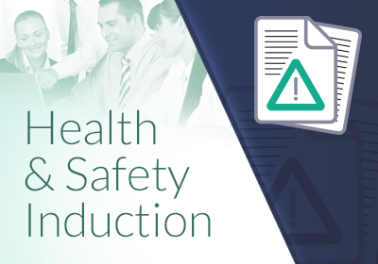

THIS FORM SHOULD BE USED FOR THE INDUCTION OF ALL NEW STAFF INCLUDING ANY TEMPORARY OR AGENCY STAFF.
IT DOES NOT REPLACE ANY SPECIFIC HEALTH & SAFETY EDUCATION, TRAINING OR AWARENESS THAT STAFF MAY REQUIRE TO FULFIL THEIR ROLES AND RESPONSIBILITIES.
INFORMATION RELATING TO EMERGENCY PROCEDURES (FIRE AND FIRST AID) SHOULD BE PROVIDED ON THE FIRST DAY OF WORK.
OTHER INFORMATION SHOULD BE PROVIDED WITHIN THE FIRST WEEK. THE FOLLOWING SHOULD BE ADDRESSED AND BROUGHT TO THE ATTENTION OF ALL NEW STAFF:

HEALTH & SAFETY INFORMATION
- Health & Safety Policy Yes/No
- Staff Handbook Yes/No
- H&S procedures relevant to the role Yes/No
- Location of other H&S information (e.g. School Staff Zone) Yes/No

PERSONNEL AND RESPONSIBILITIES
- H&S responsibilities of the new employee Yes/No
- Name/contact details of person responsible for H&S Yes/No
- Name/contact details of H&S Representative Yes/No
- Occupational Health Service Yes/No
- School Staff Zone information Yes/No

FIRE AND EMERGENCIES
- Significant fire risks determined by the fire risk assessment Yes/No
- The prevention and precaution measures to be adopted Yes/No
- Identification of those with fire safety responsibilities Yes/No
- Instructions on emergency evacuation procedures Yes/No
- Location of escape routes and assembly points Yes/No
- Any specific roles and responsibilities of the new employee Yes/No
- Policy on the use of fire extinguishers Yes/No

FIRST AID
- Location and contact details of first aid personnel Yes/No
- Location of first aid boxes/room Yes/No
- Procedure for contacting first aid staff Yes/No

HAZARDS AND INCIDENT REPORTING
- Procedures for reporting accidents or incidents Yes/No
- Location of accident book Yes/No
- Procedures for reporting faults or defects Yes/No
- Specific hazards that may be encountered and
safe systems of work to be adopted Yes/No

WELFARE
- Location of toilets, washing facilities ,canteen facilities,
drinking water, rest areas, lockers etc Yes/No

TRAINING
- Identification of H&S training requirements specific to role Yes/No

