HOT WEATHER

GUIDANCE FOR SCHOOLS
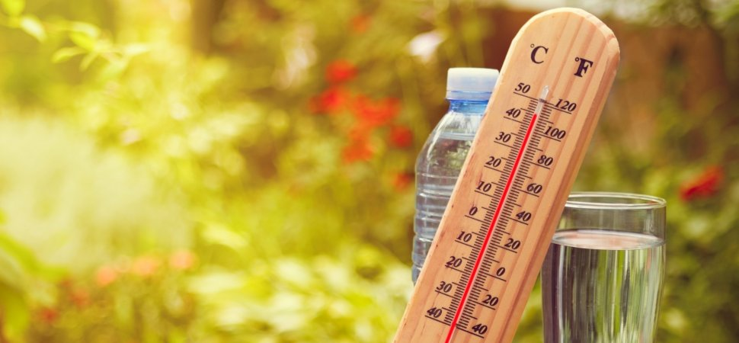

LEGISLATION
- Health and Safety at Work etc Act 1974
- Management of Health and Safety at Work Regulations 1999
- Civil Contingencies Act 2004

WHAT YOU NEED TO DO
- Determine if the school has concerns over excessive temperatures
- Plan for hot weather conditions
- Put in place appropriate measures to respond to hot weather conditions
- Keep measures under review during hot weather periods and take additional measures where required

INTRODUCTION
Hot summers can be a problem in schools due to excessive indoor temperatures. This rise in temperature can be aggravated by the design of many buildings especially in Edwardian schools and the glass/concrete constructions of the 1960s and 1970s.
Very high temperatures can affect the ability staff and pupils to concentrate and to work effectively and can cause physical discomfort and illness. If people get too hot, they risk dizziness, fainting, or even epileptic fits or heat cramps.
In very hot conditions the body’s blood temperature rises. If the blood temperature rises above 39°C, there is a risk of heat stroke or collapse. Delirium or confusion can occur above 41°C. Blood temperatures at this level can prove fatal and, even if people recover, they may suffer irreparable organ damage.
Thermal comfort is not just related to air temperature alone. It considers a range of other environmental and personal factors including radiant temperature, air velocity, humidity, clothing insulation and metabolic heat. These factors make up what is known as the “human thermal environment”.

MAXIMUM TEMPERATURES
There is no prescribed maximum temperature at which action needs to be taken to lower temperatures. However, schools must ensure that all reasonable steps have been taken to achieve a comfortable temperature.
The Health and Safety Executive has issued guidance on thermal comfort which states an acceptable zone of thermal comfort lies roughly between 13°C (56°F) and 30°C (86°F).
Realistically, considering the variable factors mentioned, the best that an employer/occupier can achieve is a thermal environment that satisfies most people and offers ‘reasonable comfort’.
The Health and Safety Executive considers 80% of occupants as a reasonable limit for the minimum number of people who should be thermally comfortable in an environment.
Most individuals will not suffer medical symptoms due to thermal discomfort, beyond irritability and tiredness. However, in some circumstances, exposure to excessive heat can result in more severe conditions such as heatstroke and dehydration, leading to dizziness, fainting, confusion and heat cramps.

SUMMER HEAT PLANNING
If the establishment has a building that has historically overheated in the summer, being prepared can help to ease any discomfort felt by building users from overheating.
It is important that all schools have in place contingency plans to help staff and pupils cope with the heat. There is little that can be done to alleviate problems if schools do not plan and take note of the weather forecast for the week ahead.
By undertaking an assessment, establishments can identify high-risk individuals/activities/work locations and take the appropriate steps to reduce risks and reduce the potential impacts of extreme hot weather.

Controlling Indoor Hazards
The following are some suggested measures that may be taken:
RISK FACTOR | POSSIBLE CONTROLS
Heat Source:  - Sun entering and heating a room  - Additional heat sources in rooms | Stop sun/heat entering the room by:  - Keeping lights off, if possible  - Using blinds (Venetian or slatted blinds allow light in, while keeping sun rays out)  - Reflective film on windows  - Intelligent glazing systems  - Moving workstation away from direct sunlight  - Overhangs or awnings outside windows  - Insulation - the material acts as a barrier reducing heat flow  - Insulating hot pipes or equipment  - Curtailing heat-generating activities e.g. Use of computers, Bunsen Burners, ovens etc.
Environmental: Air Temperature  - High ambient air temperature | Decrease air temperature by:  - Providing portable air-conditioning  - Providing fixed air-conditioning
Environmental: Air Movement  - Lack of air movement | Improve air movement* by:  - Ensuring windows can be easily opened  - Ensuring windows are open  - Providing fans - wall or ceiling mounted are better
Environmental: Physical  - Room retains heat | Improve physical conditions by:  - Relocating classes to cooler areas  - Working outside in shaded areas  - Rotating use of hot rooms
Task or Activity  - Task is strenuous in nature  - Lack of breaks during task  - Task requires protective clothing | Amend the task being undertaken by:  - Avoiding strenuous activities or amending the task  - Restricting the length of time people are exposed to hot conditions  - Arranging for extra breaks to let people cool down  - Arrange for school to start earlier and finish earlier
Individual  - Person has medical condition  - Person is elderly  - Person is very young | Protect the individual by:  - Providing regular drinking water in classrooms  - Relaxing dress codes  - Providing surveillance for those with medical conditions  - Regularly checking on children’s well-being
Information and Training  - No awareness of thermal comfort issues | Improve staff and pupil awareness by:  - Informing staff of signs and symptoms of heat stress and treatment, hot weather plan procedures etc.  - Informing pupils of what they should do (e.g. plenty of fluids, dress codes etc.)
* Under the School Premises (England) Regulations 2012 all occupied areas in a school building should have controllable ventilation at a minimum rate of 3 litres of fresh air per second for each of the maximum number of persons the area will accommodate.
All teaching accommodation, medical examination or treatment rooms, sick rooms, isolation rooms, sleeping and living accommodation shall also be capable of being ventilated at a minimum rate of 8 litres of fresh air per second for each of the usual number of people in those areas when such areas are occupied.

Sun Safety
During term time, children and adults can be found in an outdoors environment during the peak UV hours. Most skin cancers are caused by UV radiation from the sun. It is estimated that people get around 80% of their sun exposure by the age of 21. Much of this exposure occurs when at school.
SunSmart is the national skin cancer prevention campaign run by Cancer Research UK. Schools can become more ‘SunSmart’ by:
- developing their own school sun protection policy
- incorporating sun protection into the school curriculum
- making sure they provide sufficient shade in the school grounds
- warning staff and parents about the dangers of too much sun
- having in place suitable control measures
Further information is available from: www.sunsmart.org.uk

Controlling Outdoor Hazards
The following are some suggested measures that may be taken:
RISK FACTOR | POSSIBLE CONTROLS
Environment:  - Lack of shade | Reduce sun exposure by:  - Creating shady areas using trees, awnings, overhangs, parasols etc.
Task:  - Strenuous activities  - Too much time in the sun | Reduce risk by:  - Restrict activities outside between 11am-3pm  - Reduce strenuous activities or carry out at cooler times  - Arranging extra breaks to allow people to cool down  - Increase morning break and reduce lunch break
Individual:  - Dehydration  - Sunburn  - Sunstroke | Reduce risks by:  - Providing access to drinking water  - Ensuring pupils and staff wear wide brimmed sun hats  - Relaxing dress code (allow loose, light coloured clothing that covers neck and shoulders etc.)
Training and Information:  - No awareness of sun safety | Improve awareness by:  - Incorporating sun protection into curriculum  - Promoting sun protection to pupils via assemblies, workshops, talks  - Training teachers in the importance of sun protection  - Informing parents of the importance of sun protection

SUN PROTECTION
Pupils and staff can be protected from the sun at break times/outdoor lessons by:
- providing shady areas where possible
- encouraging the wearing of loose clothing that covers the upper arms and legs
- asking parents to provide sun hats or caps on hot days
- altering outdoor activity times
The Governing Body/Head teacher should decide whether children can bring in sun cream.
Due to child protection issues (and not health and safety) staff are advised not to assist children to apply sun creams (mainly applies to primary schools). Children should be discouraged from sharing creams and younger children should be supervised when applying cream.
Pupils of all ages should be discouraged from bringing into school sun cream in spray and oils forms, as these are more easily abused.

