HEALTH & SAFETY MANAGEMENT

GUIDANCE FOR SCHOOLS
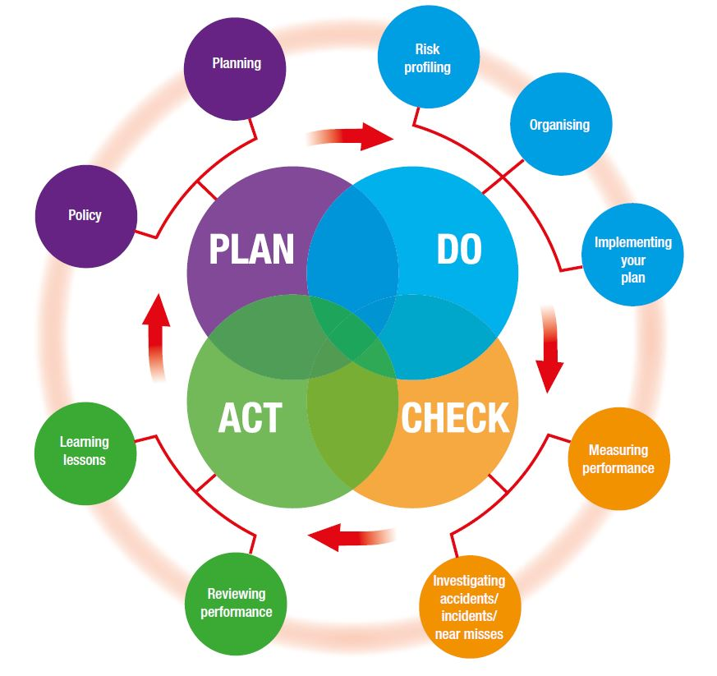

LEGISLATION
- Corporate Manslaughter and Corporate Homicide Act 2007
- Health and Safety at Work etc. Act 1974
- Management of Health and Safety at Work Regulations 1999

WHAT YOU NEED TO DO
To successfully manage health and safety, take the following action:
- Nominate a Governor to be responsible for health and safety
- Develop a school Health & Safety Policy
- Plan how health and safety will be implemented
- Set performance targets
- Have health and safety as a standing agenda item on committee
- Identify staff responsible for implementing health and safety
- Ensure staff receive adequate education, training and awareness
- Seek outside competent assistance when required
- Identify significant risks through completion of risk assessments
- Implement risk control measures
- Regularly inspect the premises to identify any physical faults and defects
- Investigate unwanted incidents and take remedial action
- Monitor health and safety performance via regular reports
- Review health and safety procedures on a regular basis

APPOINTING A HEALTH & SAFETY GOVERNOR
Governing Bodies and Headteachers are responsible for ensuring that health and safety policy and procedures are developed and implemented.
The Governing Body should lead by example and take ownership of health and safety. It should demonstrate commitment and provide clear direction so as to let everyone know health and safety is important.
This can be achieved by appointing a Governor to be responsible for health and safety. This person should ensure that health and safety performance is monitored/reviewed by the Governing Body and that adequate resources are provided to control risks.

DEVELOPING A HEALTH & SAFETY POLICY
The health and safety policy should influence all activities, including the selection of people, equipment and materials, the way work is done and how goods, equipment and services are provided. The Policy should have three clear sections:
- A statement of intent
- Organisational requirements including roles and responsibilities, training and communication
- Arrangements for implementing and monitoring the statement of intent
Further assistance on writing a Health & Safety Policy can be found in the guidance document: School Health & Safety Policy Guidelines

PLANNING FOR HEALTH & SAFETY
Planning is the key to ensuring that health and safety efforts really work. Planning for health and safety involves setting objectives, identifying hazards, assessing risks, implementing standards of performance and developing a positive culture. Planning should typically provide for:
- Identifying hazards and assessing risks, and deciding how they can be eliminated or controlled
- Complying with the health and safety laws that apply to the school
- Agreeing health and safety targets with managers and supervisors
- Design of tasks, processes and safe systems of work
- Procedures to deal with serious and imminent danger
- Setting standards against which performance can be measured

HEALTH & SAFETY ON COMMITTEE
Consider the following questions:
- Do you have a committee where health and safety is discussed?
- Is health and safety a standing agenda item at this committee?
- Does the committee review health and safety performance?
The Governing Body should have a means by which health and safety related matters can be discussed and action agreed upon. This can be a separate H&S Committee or it can be integrated into other committees such as a premises committee or finance committee.
It is also important that the main Governing Body committee reviews health and safety matters at least once a year. Governors should ensure that:
The Health & Safety Policy is reviewed annually
- The H&S Plan has been developed and implemented
- Review performance against the targets set
- Appropriate staff have been given roles and responsibilities
- Staff have received education, training and awareness
- Risk assessments have been completed and reviewed
- Inspection, incident and investigation reports are reviewed
- Reports on health and safety performance are prepared and considered
- A review of health and safety procedures is undertaken

ORGANISE ROLES AND RESPONSIBILITIES
Consider the following questions:
- Have you allocated responsibilities for health and safety to specific members of staff?
- Are they clear on what they have to do?
- Are they held accountable?
- Do they have the right levels of expertise?
- Are these members of staff properly trained?
- Do you need specialist competent advice from outside?
- If so, have you arranged to obtain it?
The school should identify people responsible for particular health and safety jobs – especially where special expertise is called for, such as doing risk assessments, inspecting the premises, giving first aid treatment, arranging school trips etc.
Establishments should ensure these employees understand their responsibilities, have the time and resources to carry them out, are aware of what they must do and how they will be held accountable.

EDUCATION, TRAINING AND AWARENESS
Consider the following questions:
- Have the skills and knowledge needed for people to do their job in a safe and healthy way been identified?
- Have risk assessments identified any specific need for education, training or awareness?
- Has the means of delivering education, training and awareness been identified?
Effective education, training and awareness will contribute towards making employees competent in health and safety and may be required:
- At induction for all staff members
- For those with management responsibilities for health and safety
- For those with specialist roles and responsibilities (e.g. first aid)
- When new processes or procedures are introduced (e.g. new equipment)
It should also be borne in mind that regular refresher training may also have to be undertaken, such as first aid training.
The schools health and safety training matrix on School Staff Zone may assist schools in developing an appropriate regime that identifies staff members that have specific roles and responsibilities as well as the education, training or awareness they need.

IDENTIFY AND ASSESS RISKS
Consider the following questions:
- Has a risk analysis of activities been undertaken
- Have assessments of all significant risks been made and recorded
- Have designated staff received adequate training in risk assessment procedures
The purpose of risk assessing is to minimize the risk of anyone becoming ill or getting hurt as a result of a work activity and to comply with health and safety law.
Further information can be found in the separate guidance on risk assessing.

IMPLEMENT RISK CONTROL MEASURES
Risk control measures should be capable of ensuring, so far as is reasonably practicable that all relevant legislative and good practice requirements are met. The following list provides a summary of the main legislative requirements:
MANAGEMENT RELATED | PROPERTY RELATED | PEOPLE RELATED
Manslaughter- failure to have in place appropriate managerial and organisational elements that result in the death of an individual to whom there was a duty of care. Breach of Corporate Manslaughter and Corporate Homicide Act 2007  General duties-failure to ensure so far as is reasonably practicable the health, safety and welfare of employees and others persons who could be harmed by our undertakings. Breach of Health and Safety at Work etc. Act 1974 (Section 2 and 3)  Organisational elements and risk control-failure to have in place adequate organisational elements and risk control measures. Breach of Management of Health and Safety at Work Regulations 1999  Individual liability-deliberate failure of an individual to ensure that risks are reasonably controlled. Manslaughter (gross negligence) common law | Asbestos- failure to control exposure to fibres due to poor management arrangements. Breach of Control of Asbestos Regulations 2012.  Construction/contractors-failure to select appropriate contractors, poor work, accidents when on site. Breach of Construction (Design and Management) Regulations 2015  Electrical Installation/Equipment-failure to maintain plant and equipment. Electrical shock and fire risks. Breach of Electricity at Work Regulations 1989.  Fire Safety-failure to prevent fires or have in place suitable arrangements in the event of a fire. Breach of Regulatory Reform (Fire Safety) Order 2005 and Dangerous Substances and Explosive Atmospheres Regulations 2005.  Gas Safety-failure to install appropriate or maintain gas system. Breach of Gas Safety (Installation and Use) Regulations 1998  Legionella-failure to control legionella bacteria in water systems-exposure. Breach of Control of Substances Hazardous to Health Regulations 2002.  Plant and Equipment-failure to control use and maintain plant and equipment (inc play equipment). Breach of Provision and Use of Work Equipment Regulations 1998, Lifting Operations and Lifting Equipment Regulations 1998, Pressure Systems Safety Regulations 2000  Signs and Signals-failure to have adequate signage and warning signs and display of posters. Breach of Health and Safety ( Safety Signs and Signals) Regulations 1996 and Health and Safety (Information for Employees) Regulations 1989  Water-failure to ensure quality of water supply. Breach of Water Supply (Water Fittings) Regulations 2009  Workplace (general)-failure to provide and maintain buildings and internal environmental factors, welfare facilities etc. breach of Workplace (Health, Safety and Welfare) Regulations 1992 and Education (School Premises)(England) Regulations 2012 | Accident Reporting-failure to report and/or investigate accidents. Breach of Reporting of Injuries, Diseases and Dangerous Occurrences Regulations 2013 and Social Security (Claims and Payments) Regulations 1979  Display Screen Equipment-failure to undertake workstation assessments. Breach of Health and Safety (DSE) Regulations 1992  Educational Visits-failure to adequately control risks on educational visits. Breach of various pieces of legislation.  First Aid and Medication-failure to have in place adequate arrangements. Breach of Health and Safety (First Aid) Regulations 1981.  Harmful/Dangerous Substances-failure to control exposure to harmful chemicals or substances. Breach of Control of Substances to Health Regulations 2002, Ionising Radiations Regulations 1993, Personal Protective Equipment Regulations 1992 and Manufacture and Storage of Explosives Regulations 2005  Lone Working-failure to ensure the safety of lone working employees. Breach of ‘Management Regulations’  Manual Handling/MSD-failure to prevent work-related upper limb disorders and back problems. Breach of Manual Handling Operations Regulations 1992  New/Expectant Mothers-failure to prevent harm to mother and unborn child. Breach of ‘Management Regulations’  Noise/Vibration-failure to prevent exposure to noise and vibration. Breach of Control of Noise at Work Regulations 2005, Control of Vibration at Work Regulations 2005 and Personal Protective Equipment Regulations 1992  Stress-failure to identify and control stress to employees. Breach of ‘Management Regulations’ (plus civil claims)  Violence and Aggression-failure to prevent or control exposure to violence and aggression. Breach of ‘Management Regulations’.  Working at height-failure to control working at height. Breach of Work at Height Regulations 2005
Further guidance on implementing risk control measures can be found in the accompanying guidance documents.

INSPECT PREMISES
An inspection is a comprehensive formal examination of all or part of a workplace in order to identify deficiencies that create unacceptable risks to health and safety. This will include the identification of unsafe physical conditions and working practices.
They are an invaluable way of identifying potential workplace hazards before they cause a health and safety problem.
Health and safety inspections should be undertaken by persons who are competent to identify the relevant hazards and risks and who can assess the conditions found.
Further information can be found in the accompanying guidance on inspecting premises.

MONITOR PERFORMANCE
Establishments will need to measure health and safety performance to find out if they are being successful.
Active monitoring, before things go wrong, involves regular inspection and checking to ensure that standards are being implemented and management controls are working.
Reactive monitoring, after things go wrong, involves learning from mistakes, whether they have resulted in injuries and illness, property damage or near misses. Look closely at serious events and those with potential for serious harm. Both require an understanding of the immediate and the underlying causes of events. Investigate and record what happened - find out why.
Refer the information to the people with authority to take remedial action, including organisational and policy changes.

REVIEW SYSTEMS
Audits, by your own staff or outsiders, complement monitoring activities by looking to see if your policy, organisation and systems are actually achieving the right results.
They tell you about the reliability and effectiveness of your systems. Learn from your experiences. Combine the results from measuring performance with information from audits to improve your approach to health and safety management

FURTHER INFORMATION
Further information on managing health and safety can be found in the following document that is free to download from the HSE website (www.hse.gov.uk) HSG65: Successful Health and Safety Management.
Additional information is also available on School Staff Zone

