hazards checklist staff

GUIDANCE FOR SCHOOLS
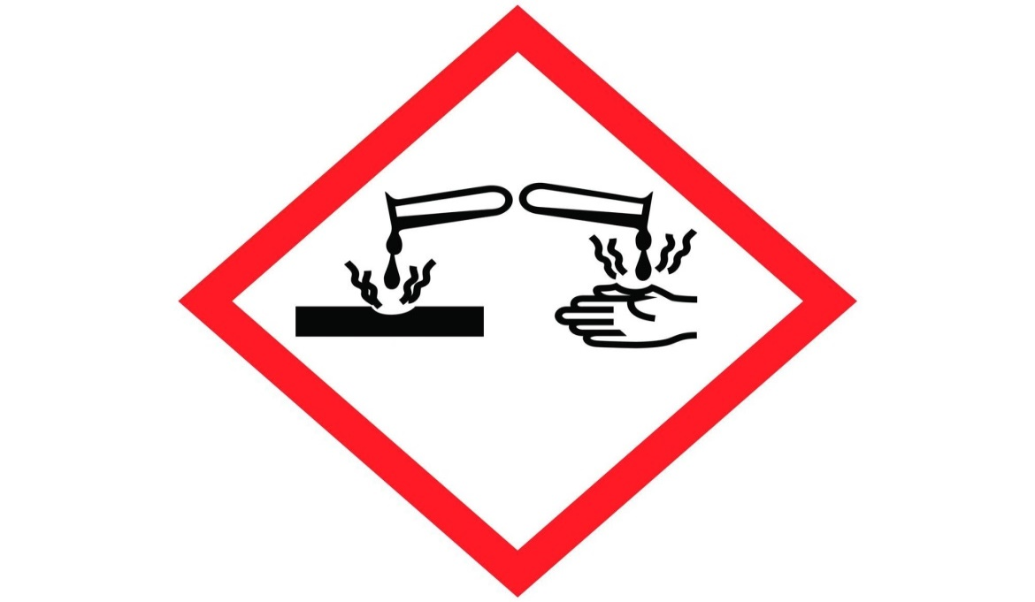

INTRODUCTION

Just like any other workplace, there are risks presented within schools from the working activities of staff which need to be assessed to ensure that staff members remain safe and healthy.

This guidance has been prepared to assist Headteachers and other staff in schools in complying with the health and safety regulations and to provide clear information on the hazards that need risk assessing relating to school staff. The checklist below can be used to assist in the completion of risk assessments for staff be they involved in teaching or support activities.

Risk assessing is nothing more than a careful examination of what in the area of your responsibility could cause harm to people, so that you can weigh up whether you have taken enough precautions or should do more to prevent harm. This will involve identifying significant hazards associated with workplace activities and, taking into consideration the precautions already in place, determining the level of risk.

STAFF RELATED ISSUES

Before determining what the risks are, it is essential that the relevant hazards are identified that need to be assessed. A number of different ways may be used to identify the hazards present in the establishment’s activities. This may include:

- Walking around the workplace and looking at what could be expected to cause harm
- Legislative guidance from the HSE, trade associations etc
- Occasional studies of work activities (such as job safety analysis)
- 'Campaign' studies of particular hazards and risks
- Manufacturers/suppliers instructions for safe use
- Talking to staff and their representatives
- Day-to-day hazard spotting by staff and supervision
- Accident and incident experience

Hazards | Comments | Potential Controls
Verbal and physical violence and aggression by member of public (e.g. parent) | All school staff can potentially be at risk from violence and aggression instigated by members of the public including parents and intruders. | Schools should complete a security risk assessment to determine the level of risk and put in place appropriate control measures based upon safe place, safe systems, safe person.
Verbal or physical violence and aggression by pupil | Teachers and teaching assistance can be at risk from violence and aggression from pupils who are disruptive | Schools should develop a policy in relation to pupil standards of behaviour, taking account of Government guidance relating to this area that is available from the DofE website
Repetitive strain injuries or musculoskeletal injuries to upper body through use of computers | Administrative staff may be using computers for long periods of time  Laptop computers also present a risk to staff if used for prolonged periods of time. | Staff to complete a self-assessment form if using computers for prolonged periods of time
Back injuries/upper limb injuries by lifting or carrying heavy loads/children | The lifting and/or carrying of heavy loads or children can create cumulative health risks or an acute injury. | Schools should identify any activities that involve lifting and/or carrying heavy loads.  In relation to pupils, there should be a clear policy on whether lifting and carrying of children is allowed.  Where lifting and carrying is to be undertaken, this should be subject to a risk assessment of the individuals involved
Exposure to excessive noise levels from machinery or certain lessons (e.g. music) | Site care staff maybe exposed to excessive noise from certain items of plant and equipment (e.g. leaf blowers)  Teaching staff maybe exposed to noise due to the use of musical instruments.  The Control of Noise at Work Regulations will apply | Where noise exposure cannot be reduced to below the limits detailed in legislation, staff should be provided with hearing protection.
Headaches/sore eyes/eye strain from whiteboard use | Projectors for interactive whiteboards applications, have projection distances that are large enough to allow people to stand in front of them and look at the very intense light that they produce | Ceiling mount projectors to avoid line of sight. Use blinds to reduce ambient light levels.  Consider ‘ultra-short throw’ devices when purchasing new or replacement equipment
Electric shock due to contact with electrical equipment | Portable electrical equipment including kitchen equipment can cause electric shock. The Control of Electricity at Work Regulations will apply | Schools to ensure that all equipment is appropriate for use, is subject to regular inspection and periodic testing by a competent person
Stress from working environment and conditions | Stress at work can be caused by many factors and can manifest itself in many ways in a school environment. | Schools should take action to identify the potential causes of stress, take action to reduce these and have in place an employee assistance programme
Falls from working at height (e.g. ladder) | Site managers can often be asked to use stepladders or lean-to ladders whilst teaching staff can be asked to put up displays high up or use storage that is high up | Schools should ensure that the most appropriate equipment is available for staff to sue, that it is maintained and that staff are told of the need to use the equipment
Exposure to infectious diseases (e.g. ill child) | Staff can be exposed to infectious diseases through various routes including body fluids, needles, bites etc | Good hygiene control procedures should be adopted by schools according to best practice from the Health Protection Agency
Exposure to harmful/hazardous chemicals and substances | Site managers, cleaners, kitchen staff can all use and be exposed to substances.  Teaching staff and technicians may also be exposed to substances as part of lessons | Material Safety Datasheets should be obtained and the risks from using chemicals assessed
Voice loss | Teaching staff may have to speak for considerable periods of time. DfE has recognised, in ‘Fitness to Teach’, that teachers are more likely than most other occupational groups to be obliged to consult their doctors about voice disorders. | Staff should be made aware of the risks and provided with basic guidance on how to prevent health problems
Slips, trips and falls in classrooms, corridors, staircases and school grounds | All staff can suffer slips, trips or falls. They are the most common accidents in schools | Schools should ensure that there are good housekeeping procedures, that spills are cleaned up immediately and that all flooring, carpets, stairs etc are in good condition and are adequately lit
Vulnerable persons (pregnant staff, disabled staff, etc) | There may be occasions when staff or more vulnerable, for example due to pregnancy, temporary or long-term disability or illness etc | Where necessary, a specific risk assessment should be undertaken for the individual involved
Poor environmental conditions in the workplace (lighting, heating, ventilation) | Thermal comfort in particular can be a cause for concern for many staff although it is unlikely to create a significant risk | Schools should ensure that a reasonable temperature is maintained and that natural or mechanical ventilation systems are used. Any mechanical system must also be well maintained
Lack of information, instruction, guidance or training | General lack of induction training and knowledge of risks faced along with the safety procedures adopted can result in any of the above hazards materializing | All staff must be provided with basic H&S induction training on being recruited as well as any more specific information and instruction relating to their roles and responsibilities

