HAZARDOUS AND DANGEROUS SUBSTANCES

GUIDANCE FOR SCHOOLS

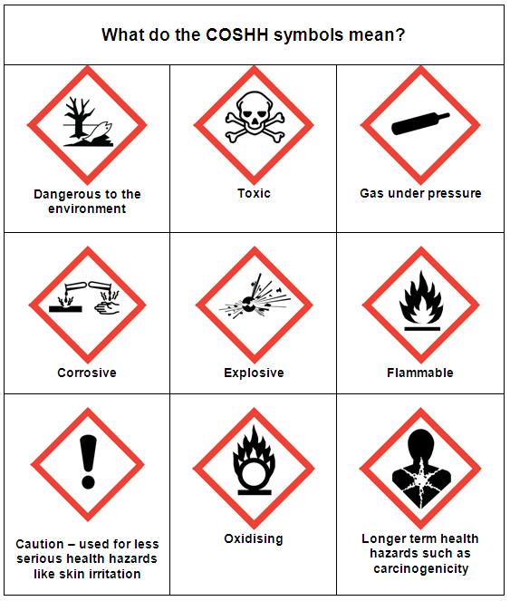

LEGISLATION

- Control of Substances Hazardous to Health Regulations 2002 (COSHH)
- Registration, Evaluation, Authorisation and Restriction of Chemicals (REACH)
- Control of Lead at Work Regulations 2002
- Ionising Radiations Regulations 1999
- Radioactive Substances Act 1993
- Dangerous Substances and Explosive Atmospheres Regulations 2002
- Regulatory Reform (Fire Safety) Order 2005

WHAT YOU NEED TO DO

- Identify hazardous and/or dangerous substances used at work
- Identify any radioactive substances used at work
- Assess the risks from the use, handling, storage and disposal of substances
- Put in place adequate control measures relevant to the substance
- Ensure any equipment provided to control risks is maintained
- Provide adequate information, instruction and training to relevant persons
- Provide any necessary monitoring and health surveillance
- Ensure that appropriate emergency procedures are in place

INTRODUCTION

Using chemicals or other substances at work can put people’s health at risk, so the law requires employers to control exposure to hazardous substances to prevent ill health and to ensure that dangerous substances do not create a risk, particularly from fire.

WHAT IS A HAZARDOUS SUBSTANCE

This has a wide definition and includes:

- Substances which have been classified as hazardous under CHIP 4 as very toxic, toxic, harmful, corrosive, sensitising, irritant, carcinogenic, mutagenic or toxic for reproduction
- Substances which have a Workplace Exposure Limit set by the Health and Safety Executive
- Biological agents e.g. Hepatitis B, Legionella, Leptospirosis
- Dusts, when present in substantial concentrations e.g wood dust
- Any other substance, which presents a similar risk to health and safety

WHAT IS A DANGEROUS SUBSTANCE

Dangerous substances are any substances used or present at work that could, if not properly controlled, cause harm to people as a result of a fire or explosion. They can be found in nearly all workplaces and include such things as solvents, paints, varnishes, flammable gases, such as liquid petroleum gas (LPG), dusts from machining and sanding operations and dusts from foodstuffs.

A dangerous substance is defined as one of the following:

- A substance or preparation which is explosive, oxidising, extremely flammable, highly flammable or flammable, whether or not that substance or preparation is classified under the CHIP Regulations
- A substance or preparation which because of its physico-chemical or chemical properties and the way it is used or is present at the workplace creates a risk
- Any dust, whether in the form of solid particles or fibrous materials or otherwise, which can form an explosive mixture with air or an explosive atmosphere

RADIOACTIVE SUBSTANCE (SECONDARY SCHOOLS)

Secondary schools may hold radioactive substances. Each establishment should have a nominated Radiation Protection Supervisor (RPS) to have day-to-day responsibility for the safe storage, use and monitoring of radioactive sources.

The RPS should be aware of the hazards, risk assessments and control measures associated with each radioactive source in his or her care.

All secondary schools that hold radioactive substances are required to apply the appropriate regulations by making reference to CLEAPPS guidance L93: Managing Ionising Radiations and Radioactive Substances in Schools, etc

MATERIAL SAFETY DATA SHEETS

Manufacturers and suppliers are required by law to provide material safety data sheets for all the hazardous substances they manufacture or supply. These must be obtained for all hazardous substances purchased for use by employees and students. The material safety data sheet provides:

- Detailed information regarding the potential that the substance has to cause harm
- The information needed to make an assessment of the risk to health and safety which the substance presents when it is in use.

A MSDS should be provided free of charge on paper or electronically. A MSDS should provide the necessary information about the substance that will enable a suitable and sufficient risk assessment to be undertaken.

RISK ASSESSMENT

Hazardous Substances
A risk assessment is not just a paper exercise. It’s about taking sensible steps to prevent ill health. It is necessary to know how workers are exposed, and to how much, before deciding whether to do anything to reduce their exposure.

The following checklist outlines the details that must be considered as part of an assessment:

1 | What substances are present and in what form | Check inventory of substances
2 | What harmful effects are possible | Check MSDS
3 | Where and how are substances used, handled, stored and disposed | Check MSDS
4 | What harmful substances are given off (e.g. dust, fume, liquid) | Check existing data sources and previous work experience
5 | Who could be affected, to what extent and for how long | Understand and examine work activities
6 | Under what circumstances | Determine work location and existing environmental conditions
7 | How likely is it that exposure will happen | Check how frequently activity is carried out and for how long  Determine current control that are used
NOTE: Substances can be inhaled, ingested, absorbed or injected

Appendix A contains a sample COSHH Risk Assessment form.

Dangerous Substances
In most circumstances, the risk assessment for dangerous substances will form part of the overall fire risk assessment for the premises.

Each establishment should ensure that dangerous substances are identified and the potential fire risks involved with such substances is determined.

CONTROL MEASURES

Hazardous Substances
When considering control measure for any hazardous substance, establishments should adhere to the following hierarchy:
- Eliminate the use of a harmful product or substance and use a safer one.
- Use a safer form of the product, eg paste rather than powder.
- Change the process to emit less of the substance.
- Enclose the process so that the product does not escape.
- Extract emissions of the substance near the source.
- Have as few workers in harm’s way as possible.
- Provide personal protective equipment (PPE) such as gloves, coveralls and a respirator.

Where the control measure is an engineering control e.g., exhaust ventilation, it must be kept in efficient working order and good repair. These must be examined and tested at regular intervals (exhaust ventilation at least once every 14 months).

Personal protective equipment including respirators and breathing apparatus must be examined frequently as recommended by the manufacturers.

Dangerous Substances

By applying the following five principles establishments will be making sure that they are working safely with dangerous substances:

- Ventilation: Is there plenty of fresh air where flammable liquids or gases are stored and used? Good ventilation will mean that any vapours given off from a spill, leak, or release from any process, will be rapidly dispersed.
- Ignition: Have all the obvious ignition sources been removed from the storage and handling areas? Ignition sources can be very varied and they include sparks from electrical equipment or welding and cutting tools, hot surfaces, open flames from heating equipment, smoking materials etc.
- Containment: Are your flammable substances kept in suitable containers? If you have a spill will it be contained and prevented from spreading to other parts of the working area? Use of lidded containers and spillage catchment trays, for example, can help to prevent spillages spreading.
- Exchange: Can you exchange a flammable substance for a less flammable one? Can you eliminate flammable substances from the process altogether? You may be able to think of other ways of carrying out the job more safely.
- Separation: Are flammable substances stored and used well away from other processes and general storage areas? Can they be separated by a physical barrier, wall or partition? Separating your hazards in this manner will contribute to a safer workplace.

TRAINING

Where work is liable to expose an employee to a substance hazardous to health, they should be provided with suitable and sufficient information, instruction and training. This must include:
- Details of the substances that are dangerous or hazardous to health to which the employee is liable to be exposed
- The significant findings of the risk assessment/s
- The appropriate precautions and actions to be taken by the employee when using, handling or storing substances
- The results of any monitoring of exposure that is undertaken
- The collective results of any health surveillance undertaken

MONITORING AND HEALTH SURVEILLANCE

Exposure should be monitored where the risk assessment shows that it is necessary to maintain adequate control of the employees exposure to
substances hazardous to health.

Establishments must ensure that the monitoring is undertaken in accordance with a suitable procedure.

Suitable health surveillance must be provided where employees are, or are liable to be exposed to a substance hazardous to health and such health surveillance is appropriate for the protection of their health.

STORAGE AND DISPOSAL

Certain chemicals must not be stored with each other. For example, acids are not to be stored near oxidising agents and chemicals should be protected from moisture.

There should be adequate warning notices posted around the storage area.

An inventory should be kept of all hazardous and dangerous substances present. Separate inventories for different work areas may be needed if large numbers of substances are in use, for example, in secondary schools, the science, design and technology, art and design departments will need their own inventories. The inventory should indicate whether a risk assessment is required for the substance.

Any unwanted substances should be disposed of responsibly. It is an offence under the Environmental Protection Act 1990 to dispose of certain substances illegally through the sewage system or with non-hazardous waste. Under no circumstances should hazardous substances be disposed of down sinks, toilets or drains.

EMERGENCY PROCEDURES

Special procedures may be required for managing any uncontrolled release of a hazardous substance which could result in exposure well beyond that associated with day-to-day activities e.g. spillages, sudden failure of extraction ventilation or during a fire or flood. This could include:

- Availability of information on the specific hazards likely to arise in certain circumstances e.g. during a fire or accidental mixing of substances
- Practice of emergency procedures
- Information and training for employees in the special procedures
- Information for emergency services
- Procedures for clearing up and safe disposal e.g. availability of a suitable spillage kit

CONTRACTORS

Contractors working on Council sites should:

- Obtain hazard data sheets for any hazardous or dangerous substances which they are using
- Carry out risk assessments for any work activities involving hazardous or dangerous substances on Council sites
- Prepare written safe systems of work for the tasks carried out
- Store hazardous and dangerous substances securely when not in use

APPENDIX A: COSHH RISK ASSESSMENT

Dept: Location:
Product Trade Name
Product Type
MAIN HAZARD
Gas | Vapour |  | Fume |  | Dust |  | Solid |  |  | Swallowing
Usual Appearance:
RISK
High |  |  |  | Medium |  |  |  | Low
MAIN HAZARD IDENTIFIED
Harmful |  | Irritant |  |  |  | Highly Flammable |  |  | Toxic
PRECAUTIONS
Emergency Actions

Storage Requirements

Working Conditions

Personal Protective Equipment
Goggles |  |  |  |  |  | Respirator/Mask
Gloves |  |  |  |  |  | Other
Outer Clothing |  |  |  |  |  | Type to be Worn
Personal Hygiene

Methods of Safe Disposal

First-Aid Measures

Further Information

Manufacturers Details

Date of Assessment |  |  |  |  |  | Review date
Assessor |  |  |  |  |  | Assessors Signature

