writing a h&s policy

TEMPLATE FOR PRIMARY SCHOOLS
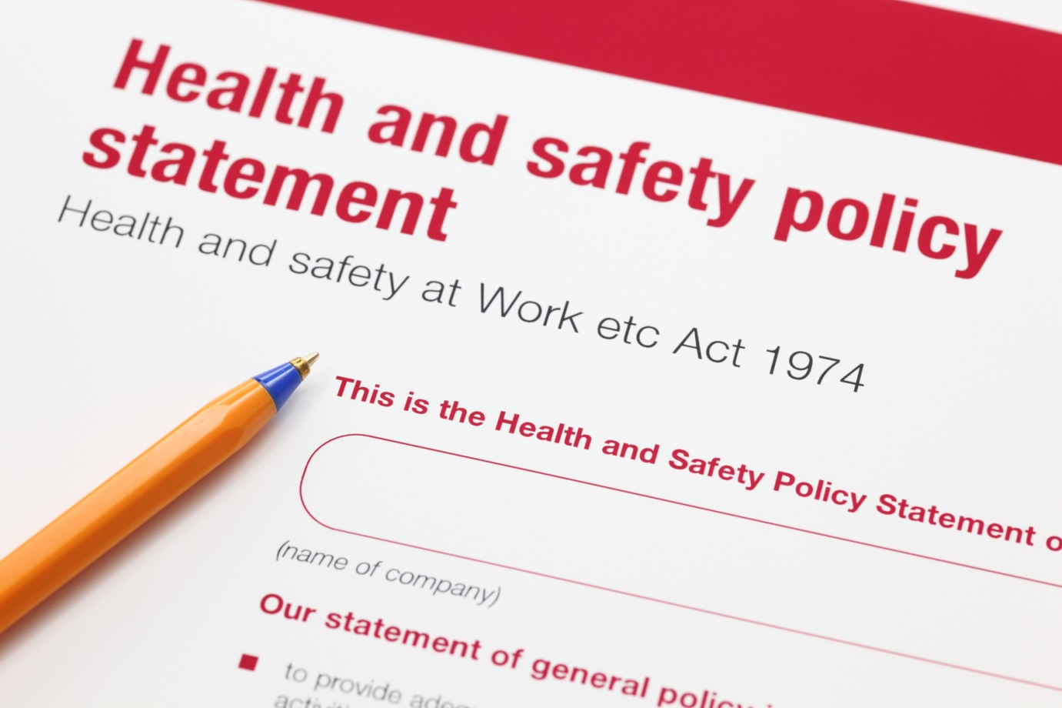

A.N. OTHER PRIMARY SCHOOL

SCHOOL BADGE HERE

HEALTH & SAFETY POLICY
DATE HERE
THIS HEALTH & SAFETY POLICY WAS APPROVED AND ADOPTED BY THE FULL GOVERNING BODY ON:

STATEMENT OF INTENT
In accordance with the Health and Safety at Work etc Act 1974, it is the policy of the Governing Body of …………………………………… School, to ensure, so far as is reasonably practicable, the safety, health and welfare at work of all employees and to protect non-employees such as pupils, visitors, contractors and other persons at the school from injury and ill health arising from any activities undertaken.
In compliance with health and safety legislation and regulations, the Governing Body and Head Teacher will ensure so far as is reasonably practicable that:
- Adequate resources are made available to enable the effective implementation of this Policy and associated procedures
- Advice is sought from competent persons on legal requirements for health and safety and on current best practice
- Those with specific roles and responsibilities for health and safety will be engaged and are competent to successfully undertake their duties
- Arrangements for communicating and consulting with employees and other relevant parties are implemented
- Suitable and sufficient assessments are undertaken and recorded for all activities undertaken by the establishment
- Appropriate risk control measures and safe systems of work are developed and implemented
- Appropriate procedures are adopted to monitor the successful application of this policy and associated procedures
The Governors and staff of …………………………………… School are committed to playing an active role in the implementation of this policy and undertake to annually review and revise it in light of changes in legislation, experience and other relevant developments.
Hammersmith & Fulham Council, as the employer in community schools has overall responsibility for health and safety within the establishment. The school will follow any policies and procedures issued to the school by the Council in respect of health and safety in accordance with the local management of schools regime and fair funding.
This Health & Safety Policy, its supporting documentation and arrangements for implementation will meet our legal obligations and contribute to our objectives relating to continuous improvement on health and safety performance.
Signed: ___________________________ Signed: _________________________
Head Teacher: _____________________ Chair of Governors: _______________
Date: ____________________________ Date: __________________________

ORGANISATIONAL RESPONSIBILITIES
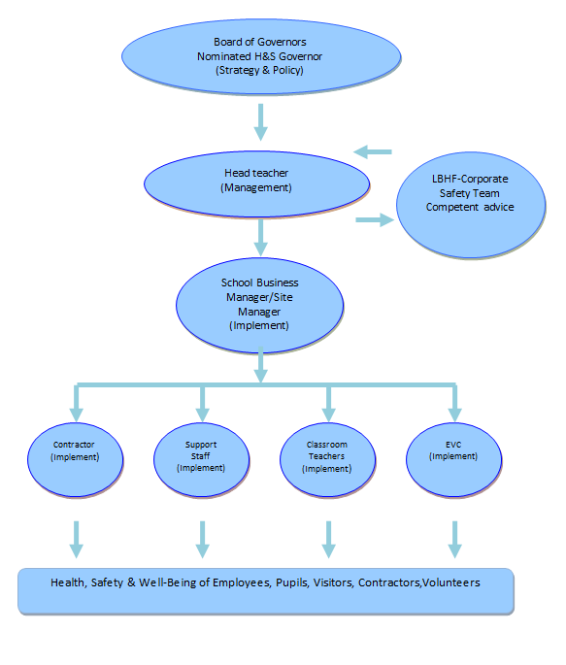

The Governing Body
The Governing Body has overall responsibility for H&S. In consultation with the Headteacher, the Governing Body will:
- Nominate a Governor to be responsible for health and safety matters
- Ensure that suitable resources and strategic direction are available to discharge the school’s health and safety responsibilities
- Ensure that a H&S Policy and procedures are developed and implemented, following best practice guidance
- Ensure that, where necessary, objectives and actions plans are developed to implement the H&S Policy and associated procedures
- Ensure that there is an appropriate forum where health and safety matters can be discussed and strategic decisions made
- Ensure that health and safety is monitored by the appointed Governor and committee so that legal and best practice requirements are met
- Monitor, via reports, the overall performance of the schools health and safety management system
- Ensure that the establishments health and safety policy and management system is reviewed regularly

The Head Teacher
In consultation with the schools senior staff and Governing Body, the Head Teacher will have day-to-day management responsibility for health and safety and will:
- Implement the requirements of this Policy and associated procedures for ensuring compliance with all health and safety legislation within the school
- Demonstrate a personal commitment to health and safety by providing visible and active leadership and leading by example
- Ensure a positive health and safety culture is evident and a proactive approach to health and safety management is adopted within the school
- Appoint persons to assist them with meeting the safety objectives, standards and checks detailed in this policy
- Ensure all school decisions (including new projects, procurement decisions, contractor selection, etc.) fully take into account health and safety considerations
- Ensure that school employees recognise health and safety as an integral element of their work, and that health and safety is given equal status alongside other management functions
- Ensure that health and safety is adequately resourced with both time and finances and that managers make adequate provision in their budgets for managing health and safety
- Ensure suitable persons are nominated to undertake key health and safety functions within the school and to ensure these individuals are adequately supported and suitably trained

The School Business Manager/Site Manager
The School Business Manager/Site Manager, in consultation with the Head Teacher, will be responsible for ensuring the day-to-day operational requirements of the H&S Policy and associated procedures are implemented. The School Business Manager/Site Manager will:
- Maintain an up to date copy of the health and safety policy together with all associated documentation
- Notify the Head Teacher of any health and safety concerns and any financial implications identified by the Risk Assessment process
- Be the focal point for reference on health safety and welfare matters and to give advice or indicate source of advice
- Liaise with and report directly to the Governors or through the Headteacher, on all matters of Health and Safety
- Ensure the day to day implementation of this policy and associated procedures including seeking the approval of the Governors for meeting the financial implications of identified control measures
- Ensure that all certification and statutory inspections are kept up to date
- Establish and maintain safe working procedures and carry out regular health and safety assessments of the activities/premises for which they are responsible, and report to the Head Teacher any defects, which need attention
- Carry out a daily health and safety inspection of the premises in the morning before school starts and at the end of the school day
- Advise the Head Teacher on requirements for health and safety equipment and on additions or necessary improvement to plant, tools, equipment or machinery.

Educational Visits Co-ordinator
The Educational Visits Co-ordinator will be responsible for all aspects of ‘learning outside the classroom’ and will ensure that health and safety forms an integral part of planning of trips. The EVC will:
- Be responsible for managing educational visit in line with the learning outside the classroom agenda
- Work with group leaders to ensure that the aims of the educational visit are achievable and in line with those of the school
- After discussion with the headteacher and governing body, approve proposals or submit proposal to the LBHF H&S Manager
- Confirm that adequate risk assessments have been carried out
- Confirm the leadership of the group is appropriate and provide mentoring to group leaders and staff as necessary

Teachers and Teaching Assistants
The health and safety of pupils in classrooms is the responsibility of class teachers and teaching assistants. Class teachers and teaching assistants are expected to:
- Check that classroom areas and equipment is and remains safe and report any defects to the Site Manager
- Give clear instruction and warnings to pupils, as often as necessary
- Avoid introducing personal items of equipment into school without authorisation from the Head Teacher
- Follow the requirements of the H&S Policy and working procedures
- Complete classroom risk assessments/checklists as instructed by the Head Teacher

All Staff
All staff are expected to know the health and safety organisational responsibilities and arrangements to be adopted in the school. Employees have a duty to:
- Co-operate with managers on health and safety matters and follow all requirements of the H&S Policy and procedures
- Take reasonable care of their own health and safety and others
- Make suggestions to improve any aspect of health and safety
- Report any local hazards that they become aware of to the Site Manager
- Report incidents that have led to injury or damage, or near misses that may have led to injury or damage

Health and Safety Representatives
The Governing Body will make arrangements for the establishment of Health and Safety representatives to oversee all matters of health and safety. Health and Safety representatives will be allowed:
- To investigate accidents and potential hazards
- To make representation to the employer about general issues affecting health, safety and welfare in the workplace
- To carry out school inspection within directed time, but wherever practicable outside teaching time
- To represent members in consultation with enforcement agencies

Contractors
The catering contractor is responsible for all their catering staff and for ensuring that health and safety requirements are met in the kitchen area. The catering manager and kitchen staff will familiarise themselves with the school policy and associated procedures. Catering staff are required to co-operate with the school and the kitchen manager will advise the Site Manager of any health and safety concerns.
The premises maintenance contractor is responsible for ensuring that health and safety requirements are met in relation the maintenance of all plant and equipment. The maintenance contractor will co-operate with the school and will advise the Site Manager of any health and safety concerns.
The school will seek to ensure that contractors conduct themselves and carry out their operations in full compliance with all statutory and advisory safety requirements.

Visitors and Hirers
The school will seek to ensure that hirers and others who use the school premises, conduct themselves and carry out their operations in full compliance with all statutory and advisory safety requirements.
When the premises are hired to persons outside the employ of the Governing Body, it will be a condition for all hirers, contractors and others using the school premises or facilities, that they are familiar with this policy, that they comply with all safety directives from the Governing Body and that they will not, without prior consent from the Governing Body:
- Introduce equipment for use on the school premises
- Take any action that may create hazards for persons using the premises or the staff and pupils of the school.
Visitors will be required to observe the health, safety and welfare rules of the school. In particular, parents and other volunteers helping out in the school, will be made aware of the health and safety policy applicable to them by the teacher to whom they are assigned.

ARRANGEMENTS AND PROCEDURES

Management

Consultation & Communication
The Governing Body and Head Teacher will involve all staff including appointed representatives in the development of health and safety. There will be a regular programme of staff briefing meetings where staff will be consulted on all areas of health and safety.
The H&S Law Poster is displayed in the main office. Copies of the H&S Policy and associated procedures are made available to all staff via the Head Teacher and Site Manager. The Staff Handbook will also be used to communicate on H&S matters.

Staff Learning & Development
All employees shall be instructed as to possible hazards which may occur at their place of work and shall receive such information, instruction and training as may be deemed necessary to enable them to do their work in a safe and efficient manner.
Staff receive health and safety information during their induction and from the School Business Manager/Site Manager. Regular updates are given as required and relevant information is displayed in the staff room in the main school building.

Risk Assessing
The Site Manager will be responsible for ensuring that suitable and sufficient risk assessments are completed for:
- The premises and grounds
- Playground and outdoor play equipment
- Fire (via external competent person)
- Asbestos
- Legionella (via external competent person)
- Premises security
Each classroom teacher will undertake a Classroom risk assessment every term.
The Educational Visits Co-ordinator and Group Leaders will complete a risk assessment for each school trip
The SENCO will complete risk assessments for pupils with special needs

Accident reporting and investigation
The school will use the London Borough of Hammersmith & Fulham accident and incident reporting system to report and record incidents. For minor incidents, the school will keep local records.
The LBHF Corporate Safety team will undertake any necessary RIDDOR reporting requirements on behalf of the school.
The Head Teacher and Site Manager will investigate incidents reported by staff as necessary, depending upon the circumstances of the incident and report findings to the Governing Body.
Where deemed necessary, support will be sought from the LBHF Corporate Safety Team in investigating the more serious incidents.

First aid and medications
The school will determine through an assessment, first aid requirements both for on-site activities and educational visits. The following arrangements are to be followed:
- Sufficient first aid trained staff will be available on-site in accordance with legal requirements as detailed in LBHF guidance.
- First aid arrangements for off-site educational visits will be determined as part of the trips risk assessment.
- All staff nominated to provide first aid or paediatric first aid will receive recognised training. Records of staff trained will be maintained.
- Appropriate first aid material, equipment and facilities will be provided and located throughout the premises.
- All equipment will be checked on an annual basis by the Site Manager.
- First aid arrangements will be made known to staff and pupils.
- Where first aid treatment is given, suitable records will be kept.
The school has developed a separate policy on the administration of medications, based upon good practice guidance from the Government.

Control of contractors
For non-construction work, the Site Manager will undertake the following:
- Identify all aspects of the work that the contractor will be required to do
- Identify any risks associated with the work
- Undertake checks on contractors competence in terms of health and safety
- Provide any necessary health and safety related information to the contractor
- Ensure that appropriate risk assessments and method statements are prepared by the contractor
- Ensure that sufficient rules and control measures are in place when the work is undertaken
- Ensure that contractors are monitored when on-site
To assist in this process, a separate checklist available from ‘School Staff Zone’ will be utilised.

Construction work
Where work coming under the requirements of the Construction (Design and Management) Regulations is commissioned by the school, it is recognised that the Governing Body will be the client and will meet all legal requirements in the above regulations.
Advice will be sought from a competent person and the corporate safety team in LBHF.

Inspections and monitoring
The Governing Body has a Finance and Premises Committee that is used to monitor health and safety and to discuss/resolve issues. The Committee will receive regular reports from the Head Teacher and Site Manager.
The Head Teacher and Site Manager undertake an inspection of the school every term. In addition, the nominated H&S Governor will undertake an inspection every year.
All inspections will generate a written report.

Premises

Fire safety and emergency management
The Site Manager will maintain a Fire Log Book. This will contain details of all training, fire drills, testing of alarm system, maintenance of fire related equipment etc. The following procedures are adopted:
- All staff will receive basic fire safety instruction and training at induction and then at regular intervals. The Site Manager will deliver this training.
- A fire risk assessment is completed by an external competent third party. This is reviewed on an annual basis.
- Based upon the fire risk assessment, a fire detection and alarm system, emergency lighting and fire-fighting equipment will be installed and maintained
- The Site Manager will ensure that contractors maintaining equipment are competent to do so
- Procedures for action to take in the event of a fire are developed in the form of a separate fire emergency plan. This is based upon best practice from the LFB
- The Site Manager will ensure that means of escape are well maintained and safe to use at all times the establishment is occupied

Asbestos management
The school has adopted the following procedures in relation to the management of asbestos containing materials:
- The Site Manager has been nominated to manage asbestos within the establishment and will be provided with training to enable them to do so
- The school will obtain a copy of the asbestos register and survey report from LBHS School Resources
- The school will develop an asbestos management plan in conjunction with LBHF School Resources and review this regularly
- All staff will be made aware of the presence of asbestos containing materials and the control measures required to prevent fibre release
- The school will ensure that all asbestos containing materials remaining in the premises are subject to a visual inspection as detailed in the asbestos plan
- Any contractors working in the premises will be required to review the asbestos register and sign that they have seen it
- Any works commissioned by the school that involve the removal of asbestos containing materials will be done so within the requirements of the Control of Asbestos Regulations 2012

Hazardous and dangerous substances
To effectively manage the use, handling and storage of hazardous or dangerous substances, the school will adopt the following procedures:
- Any hazardous and/or dangerous substances used at the school will be identify through the Safety Data Sheet supplied
- The school will assess the risks from the use, handling, storage and disposal of substances
- Appropriate control measures relevant to the substance will be adopted, based upon the risk assessment
- All those involved in the use, handling or storage of substances will be provided with adequate information, instruction and training
- Where deemed necessary monitoring and health surveillance of staff using or handling substances will be undertaken
- Appropriate emergency procedures will be developed where the type and quantities of substances require this

Premises, plant and equipment
The school will work in conjunction with ……………… to ensure that all items of plant and equipment are well maintained. The procedures adopted are as follows:
- All items of plant and equipment will be identified along with relevant legal compliance requirements
- A scheme of inspection, testing and maintenance based upon legal requirements and/or best practice will be developed by DHP
- ……………… will ensure that third party contractors are competent to undertake the necessary inspection, testing and maintenance
- ……………… in conjunction with the Site Manager and Head Teacher will ensure that any remedial work recommended following testing, inspection and maintenance is undertaken
- The Governing Body will ensure that suitable finances are allocated to inspection, testing and maintenance
- The Site Manager will keep suitable records of all testing, inspection and maintenance
The premises will be kept in a state of good repair and efficient working order with particular attention on the following:
- The maintenance and use of appropriate glazing elements throughout the school
- The prevention of slips and trips by keeping flooring, surfaces etc free from faults, obstructions and substances
- Finger traps on doors will be prevented by the use of ‘finger guards’ where appropriate
- Lighting will be well maintained so as to ensure occupants may observe any hazards and to enable them to undertake work activities safely
- Heating and temperatures will be maintained in accordance with legal requirements.

Kitchens
The school kitchen is run by an external contractor. However, it is recognised that there is a need for the school and contractor to co-operate and share information in relation to H&S.

Premises security
The school will develop and adopt procedures for managing personal safety risks based upon safe premises, safe procedures and safe people. The following procedures are adopted:
- All points of access and egress to the school will be secured so as to prevent unauthorised access to the school.
- The school will ensure that a procedure for the safe collection of pupils is developed and made known to all staff
- All staff will be made aware of the procedures to be followed if they suspect any person to be on the premises without permission
- All persons visiting the school will be required to sign-in and wear an appropriate identification badge
- Visitors to the school who are not CRB cleared will be escorted by a member of staff at all times

Persons

Health and well-being of staff
The health and well-being of school staff is deemed essential. The school will adopt the following procedures:
- A policy and procedures on stress management will be adopted based upon best practice
- Where an individual informs the school that they have stress the school will consider this and take appropriate action with the support of LBHF Human Resources and Occupational Health
- The school will ensure that support services and measures are in place for any individual who is suffering from stress

Display screen equipment
The following procedures have been adopted by the school:
- Staff deemed to be ‘display screen users’ and ‘operators’ will complete a self-assessment form available from School Staff Zone
- The school will ensure that all workstations meet the requirements set out in the Schedule to the Regulations.
- Activities of display screen users will be planned so that their display screen work is periodically interrupted by breaks or changes of activity.
- The school will provide eye and eyesight tests to display screen users and corrective appliances where needed.

Manual handling
The school does not encourage staff to carry or handle pupils. However, it is recognised that some members of staff may have to handle loads. The following procedures have been adopted:
- All lifting and handling operations that may have to be undertaken will be identified by the Site Manager
- Staff members that will have to lift and handle loads or children will be identified
- Where possible the need to lift or handle loads or children will be eliminated by the use of mechanical aids and equipment
- Where manual handling cannot be eliminated, a preliminary assessment will be undertaken
- Where there is a significant risk, a detailed risk assessment will be completed by the Site Manager
- The risk from handling will be reduced by adapting the load, task or environment or by providing appropriate lifting or handling aids
- Training to staff members who have to lift or handle loads or children will also be provided if required

Pupils with SEN
All pupils with special educational needs will be identified by the SENCO who will complete a risk assessment based upon HSE good practice that is available from School Staff Zone. This will form part of the pupils care plan.

Curriculum

Classroom Safety
All classroom teachers will be required to complete a classroom risk assessment every term and will ensure that the classroom remains safe throughout the school year.

Playground Safety
To ensure the safety of pupils using the playground, the school has adopted the following procedures:
- All new equipment/safety surfaces will be designed and installed to the appropriate standards
- Where any new equipment/safety surface is installed, appropriate certification and documentation will be obtained
- The risks associated with play activities will be assessed and appropriate control measures will be adopted
- The school will ensure that there is appropriate levels of supervision during play periods
- All play grounds and play equipment will be subject to regularly inspection by the Site Manager and will be subject to annual maintenance by a competent external person

Educational visits
The school has developed a separate policy and procedures in relation to educational visits based upon the ‘Learning Outside the Classroom’ agenda

Non-Curriculum

Extended services
Any extended services run from the school will be subject to a risk assessment, completed by the manager responsible for the service. All services will be required to follow the schools H&S Policy and the accompanying procedures.

