GOVERNORS ROLE IN HEALTH AND SAFETY

GUIDANCE FOR SCHOOLS
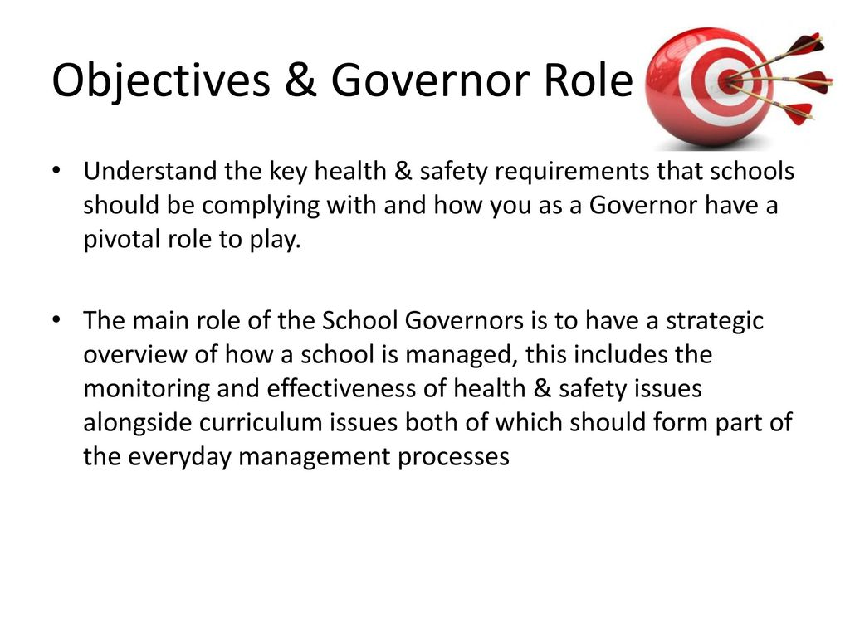

LEGISLATION
- Health and Safety at Work etc. Act 1974
- Corporate Manslaughter and Corporate Homicide Act 2007
- Management of Health and Safety at Work Regulations 1999
- Regulatory Reform (Fire Safety) Order 2005
- Construction (Design and Management) Regulations 2015
- Occupiers Liability Acts 1957/1984
- Health and Safety Offences Act 2008
- School Standards and Framework Act 1998
- Equalities Act 2010

WHAT YOU NEED TO DO
- Ensure that the Governing Body is aware of its health and safety responsibilities under local management of schools, Council H&S Policy and legislation
- Ensure that the school is aware of and abides by Hammersmith & Fulham Councils H&S Policy and procedures
- Appoint a named Governor to be responsible for health and safety matters
- Establish a committee or forum where health and safety matters are a standing agenda item
- Develop, review and approve the establishments Health & Safety Policy
- Ensure the Chair of Governors signs the H&S Policy
- Ensure that the Governing Body plan to ensure the H&S Policy is implemented
- Ensure that health and safety is monitored by the appointed Governor and/or committee so that legal and best practice requirements are met
- Ensure that the establishments health and safety policy and management system is reviewed regularly

HEALTH & SAFETY RESPONSIBILITIES
The Health and Safety at Work etc. Act 1974 places overall responsibility for health and safety with the employer. Who this is varies with the type of school.
Hammersmith & Fulham Council is the employer in respect of community schools, community special schools, maintained nursery schools and pupil referral units.
Legislation, Local Management of Schools and Children’s Services Health & Safety Policy, gives the Governing Bodies and Headteachers of these establishments responsibility for the management of health and safety matters.
However, delegation of responsibility does not mean that Hammersmith & Fulham Council has no involvement in health and safety in community establishments.
As the employer, the Council continues to have legal duties to ensure, so far as reasonably practicable, the health, safety and welfare of employee’s, children and visitors.
The Council must be able to demonstrate to the Health and Safety Executive, London Fire Brigade and Ofsted, that it is fulfilling these legal duties.
Note: In foundation schools, foundation special schools, voluntary-aided schools, free schools and academies, statutory health and safety responsibilities fall on the governing body as the employer.

ROLE OF LOCAL AUTHORITY
As employer, Hammersmith & Fulham Council has the power to ensure that its health and safety policy and procedures are carried out in-school and on all school activities.
The Council will provide advice, guidance and competent support as well as learning and development opportunities to school staff and Governors to enable them to manage health and safety on behalf of the Council.
The Council will also monitor establishments where it is the employer to ensure required standards are reached and will take the necessary action where they are not.
Where the Council believes the health and safety of anyone on-site, or of anybody engaged on school activities off-site, is at risk it can make a direction to the governing body and head teacher to take remedial action.
A direction can specify action to be taken or it can require the governing body and head teacher to comply with a specific aspect of the Councils health and safety policy or procedures.
Ultimately and rarely, compliance would be enforceable through the courts. Substantial or persistent non-compliance with requirements may be a ground for suspending delegation, subject to the governing body’s right of appeal.

ROLE OF GOVERNING BODY
Whether they are the employer or not, the governing body plays an important part in ensuring the overall health and safety of staff, pupils and visitors to the school. This is a broad remit and governing bodies should give consideration to a range of topics relating to health and safety.
The Governing Body should lead by example and take ownership of health and safety. It should demonstrate commitment and provide clear direction so as to let everyone know health and safety is important.
The governing body, having control of the premises, must take reasonable steps to make sure that the buildings, equipment and materials are safe and do not put the health or safety of persons at risk while they are on the premises.
The governing body, as the management body, must have due regard for the Councils legal responsibilities (where applicable) and should ensure that school staff and premises comply with the Hammersmith & Fulham Council health and safety policy and practices.
To this end, a Governor should be nominated to have responsibility for health and safety and should ensure they have a sufficient level of knowledge to enable them to undertake this role.

COMMITTEE FOR HEALTH & SAFETY
The Governing Body should have a means by which health and safety related matters can be discussed and action agreed upon. This can be a separate H&S Committee or it can be integrated into other committees such as a premises committee or finance committee.
It is important that health and safety is a standing agenda item on this committee. The issues to be discussed will vary according to establishment requirements but in general terms they will relate to the areas detailed below in relation to implementing the H&S Policy, monitoring health and safety performance and reviewing the system that is in place.

HEALTH & SAFETY POLICY DEVELOPMENT
The health and safety policy should influence all activities, including the
selection of people, equipment and materials, the way work is done and how goods, equipment and services are provided. The Policy should have three clear sections:
- A statement of intent-signed and dated by Head and Chair of Governors
- Organisational requirements including roles and responsibilities, training and consultation arrangements
- Arrangements for implementing/controlling hazards and monitoring performance
The nominated person responsible for health and safety should, in conjunction with senior school staff ensure that an establishment specific policy is developed and agreed by the Governing Body. It should be reviewed on an annual basis.
Further assistance on writing a Health & Safety Policy can be found in the guidance document: School Health & Safety Policy Guidelines
Once agreed, it is good practice for the H&S Policy to be signed and dated by the Headteacher and Chair of Governors.

IMPLEMENTING HEALTH & SAFETY
Planning is the key to ensuring that health and safety really works and is an integral part of everyday school life. Planning involves setting objectives and targets that will ensure that health and safety is implemented in the establishment.
This planning and implementation should form part of the establishments overall development planning and where necessary individual CPD planning (foe example if training is required).
Appendix A contains a breakdown of an H&S management system along with the objectives and potential targets that may be set to ensure the system is implemented.
This can be used to generate any establishment specific requirements that can then be integrated into the establishments overall development planning.

MONITOR HEALTH & SAFETY PERFORMANCE
Governors will need to monitor H&S performance to ensure that the system developed is being successful and that any objectives/targets set are being met.
Active monitoring, (i.e. before things go wrong), involves regular inspection and checking to ensure that objectives/targets are being implemented and that risks are being controlled.
An inspection is a comprehensive formal examination of all or part of a workplace in order to identify deficiencies that create unacceptable risks to health and safety. This will include the identification of unsafe physical conditions and working practices.
Health and safety inspections should be undertaken by persons who are competent to identify the relevant hazards and risks and who can assess the conditions found.
However, proactive monitoring also involves checking on the implementation of the H&S system by making sure the organisations arrangements are being implemented, that hazards are being identified, that risk assessments are being completed and control measures are being put into practice.
Reactive monitoring, (i.e. after things go wrong), involves learning from mistakes, whether they have resulted in injuries and illness, property damage or near misses. This will involve reviewing incident report forms and any investigations that have been undertaken (along with recommendations for improvement).
The following is a suggested list of matters that the Governing Body may wish to consider as part of the overall monitoring of H&S, based upon the implementation process:
- That hazards have been identified in relation to the premises, work activities, curriculum activities and relating to specific roles/persons
- That risk assessments have been completed for the premises, activities and specific roles/persons
- That a risk register has been developed and that any actions required as a result of risk assessments have been undertaken
- That emergency procedures are developed and the outcomes of testing such procedures are reviewed
- That the outcomes of incident investigations have been reviewed and any remedial action recommended implemented
- That any statistics are reviewed to identify any particular trends
- That the outcomes of any inspections undertaken are reviewed and the necessary remedial action has been taken
It is suggested that the committee used to discuss health and safety matters undertakes this monitoring with the full Governing Body being provided with a summary report.

REVIEW HEALTH & SAFETY PROCEDURES
The elements that make up an H&S management system should be subject to a review on an annual basis so as to ensure that they are effective and relevant to the establishment.
The following is a suggested list of matters that the Head/Governing Body may wish to consider in the review process:
- H&S Policy: has this been reviewed against best practice requirements by persons nominated to do so
- H&S policy: has this been communicated to stakeholders (staff, Governing Body etc)
- Have objectives/targets been set and met so as to implement health and safety
- Are the Governing Body/Head/Senior managers aware of any changes to legislation or guidance from the LA
- Have any changes in practices or procedures been communicated to staff
- Are all roles and responsibilities delegated and being successfully undertaken
- Has all necessary learning, development, instruction and training been provided
- Has the risk register been updated in the last 12 months and reviewed by the appropriate committee
- Have risk assessments been reviewed according to review dates or where significant change has taken place
- Has remedial action due to risk assessments, inspections or incident investigation been completed according to the timescales set
- Have emergency procedures been tested and amended where required
It is normally good practice for the Head, Business Manager, nominated H&S Governor and other members of senior staff to undertake this review and report to the appropriate committee, which can then report to the full Governing Body.

APPENDIX A: H&S MANAGEMENT SYSTEM IMPLEMENTATION
The following can be used to generate establishment specific planning to ensure H&S is effectively implemented and managed. It is not a definitive list and can be amended according to establishment needs.
ELEMENT | OBJECTIVES | POSSIBLE TARGETS TO PLAN FOR
Policy & Management | H&S Policy is developed and regularly reviewed | - Those responsible for developing and reviewing the H&S Policy are identified  - The H&S Policy is reviewed annually to take account of LA guidance and requirements as well as local changes  - The H&S Policy is approved by the full Governing Body  - The H&S Policy is signed and dated by the Headteacher and Chair of Governors
 | H&S Policy is communicated to stakeholders | - The H&S Policy is brought to the attention of all staff (e.g. on INSET day), Governors and others as necessary  - The H&S Policy is made available to all staff (e.g. via intranet or staff room notice board)
 | Governing Body/Head are aware of H&S responsibilities | - The Governing Body/Head have referred to Council Policy and guidance on health and safety  - The school H&S Policy reflects the legal and Council policy requirements relating to responsibilities
 | Governor nominated to be responsible for H&S | - A named Governor has been made responsible for H&S matters  - The named Governor has undertaken appropriate learning and development opportunities
 | Governing Body has process to discuss H&S issues | - A committee is instigated that allows H&S to be discussed  - H&S is a standing agenda item on the committee  - The Committee meets at least once a term and monitors H&S performance  - The Committee reviews the H&S system at least once a year
Organisation and Arrangements | Roles and responsibilities are identified | - Specific H&S jobs have been determined (e.g. writing H&S Policy and procedures, risk assessing, maintenance, EVC etc)  - People required to undertake jobs have been identified  - Roles and responsibilities have been detailed in the H&S Policy
 | Staff are engaged and supervised | - Staff with specific duties know what to do (written into JD’s, awareness and information provided)  - Staff are given time and resources to undertake duties  - Staff are monitored to ensure they are undertaking duties (e.g. performance management, appraisals, one-to-one, meetings)
 | Learning and development requirements are identified | - H&S training matrix is developed  - H&S induction training is identified and checklist is developed  - Staff handbook contains basic H&S information based upon induction checklist  - Learning and development for staff with specific duties has been determined (e.g. training courses, mentoring, distance learning, NVQ, INSET etc)
 | Information, instruction and training is provided | - H&S training is provided to all staff at the start of the school year  - H&S induction training is provided to new staff when they join the establishment  - Specific information, instruction and training is for planned and undertaken  - Records of information, instruction and training are maintained (e.g. part of CPD)
 | Consultation and communication on H&S issues takes place | - Means of consulting with staff on H&S is established  - Means of informing staff of any changes in policy and procedures established  - Means of informing visitors of emergency procedures is established  - H&S Law poster is displayed/H&S notice board developed
Hazards and Risk Assessing | H&S hazards have been identified | - Local authority guidance has been referred to on School Staff Zone  - School inspection reports have been completed and hazards identified  - Incident investigation reports have been completed and hazards identified  - H&S committee reports have been reviewed  - Competent advice has been sought to help identify hazards
 | Risk assessments are completed | - Risk assessments requiring completion have been identified  - Persons responsible for completing risk assessments have been identified and provided with learning/development  - Premises related risk assessments have been completed (e.g. building, play grounds, kitchen etc)  - Person related risk assessments have been completed (e.g. SEN pupil, Site Manager)  - Curriculum related risk assessments have been completed (e.g. primary classroom, educational visits, D&T, PE)  - Non-curriculum related risk assessments have been completed (e.g. extended services, Children’s Centre)
 | Risk assessments are reviewed | - Risk assessments are reviewed when significant change occurs (e.g. accident or incident, procedural change etc)  - Risk assessments are reviewed according to the review date (e.g. annual rolling programme of reviews)
 | Risk register is populated and reviewed | - Risk register owner is identified and named  - Risk register is completed using template on school staff zone with significant risks requiring action being identified in risk order  - Risk register is reviewed by committee every term to determine if necessary actions have been taken  - Risk register is updated every term by risk register owner to reflect actions taken
Risk Control | Premises control measures are implemented | - Fire safety management strategy  - Asbestos register on-site and asbestos management plan  - Legionella written scheme of control and testing  - Plant and equipment written scheme of planned maintenance  - Play equipment inspected and maintained  - Building maintained in state of good repair/good housekeeping  - Grounds and trees well maintained and inspected  - Parking and vehicles controlled on-site  - Kitchen (food hygiene, catering facilities)
 | People control measures are implemented | - SEN pupils identified and control measures implemented  - Handling/lifting of children/loads eliminated/minimized  - Health and infection control procedures (stress, noise, voice, needlesticks, sun care, animals in schools, diseases)  - Personal safety/security (lone working, violence/aggression)  - Working at height (teachers and site care)  - ICT/DSE (workstation assessments)
 | Non-curriculum control measures are implemented | - Contractors hiring, competency and management procedures  - Construction management procedures  - Substances identification and control  - Event management (school plays, parents evenings etc)  - Breakfast clubs/extended services
 | Curriculum control measures are implemented | - Classroom (primary)  - D&T according to CLEAPSS/DATA/BS 4163 good practice  - PE according to AFPE good practice  - Textiles according to CLEAPSS good practice  - Food technology  - Chemistry according to CLEAPSS/BS 4163 good practice  - Educational visits/driving according to LOTC good practice
 | Emergency procedures are in place | - First aid equipment, personnel and procedures  - Administration of medicines policy and procedures  - Fire emergency plan and procedures
Monitoring and Review | Incident reporting procedures are developed | - Councils on-line reporting system is utilized  - Reporting procedures made known to staff at induction  - Incident statistics are reviewed by Head/committee
 | Investigation procedures are developed | - Person/s nominated to undertake accident/incident investigations  - Person/s nominated to undertake accident/investigations provided with necessary learning and development  - Incident reports are produced and reviewed by Head/committee  - Remedial action agreed and planned as necessary
 | Inspections are regularly completed | - Inspection regime procedures developed and implemented  - Inspection checklist developed to be site specific  - Persons undertaking inspections provided with necessary learning and development  - Inspections formally recorded and report reviewed by Head/committee  - Remedial action agreed and planned as necessary
 | Review of H&S management is completed | - Review procedures developed and implemented  - Review checklist developed  - Review report developed to be considered by committee  - Governing Body to be provided with review report on annual basis  - Remedial action agreed and planned as necessary

