FIRE FALSE ALARMS

GUIDANCE FOR SCHOOLS

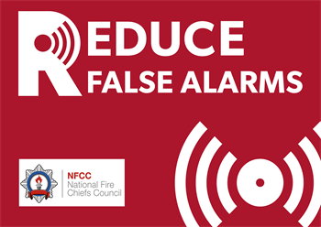

LEGISLATION

- Regulatory Reform (Fire Safety) Order 2005
- Fire Safety (Employee’ Capabilities) Regulations 2010

WHAT YOU NEED TO DO

- Ensure an individual has been appointed to manage and supervise the use, testing and maintenance of the fire detection and alarm system (FDAS)
- Ensure that the FDAS is kept in a state of good repair and efficient working order through an appropriate contract with a competent organisation
- Review the fire risk assessment to determine if an on-site call filtering system is reasonable to introduce
- Ensure that the fire evacuation/emergency plan reflects fully the findings of the fire risk assessment in relation to FDAS actuations
- Ensure that on all occasions the FDAS actuates, the premises are evacuated
- Ensure that where on-site filtering is implemented staff are trained and there are means of communication
- Ensure that where an alarm receiving centre is utilised, they are aware of any on-site filtering arrangements
- Ensure that where on-site filtering arrangements are implemented, that staff members responsible are provided with relevant information, instruction and training
- Ensure that where false alarms (unwanted fire signals) do occur, they are fully investigated and remedial action taken to prevent future unwanted fire signals
- Ensure that appropriate records are kept in relation to the use, testing, maintenance and false alarms from FDAS

INTRODUCTION

A well designed, installed and maintained automatic fire detection and alarm system (FDAS) provides for the early detection and warning of fire so as to enable all occupants of the premises to evacuate in a timely manner.

The London Fire Brigade (LFB) recognises the value of FDAS in protecting people from fire and reducing the numbers of fire deaths and injuries. However, false alarms from FDAS (known as ‘unwanted fire signals’) that are passed onto the fire service are an unnecessary drain on resources.

The London Fire Brigade is not required to attend calls that are made soley because a fire alarm system has actuated. Where the LFB does attend, they may charge for attending in-line with current LFB policy (see ‘Further Information’ for details).

In addition, repeated false alarms could result in the responsible person facing enforcement action under the Regulatory Reform (Fire Safety) Order 2005.
The responsible person for fire safety must ensure that any FDAS installed should be managed appropriately so as to reduce false alarms and unwanted fire signals.

MANAGEMENT OF FIRE DETECTION AND ALARM SYSTEMS

All FDAS should be designed, installed, used and maintained in accordance with best practice as contained in BS5839: Fire detection and alarm systems-code of practice for system design, installation, commissioning and maintenance.

To ensure the system is used, tested and maintained to an appropriate standard, an individual should be nominated to supervise and manage the FDAS. They should have a good understanding of the operation of the FDAS and ensure that a competent contractor is used to maintain the system.

A system that is well designed, installed, used and maintained will assist in minimising the number of unwanted fire signals. However, where a system is producing an unacceptable level of false alarms the causes must be investigated (see below) and reasonable action taken to reduce unwanted fire signals to the LFB.

ON-SITE FILTERING RISK ASSESSMENT

The London Fire Brigade recognized that it is not always possible to prevent false alarms but that where there are sufficient false alarms to unreasonably impact on emergency services, it is appropriate to consider the introduction of filtering measures.

On-site filtering measures are only to be employed as a result of a suitable and sufficient fire risk assessment that accounts for both the fire alarm system and management practices ability to support the filtering practices considered.

The premises fire risk assessment must address the risk and protective measures required for any staff members that are required to investigate the cause of the actuation. The following should be taken into account:

- The building size, layout and facilities
- The capabilities and flexibility of the alarm system
- Time available
- Communications
- Suitable training
- Maintaining a safe exit
- Any lone worker arrangements
The template below can be used to determine if on-site filtering is capable of being undertaken.

If the decision to undertake some form of on-site filtering is deemed as reasonable, the arrangements must be noted in the fire risk assessment and detailed in the fire evacuation/emergency plan.

Similarly, if on-site filtering is not deemed reasonable, the justification for this must be detailed in the fire risk assessment. The fire evacuation/emergency plan should detail the actual fire evacuation procedures.

ON-SITE FILTERING ARRANGEMENTS AND PROCEDURES

Where it is deemed reasonable to introduce on-site filtering procedures, the following will need to be given consideration.

Staff Training and Communication

Where an on-site filter system is to be introduced, all staff involved should be given the necessary information, instruction and training so as to ensure they are competent to undertake their duties.

There must also be a means of communicating with those staff members nominated to undertake an on-site investigation.

It should be emphasized that at no time should these members of staff place themselves at risk when undertaking an investigation.

Alarm Receiving Centre

The majority of establishments are connected to an ‘Alarm Receiving Centre’ (ARC) via the ‘Redcare’ telephone line. Where this system exists, the ARC will automatically call the LFB on receipt of a fire signal from the FDAS.
As part of the on-site filtering system, the responsible person may have to introduce a process whereby the automatic transmission to the ARC and hence the LFB is delayed. This will allow time for the cause of the alarm to be investigated during working hours to confirm a fire or false alarm.

A time-delay system can be considered that gives a set period of time to investigate prior to the signal being transmitted to the ARC.

The relevant ARC should be contacted to discuss the options that are available.

Fire Emergency/Evacuation Plan

All schools should have a fire evacuation/emergency plan that details the arrangements that are to be taken in the event of a fire or fire alarm actuation.

The procedures for responding to FDAS actuations should be detailed in the plan with particular attention being paid to any on-site filtering arrangements that are to be implemented.

On-Site Filtering Procedures
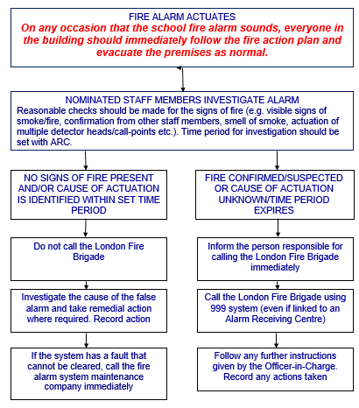

NO ON-SITE FILTERING ARRANGEMENTS AND PROCEDURES

Where it is deemed unreasonable to introduce on-site filtering procedures, the schools normal fire evacuation procedures should implemented as follows:

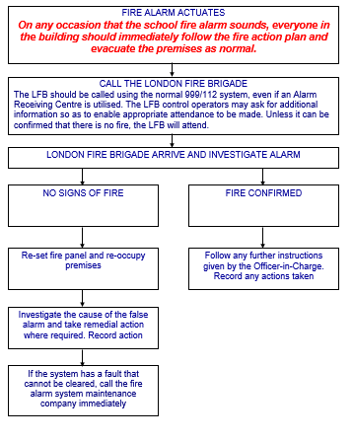

ALARM ACTUATION: OUT-OF-HOURS

Where premises are linked to an Alarm Receiving Centre (ARC), the London Fire Brigade will be informed of the alarm actuation by the ARC. Depending upon the circumstances, a call filtering arrangements may be introduced, particularly if there are over 5 false alarms in any 12 month period.

In any case, where the premises are unoccupied, a person from the school should be in attendance within 20 minutes and be able to access and operate the fire alarm panel. They should also be able to provide access to the LFB.

It should be noted that the LFB may not wait longer than 20 minutes if they cannot gain access to the premises and there are no external signs of fire.

It should be noted that the LFB are not responsible for the resetting of the fire alarm panel.

INVESTIGATING AND RECTIFYING FALSE ALARMS

Where a false alarm does occur, this should be investigated, where necessary in conjunction with the organization responsible for maintaining the FDAS. Appropriate remedial action should be taken to prevent recurrence.

Failure to take action to prevent false alarms could be deemed by the enforcing authority to be a contravention of the Regulatory Reform (Fire Safety) Order 2005 (by not maintaining the FDAS in a state of good repair and efficient working order).

Consequently, enforcement action could be taken to rectify the situation. In addition, if false alarms continue, the London Fire Brigade may also charge for attending and may also reduce the level of attendance.

FURTHER INFORMATION

- London Fire Brigade-GN54: False Alarms Caused by Automatic Fire and Smoke Detection
- Chief Fire Officers Association-Policy for the Reduction of False Alarms & Unwanted Fire Signals
- BS5839: Fire detection and alarm systems-code of practice for system design, installation, commissioning and maintenance
- London Fire Brigade: www.london-fire.gov.uk/reducingafas.asp

ON-SITE CALL FILTERING ASSESSMENT

The following may be used to assist schools in determining if on-site filtering is capable of being undertaken. This should form part of the schools overall fire risk assessment.
