SCHOOL FIRE EMERGENCY PLAN

GUIDANCE FOR SCHOOLS
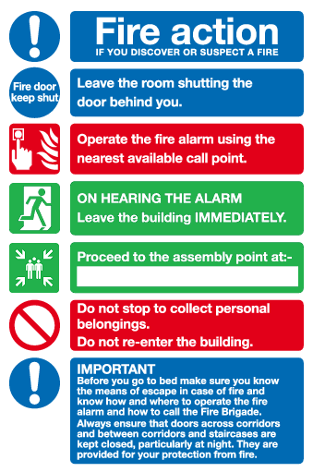

PURPOSE OF PLAN
The purpose of this Plan is:

To ensure that people occupying_________________ know what to do in the event of a fire

To ensure that all people within__________________, including members of the public, temporary staff and visitors are safely evacuated in the event of a fire

To form a basis for the training of staff

______________ will review the Plan at least annually or sooner if the need arises.

The Plan will be made available to employees and their representatives.

ACTION ON DISCOVERING A FIRE
Fire Notices are prominently displayed at key point’s throughout___________.

These detail the action to be taken by person(s) who discover a fire. The procedure is as follows:

Raise the alarm by alerting those near by and by operating the nearest red fire call point/break glass
Leave the building by the nearest exit
Report to the assembly point(s) located at______________________
Do not stop to collect personal belongings
Do not use the lift (if applicable)
Do not re-enter the building until you are told it is safe to do so

FIRE WARNING SYSTEM
Manual call points are positioned around the building and are appropriately signed.

The alarm is a _________________ (e.g continuous bell) which is easily recognisable from_____________ (e.g break time bell).

The main alarm panel is located at_____________ and is linked to a remote call centre (where applicable).

The alarm will be tested by__________every week.

The alarm will be initiated from different call points each week to ensure their correct functioning. An appropriate record of the tests will be kept.

CALLING THE FIRE SERVICE
The premises fire alarm system is connected to a remote call service. If smoke or heat detectors are activated or if a break glass call point is activated, the fire service will automatically be summoned. (Only use where applicable)

In all circumstances when the fire alarm system is actuated___________________ will be responsible for calling the fire brigade.

STAFF EVACUATION ACTION
On hearing the evacuation signal, all staff, pupils and visitors will evacuate the premises calmly and in an orderly manner. All teachers in control of a class will:

Commence the evacuation of children in an orderly way
Lead children from the premises by the nearest safe route
Proceed to the assembly point
Carry out the roll call procedure
Notify: of any persons unaccounted for
Ensure children remain at the assembly point
Await further instruction from:

On hearing the evacuation signal:

School Registers will be collected by:

School visitors book will be collected by:

Children’s medications will be collected by:

The nominated first aid person is:

On hearing the evacuation signal, the following staff will shut-down plant or equipment detailed:

Name Plant or Equipment

…………………………………….. …………………………

…………………………………….. …………………………

On hearing the evacuation signal, all other staff and visitors will:

Proceed to the assembly point
Notify: of any persons unaccounted for
Await further instruction from:

All visitors to the premises will be briefed on the evacuation procedures and will be required to sign in when attending the establishment.

Any individual with mobility difficulties will be identified and an appropriate ‘Personal Emergency Evacuation Plan’ will be developed.

VULNERABLE PERSONS
Name | Location | PEEP (Y/N)
1)  2)  3) | 1)  2)  3) | 1)  2)  3)

IDENTIFICATION OF KEY ESCAPE ROUTES
All key escape routes are identified by use of appropriate signage, through induction training and undertaking of fire drills.

All escape routes are kept clear of obstruction and are inspected on a regular basis to ensure that they remain clear and to ensure that signage is in good condition.

FIRE FIGHTING EQUIPMENT
All staff are instructed that they should not attempt to use fire extinguishers unless they are specifically trained and it is safe to use extinguishers.

ASSEMBLY POINT/S
Assembly points are located at (detail here and if possible attach a map highlighting assembly point/s)

ROLL CALL PROCEDURES
The roll call procedures are (detail here the roll call procedures)

LIAISON WITH FIRE SERVICE
The person responsible for liaising with the fire service will be____________.

Details of the premises and any hazardous substances are kept at_________. These will be collected by__________and given to the fire service.

BREAKFAST CLUBS
Staff in charge of breakfast clubs will take the following action:

Detail here the action to be taken

AFTER SCHOOL SERVICES
Staff in charge of extended services will take the following action:

Detail here the action to be taken

TRAINING
The manager/Head Teacher will ensure that the contents of this emergency plan are communicated as part of the staff induction, which is held on the arrival of new or temporary members of staff.

At induction employees and temporary staff will tour the building and be shown the location of fire fighting equipment, alarm call points and emergency exits. It should be made clear to them that emergency escape routes and doors are not no be blocked or inhibited in any way. They should be clearly informed of, and where required practised in any other specific responsibilities they may have in relation to the fire arrangements.

