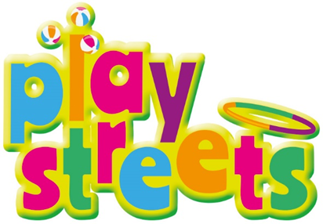

Dear Neighbour,

I am writing to let you know I am considering the idea of having a Play Street on our street.
What is a Play Street?
Play Street gives children the chance to play freely and safely, within a short distance of their home, by letting residents temporarily close their road to through traffic. Access is maintained for residents throughout the event.
How will it affect you?
We appreciate the play street may cause some minor disruption but don’t worry, whilst through motor traffic will be banned during the play street event, residents will still have access and will be able to park near their home.
The road will be fully closed to through traffic and points of closure will be marshalled. Events will be under adult supervision and access will be maintained for emergency services at all times in all parts of the street(s).
We would really like your support in getting this started on your street.
We will be holding a meeting on (Insert date, time and location) so we can hear your feedback. If you cannot attend the meeting and have questions, please get in touch me.
Best wishes,
(Insert name, address and contact details)

