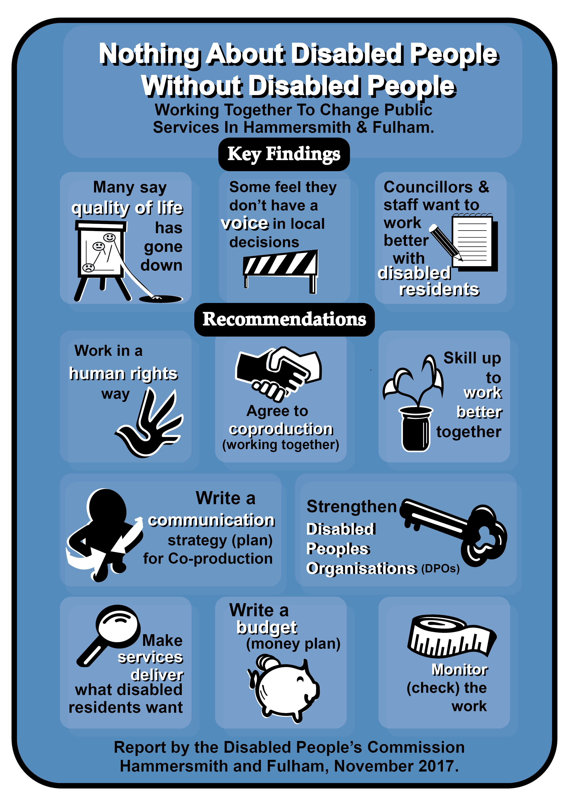

For more information about the Disabled People’s Commission Hammersmith and Fulham and its work please go to the link below:
https://www.lbhf.gov.uk/councillors-and-democracy/resident-led-commissions/disabled-people-s-commission
Contents: this means what is in this report

- The barriers that local
Disabled people living in
Hammersmith and Fulham
told the Commission about page 6
Barriers: here this means the things that stop Disabled people living equal lives.

- Chair’s summary page 7

- Our recommendations –
This means what we think
needs to happen now page 14

- Message from leader of the
Council Stephen Cowan page 20

- Disabled People’s Commission –
who we are and how we got started
  - Who are the
Commissioners page 23
  - Our approach to the
work, this means the
way we work page 27

- Key findings page 33
- Disabled people’s lives now,
Disabled people taking part in
decision making page 38

- Working with Disabled People’s
Organisations as a way of making
sure there are more Disabled
people in decision making page 41

- Co-production
  - Why is co-production
working together) the way
to move forward? page 43
  - What co-production is not page 44
  - What do other organisations
say about co-production? page 46
  - Barriers to Disabled
people taking part in
co-production page 52
  - Co-production – seeing
residents time and
experience as important page 53
Residents: in this document this means people living in Hammersmith and Fulham.

  - Making the economic case
for co-production: this
means showing that it is
worth the resources spent
on it, this means money,
time, staff etc page 54
  - Co-production (working
together) in Hammersmith
and Fulham page 57
  - Working together – real
examples of change for
Disabled residents in
Hammersmith & Fulham page 59
  - Co-production (working
together) – first steps page 62

- Conclusion page 64

- Extra information
  - Hammersmith and Fulham Disabled
People’s Commission recommendations
and how we will know things are getting
better page 68
  - What does success look
like? Nothing About Disabled
People Without Disabled
People page 79
  - Thank you/
Acknowledgements page 82

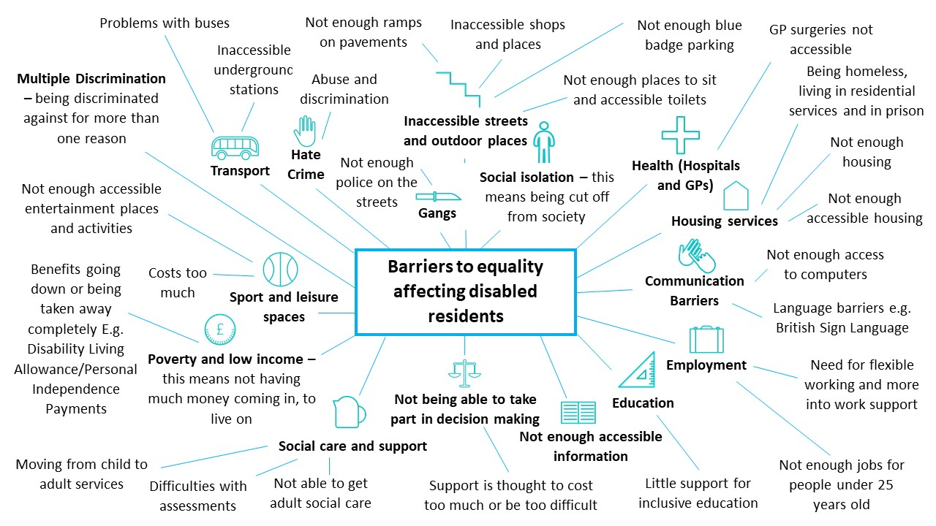
1.The barriers that disabled residents in Hammersmith and Fulham told the Commission about: The Commission was told about these barriers through a survey for disabled residents and at different events in 2017.
2. Chair’s summary
Tara Flood, Chair of the Disabled People’s Commission

Discrimination and exclusion are things that can be stopped. They happen because of the barriers that are put up by society.
Discrimination: this is when people are not treated in a fair way. This could be because of their sex, their age, or because they are a Disabled person.
Exclusion: this means being left out or not being allowed to take part.

We use the words Disabled people in this report to talk about all Disabled people. This means people with different barriers:

- Physical, this affects the way a person can move or get around
- Cognitive, this affects the way a person can communicate, make decisions and remember things

- Sensory, this affects the way a person touches, smells, sees or hears

It also means:

- People with learning difficulties

- Deaf people, deafened, hard of hearing people

- Mental health system users and survivors

- Neuro-diverse people such as those with Dyspraxia, Attention Deficit Disorder (ADHD), Asperger Syndrome and Dyslexia

- People with long term health conditions

- People who self-identify, this is when someone sees themselves as a Disabled person

We mean Disabled people of all ages that face barriers including Disabled children and young people with Special Educational Needs labels.

It is now not ok for one group of people to speak for another group of people, for example it would not be ok if a women’s organisation was run by men. However, non-Disabled people still run organisations and speak for Disabled people most of the time.

We also know that as Disabled people we might face discrimination for more than one reason. A black Disabled person may face discrimination because they are a Disabled person and because of the colour of their skin.

When working towards change we look at where we may have the same experiences but also where we might have different experiences of discrimination.

In many ways, this has been an easy report to write because it says what Disabled people have been calling for over many years.

We must be partners in changing the way that society is organised. We must especially be partners in decision making in everything that affects our lives. In the words of the international Disabled People’s Movement – Nothing About Disabled People Without Disabled People!

For many Disabled people life is a difficult experience of segregation from non-Disabled people and this is happening more and more.
Segregation: here this means keeping different groups of people apart from everyone else.

We have very few life choices and opportunities. Our personal and social care needs are not met. We are also facing isolation, unemployment, housing that doesn’t meet our needs, poverty, abuse and violence.
Isolation: this means being alone or kept apart from other people.

I agreed to be the Chair of the Disabled People’s Commission understanding that the most important thing was to get rid of local barriers. In the long term, we hope to make changes in policy in different regions and nationally.
Policy: this means decisions or a plan of action that is made by a decision maker.

The Commission is made up of 10 Disabled people who live in Hammersmith and Fulham. Disabled people living in Hammersmith and Fulham told us about many different types of barriers that we still face.

As a Commission, we decided that the best way of dealing with this would be to change the way that we are part of decision making.

We use a Social Model of Disability way of working. We have also talked about the UN Convention on the Rights of Persons with Disabilities and the Public Sector Equality Duty (Equality Act 2010).
Social model of disability: this is when Disabled people are seen as people with impairments who are ‘disabled’ by the barriers in society. These barriers discriminate against Disabled people and push us out of society. It is the way society is run and organised that is the problem, not the Disabled person.
UN Convention on the Rights of Persons with Disabilities: this is an international agreement that the government signed up to, to bring about the full rights of Disabled people in the UK.
Public Sector Equality Duty: This is a duty that public organisations have under the Equality Act. They must make sure that people are treated equally and have the same equality opportunity as everyone else.

The Commission’s recommendations are all about change to make the lives of Disabled people better. We know that neither we, nor Hammersmith and Fulham Council can change everything that we would like to. We also know that we can’t change government policy decisions which affect us so much at the moment.
Recommendations: these are the things that we think should happen to make things better.

For this reason, our recommendations look more at making sure ‘co-production’ or working together is an important part of all of the changes that we put forward. We aim for all Disabled people to be able to take part in decision making.

This should happen, even for those Disabled people who have the least say in decision making. Such as Disabled children, young people and adults in institutions or those that have been moved to different boroughs.

We know that Co-production can be a difficult word so this report sets out what we mean by co-production and how it will be planned and put in place by Disabled people.

This report also sets out the great work that can be done when local organisations such as the Council and health organisations co-produce ideas, policies, and services with Disabled people.

We have put together a working definition of
co-production, this means a definition that is not final and could be changed:

“Co-production (working together) means that Disabled residents and decision makers are working together in an active way to plan, design and review policy and services that affect our lives, to get rid of the barriers we face.”
Residents: this means people living in an area.
Decision makers: this means Councillors and people who make decisions about policy.

The recommendations will all need to be carried out across all Council departments. They will also need to be carried out in community and other public partner organisations. This should be for all Disabled people living in Hammersmith and Fulham if we want real and lasting change.

3. Our recommendations – this means what we think needs to happen now

The Commission is happy that the leader of the Council sees dealing with inequality and discrimination as very important. The recommendations that we make here are building on the good start that the Council has already made.

The Commission knows that these recommendations are mainly for Disabled people living in Hammersmith and Fulham and the Council. However, if the recommendations are co-produced as we hope, they will affect how Disabled residents and many other organisations in the Borough work together.

Building a co-production culture: this means building a way of doing things that has co-production at the centre

Recommendation 1: The Council brings in a human rights way of working to the way it plans its policy and services. The Council should use the UN Convention on the Rights of Persons with Disabilities (UNCRPD) as the base for change.

Recommendation 2: The Council brings in a policy which means that the council must work in co-production with Disabled residents.
Recommendation 3: The Council plans and puts in place an accessible communication strategy. This should promote co-production in the whole Borough.
Strategy: this is a plan of how things should be done.
Promote: here, this means to push for more use of co-production, making sure that people know what it is and how to use it.

Training and development

Recommendation 4: The Council works with the Co-production Hub to put together a co-production support strategy. Support should be put in place so that the strategy can be carried out.
Hub: this means a place that is the centre of a network which organises things and makes them work in a better way.

This means giving the right skills to Disabled residents, local Disabled People’s Organisations (DPOs), staff and councillors so that they can work together with the council to plan and carry out policies and services.

Planning services and commissioning

Recommendation 5: The Council co-produces a framework;
Commissioning: this is the way that services are planned and bought in a local area by the council.
Framework: here this means a document which sets out how the council will work.

This framework should have:

- Information about quality assurance, this is information about how the council will make sure its services and the way it works are good quality.
- Information about its values and how these are used in the council’s work. These should be social values, about how people are seen and treated by the council. It should also have information about its economic values, this means its values around money and how it is spent.

This will give information about the Councils values and how it will work and behave. It will give information about how all organisations running services which are paid for by the council will do the same.

Resourcing Co-production: this means having the money, staff and space to be able to put co-production into place

Recommendation 6: The Council looks at how much money and resources are spent on different ways of involving Disabled residents. For example, co-production, linking in with Disabled people, and consultations with Disabled residents.
Consultation: this is when people who may be affected by a change or decision are asked for information about how it will affect them.

Once the Council knows how much it spends on this, a new co-production budget should be put together.
Budget: this is a plan of how money will be spent.

Review support and funding of Disabled People’s Organisations (DPOs)

Recommendation 7: The Council sees how important Hammersmith and Fulham’s Disabled People’s Organisations and their networks are. The Council sees how important their values and voices are.

The Council must work with Disabled People’s Organisations to decide on a long-term plan for paying for this work, this can be called a funding strategy.

This will make sure that local Disabled residents can access their rights, inclusion and equality and that Disabled residents can lead on co-production.

Independent monitoring and evaluation
Independent: here, this means that it is not the Council itself that looks at how well it is doing, but another organisation that can make its own decision.
Monitoring and evaluation: this is how a person or organisation checks how well something is going. They look to see what needs to be changed or made better.

Recommendation 8: Carry out monitoring and evaluation of co-production work and of how well the recommendations are put into place. This should be done so that information about how co-production can be used and how this affects people’s lives can be shared outside of Hammersmith and Fulham.

4. Message from Councillor Stephen Cowan

Leader of the Council for the London Borough of Hammersmith and Fulham

Some years ago, when I was the borough’s leader of the opposition, a resident kindly educated me about the challenges she faces as a Disabled person.
Opposition: this is any party that is not in Government.

She told me about the difficulties Disabled people face in trying to make change happen in national and local policies that affect their lives in a very big way.

I had always thought about disability to be an issue of discrimination and rights. However, what that person and other Disabled people told me, gave me a better understanding.

They helped me to understand that Disabled people need to take the lead in planning services and making sure everyone can take part in society.

In 2014, after I became the Leader of Hammersmith and Fulham Council, we got rid of home care charges. We were the only borough in the country to do this. We made sure people would get their Independent Living Fund money when it looked like the government might get rid of it. We also had a close working relationship with local Disabled People’s Organisations (DPOs).
Home care charges: this is when people have to pay money towards their support/care.

But we aim to be the most inclusive borough and asked Tara Flood to chair a new independent Disabled Peoples’ Commission. This was done to keep a check on whether we are meeting our goals. I am therefore very grateful to Tara and all who worked so hard on the Disabled People’s Commission. This work will make a big difference.

5. Disabled People’s Commission – who we are and how we got started

On the International Day of Disabled People in December 2015, people from Hammersmith and Fulham Council agreed to work closely with Disabled residents. They agreed to work closely with us to make decisions about our support and services.

For this reason, we took the chance to set up what we believe is the first local Disabled People’s Commission in the country.

The reason for setting up the Commission was to put in place a new way of doing things where Disabled residents, Councillors and officers and other organisations in the borough are working together.

All of these people would work together to build a culture that values, respects and pushes for the rights of Disabled people living in Hammersmith and Fulham. "Nothing About Disabled People Without Disabled People” is at the heart of this borough which is one of a kind.

5.1 Who are the commissioners?

All ten Disabled People’s Commission commissioners see themselves as Disabled people, this can be called self-identifying.

They are Disabled people who face many different barriers in their daily lives. They all live in Hammersmith and Fulham.

The Disabled People’s Commission or the Commission, was set up to run from September 2016 with a plan to bring out our findings and recommendations in the spring of 2018.

On the next page are photos of the ten commissioners and on page after that are quotes from each commissioner about some of the barriers they experience.

Hammersmith and Fulham Disabled People’s Commission – The Commissioners

- Tara Flood

- Ali Buhdeima

- Jane Wilmot

- Victoria Brignall

- Patricia Quigley

- David Isaac

- Ramona Williams

- Kate Betteridge

- Martin Doyle

- Mike Gannon

The Barriers that the Commissioners experience
“In the street non-Disabled people are not comfortable communicating with me”.

“I am not able to use most public disabled toilets because they do not have enough space or a hoist”.

“It is so difficult to get a sign language interpreter, I often have to bring my brother”.

“People judge me because of the way I walk. They think I am drunk because of my physical impairment”.

“The Blue Badge parking bay outside my house is not just for me so in many cases I have nowhere to park in our street because there are more and more cars. The pain and stress this causes is hard to describe”.

“I think one of the main barriers for me is communication. For me this can happen in many different ways such as not having enough information, being given the wrong information, basically people not listening or asking the right questions”.

“In many cases people patronise me, this means people feel better or worth more than me. They think that because of my height, I am not able to have an adult conversation”.

“There are still so many Underground stations that don’t have lifts e.g. Parsons Green, Goldhawk Road, Putney Bridge, and Ravenscourt Park etc. It is difficult to get information from Transport for London about plans in this area”.

“Council housing tried to move me to areas that I don’t know. Being blind means putting me in an area I don’t know I will not be able to leave the house”.

5.2 Our approach to the work, this means the way we work
The commission’s work was in four stages:
Stage 1: A review of important information
We looked at research and examples of
co-production or working together

Stage 2: Hearing from local Disabled residents and other people
The Commission ran three surveys to get an idea of what people thought. There was a survey for Disabled residents. On page 6 you can see information about what people said. We also did surveys for Councillors and Council staff.

Stage 3: Events and meetings to get information about people’s experiences, this can be called evidence
We ran meetings where we invited speakers to tell us about their experiences of decision making and co-production. This was done to understand what was happening at that time. We had three events and one was for younger Disabled people.
Stage 4: The final report
The report sets out our findings and recommendations for change. The report was accepted by the Council’s Cabinet meeting in December 2017.
The Commission decided that the work would have a "Nothing About Disabled People Without Disabled People" way of working when planning policy and services. This was to try and make sure that we can be a part from the beginning, at the ideas stage.

This is to bring about real change that will get rid of as many barriers as possible that stop local Disabled residents in Hammersmith and Fulham from living as equal people.

The commission has taken a ‘Social Model of Disability’ way of working with a promise to be inclusive and accessible. The commission has been guided in its work by the UN Convention on the Rights of Persons with Disabilities (UNCRPD).

The UN Convention on the Rights of Persons with Disabilities, (UNCRPD) was agreed by the UK Government in 2009. It puts a duty on the Government to push for the rights and equality of Disabled people. That duty is also important to leaders of local authorities who are responsible for the way decisions are made and planning at a local level.
Duty: this is something that must be done and in some cases must be done by law.

Local authorities should be using the UN Convention on the Rights of Persons with Disabilities as a guide for dealing with the issues faced by Disabled people in their local area. The Convention means that

Government as well as local government must:

See how important Disabled people are in bringing about well-being and diversity to their communities, now and in the future...

The Convention makes sure that in international law, Disabled people have human rights and civil rights. It says that Disabled people lead in any work that pushes for our equality as human beings and as part of society.
Civil rights: these are the rights that a person has for freedom and equality in society and politics.

Disabled people wrote the Social Model of Disability to point out and act against Disabled people’s oppression and exclusion.
Oppression: this is where people or an organisation use their power to treat people in a bad or unfair way.
Exclusion: this means not being allowed to take part or being left out.

It was put together to challenge the models of disability that saw disability as:
- A person’s medical problem that needed to be stopped, made better, or kept separate
- A charity issue that saw Disabled people as unlucky people who needed to be felt sorry for and looked after by services that kept them separate from other people.

Barbara Lisicki (2013) said:
“The Social Model frames disability as something that is socially constructed. Disability is created by physical, organisational, and attitudinal barriers and these can be changed and eliminated. This gives us a dynamic and positive model that tells us what the barrier is and how to fix it.
It takes us away from the position of "blaming" the individual for their shortcoming. Therefore, the only logical position to take is to plan and organise society in a way that includes, rather than excludes, Disabled people."
____________________________________
On the next page is an Easy Read translation of what Barbara Lisicki said.

The Social Model looks at disability as something that is made by society. Disability is created by:
- Physical barriers, this means things that stop people from getting around
- Organisational barriers, this can be barriers that stop people from being able to take part, such as not having accessible information and communication
- Attitudinal barriers, this can be negative ways of thinking about Disabled people and how Disabled people are treated
These barriers can be changed and gotten rid of. This gives us a good model that tells us what the barrier is and how to fix it. It takes us away from blaming the person for what they cannot do. The only thing to do is to plan and organise society in a way that includes Disabled people instead of excluding them.
____________________________________

We have also thought about the Public Sector Equality Duty, which is part of the Equality Act 2010. This should be part of all decision making. It says that when Councils and Health Authorities give support and services, they must aim to:
- Get rid of discrimination, harassment and victimisation and any other behaviour that is illegal under the Equality Act.
Harassment: this means putting pressure on someone or saying things in an angry way making the person feel worried or scared.
Victimisation: this means choosing someone or a group of people and treating them in a bad or unfair way.

- Push for equal of opportunities between people with protected characteristic and people without.
Protected characteristics: these are parts of a person that are protected by the Equality Act, such as a person’s age, if they are a Disabled person, their race, their sex etc.

- Push for a good relationship between people with protected characteristics and those without.

6. Key findings

The findings mainly come from our surveys of Disabled residents, Council staff, and local Councillors. The findings also come from our events, which give a picture of what is happening now.

What Disabled residents told us about their lives now

Finding: Local Disabled residents face many barriers every day which are not faced by non-Disabled people. In many cases they are facing more than one type of discrimination. Please see information about the barriers to equality affecting Disabled residents on page 6.

- 60% of local Disabled residents who took part in the survey said that their quality of life has gone down or gone down a lot in the last 12 months
“…as a Disabled person, I am feeling less equal than I used to feel and certainly less valued by society generally.”
(Disabled resident)

Experiences of taking part in decision making

Finding: There are almost no Disabled people in jobs where important decisions are made about our lives.

Finding: Local Disabled residents say there not much shared decision making across the Borough.

- 46% thought that currently they do not have any say in decisions in their local area’ and a further 22% said they don’t know

“I feel left out of all the decisions which have affected my life. I’m never informed about any changes and it makes my life much more difficult.” (Disabled resident)

Informed: this means told about.

“Any engagement is asked for at the last minute and is reliant on the goodwill of DPOs. Therefore, contributions are rarely of the highest quality as they are rushed and made by organisations that don’t have time or funds to engage our members properly”.
(Disabled People’s Organisation (DPO))

Engagement: here this means people taking part in decisions or telling an organisation or person what they think.
Reliant: this means depends on.
Contributions: this means what people have to give, this could be ideas or help with something.
Rarely: this means not very often.
Engage: this means work with, speak to or get in touch with.

Finding: Disabled residents would like to change how we are able to make decisions.

- 86% would like to be more of a part of the decisions that affect them as a Disabled resident in their local area.

Finding: Council staff would like to work better with Disabled residents.

- 94% of Council staff that took part in the survey wanted local Disabled residents who get support and/or use council services to be a part of decisions in the council’s work.

Finding: Over half of Councillors who took part in the survey said there was, ‘room for improvement’, this means things could be made better. They said that things could be made better in the way the Council plans policy and puts it into place. This could be done in a way that everyone understands.

What does this mean and what needs to happen next?

Finding: Our lived experience means that local Disabled residents and Disabled People’s Organisations (DPOs) are the best people to point out how to get rid of the barriers that exclude us.
“Disabled people should be leading decision making not following.”
(Disabled resident)

- 100% of councillors who took part in the survey agree that they would like to have specific objectives. This is so that they can work together with Disabled residents in a better way.
Objectives: the results we hope to get from the work that we do.

Finding: To deal with getting rid of the barriers faced by Disabled people in daily living we need to deal with it in a planned way with enough staff and money to carry it out. At the moment we do not have this.
“Co-production needs to be done across the board and as scary as it sounds; it needs to be done in a big way.”
(Disabled resident)

7. Disabled people’s lives now

Disabled people taking part in decision making
“Nobody has ever asked me about who I am or what I need.”
(Disabled resident)

In the U.K 13.3 million people said that they had an impairment in 2015/16. This is 19% more people than in 2013/14, where 11.9 million said that they had an impairment.
Impairment: there are different types of impairments, some affect the way that a person can move and get around. Others affect how a person can see or hear. Impairments can also affect the way that a person speaks, makes decisions or remembers things.

The main reason for this change over the two years is because there were more adults of working age.

In the 2011 Census, 12.6% of Hammersmith and Fulham residents said that they have a long-term health issue or an impairment that affects the things they do each day (in 2001 this this was 14.7%). This is lower than the average in both London and England and Wales. In Hammersmith and Fulham, the 12.6% of people from the 2011 Census is made up of 22,998 people of a total of 182,500.
Census: this is a survey done all over the country to find out information about people such as their age, what they do, where they live, who they live with etc.

However, even though Disabled people are a big part of the people living in the UK, most of the time we are excluded. We are left out when it comes to planning, leading and putting into place policy decisions that affect our lives. With decisions we are often just:
- ‘consulted’, this means when you ask someone or a group of people how a change or decision might affect them
- ‘involved’, this means to be a part of something
- ‘informed’, this means being told about something
However, mostly we are not part of decisions at all.
If, for example, the number of Disabled Members of Parliament (MPs) was in line with the number of Disabled people in the UK there would be about 136 Disabled MPs.

However, after the elections in June 2017 there are only 6 MPs who self-identify as Disabled people.
There is a lot of information that supports what we found locally about barriers. It shows Disabled people are experiencing more and more inequality, poverty, exclusion, and discrimination.

Life is getting a lot worse, not better, for the nearly 13 million Disabled people living in the UK, of which there are 1.2 million Disabled people living in London.

In the UK:
Though less than 20% of the population are Disabled people, or families with a Disabled member, Disabled people now make up half of all people in poverty.
• 30% of households with at least one Disabled person were in total poverty in 2013-14, a rise from 27% in
2012-13.
• Disabled adults are twice as likely as non-Disabled adults to live in ongoing poverty. This means spending three or more years in a four-year amount of time, in poverty.
• For Disabled Londoners, the amount of money coming in after paying housing costs went down by 29% between 2007/8 and 2012/13. For non-Disabled Londoners it only went down by half this much.

8. Working with Disabled People’s Organisations (DPOs) as a way of making sure there are more Disabled people in decision making

As the Commission has seen, even though there are barriers and discrimination, Disabled residents and Disabled People’s Organisations want to tell us what is happening and want to work on dealing with these issues.

Disabled People’s Organisations have led the way in changing how society understands disability and Disabled people. They have moved people’s understanding from a medical model or charitable model to a social model of disability and human rights.
Medical model: this is when Disabled people are mostly seen as a medical problem that needs to be stopped, treated or kept in check.
Charitable model: this is when Disabled people are seen as having bad luck and needing to be looked after.

Disabled People’s Organisations have also led the way in setting up and running a number of support services. These services have made the lives of many Disabled people better over many years. Some examples of these services are self-directed support and personal budgets.

As well as this they have helped to get important laws put in place such as the Direct Payments Act 1996, the Disability Discrimination Act 1995 and the UN Convention on the Rights of Person’s with Disabilities.

If Disabled residents are the best people to start
co-production then Disabled People’s Organisations are a very important part of doing this. The support for Disabled People’s Organisations should mean that higher levels of exclusion, discrimination and inequality are dealt with in a more organised way.

This will make Disabled People’s Organisations stronger and will mean that they can carry on doing their work. It will mean that they will be able to support co-production in decision making and policy.

9. Co-production

9.1 Why is co-production (working together) the way to move forward?
The main thing we needed to do as a Commission was to find a way to deal with the barriers experienced by local Disabled people. This needed to be done in a strategic way, this means a planned way. It needed to be done in a way that everyone could understand and take part in.
Strategic: this means doing things in line with a plan so that an organisation can meet their big picture goals.

Over the past year the Commission has listened to many Disabled and non-Disabled people telling us about ‘co-production’. We have looked at lots of information and examples of co-production. Also, we have heard a lot of people say ‘we don’t understand what you are talking about. What do you mean by co-production?’
Co-production is a difficult word for us. If it means doing and making things together it is right that we should be a part of it. We know what the best things to help us are”
(A group of people with learning difficulties taking part in a co-produced project)

The definition that we are working from for
co-production is:

“Co-production (working together) means that Disabled residents and decision makers are working together in an active way to plan, design and review policy and services that affect our lives, to get rid of the barriers we face.”
Residents: this means people living in an area.
Decision makers: this means Councillors and people who make decisions about policy.

9.2 What co-production is not….

A lot of the time people do not understand what co-production means. Different communities and organisations are at different stages of working together. Most of the time Disabled people are not given the chance to take part or start important policy work from the beginning. For this reason, a lot of policy does not affect Disabled residents as much as it could.
A number of people told the Commission that what was said to be ‘co-production’ now, in many cases, ‘was the same old nonsense as before’.

A Disabled People’s Organisation (DPO) told the commission:
“…. lots of people talk about co-production, some people think it is just about involving Disabled people at some point or just to launch the new policy or service”.

A Disabled resident said:
“Quite often, we are asked to a tick a box consultation, someone will come over to you and ask you what you need and how best they can help you, they will then go away and totally ignore all of that and do what they planned to do in the first place.”

One Hammersmith and Fulham Council staff member told us:
“I think for me in my department, you can talk about engagement, involvement and consultation, and then if any organisation goes and does what it wants to do anyway then that has been a wasted effort”.
Involvement: this means being a part of or taking part in something.

So, co-production is not just a tick box way of doing things so that people take part, it is not enough to just bring different groups of people together in a room to talk about a policy or service. It is not enough to just do this and then feel pleased that co-production has been done.
9.3 What do other organisations say about co-production?

There are different definitions of co-production and explanations of citizen participation; this means how people take part in society. These have been put together by national organisations. The Think Local Act Personal's Ladder of Participation, is used to show the steps towards co-production. This is based on Arnstein’s Ladder of Citizen Participation (1969).

The ladder of participation shows co-production working as part of a process. As you go up the ladder, you move away from coercion at the bottom. You move towards power being shared more equally between people and decision makers as you get closer to co-production at the top of the ladder.
Coercion: this is when you try to talk people into doing things by threatening them or forcing them.

Co-production: It’s a long-term relationship!
Below is a text version of the co-production ladder. This starts with co-production at the top of the ladder and goes down to coercion at the bottom the ladder:
The Ladder!
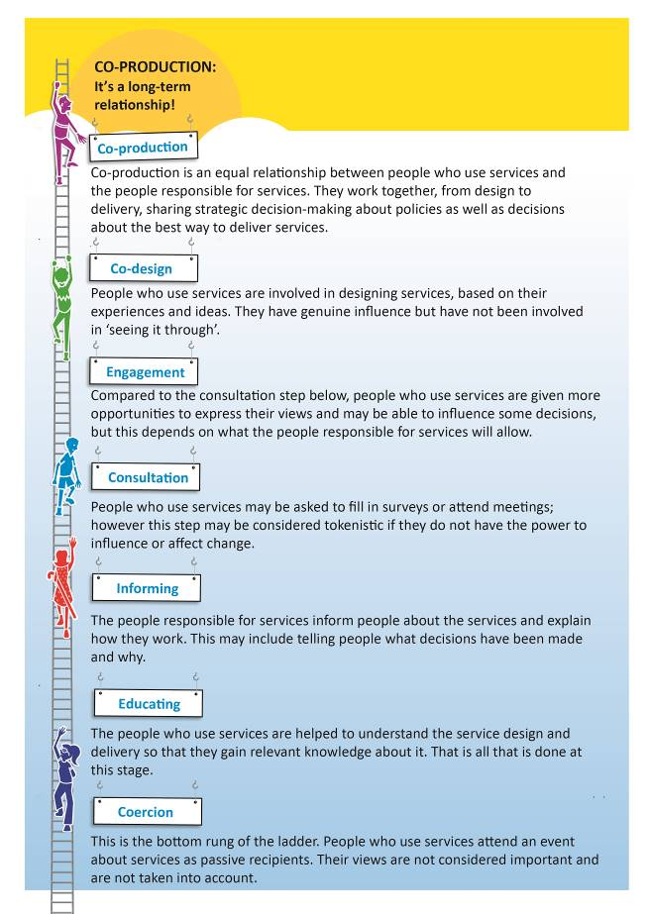
Co-production:
Co-production is an equal relationship between people who use services and the people who run services. They work together on everything, from how the service is planned to how the service is run. They share strategic decision making about policies as well as decisions about the best way to run services.
Strategic decision making: this is where a person or organisation makes decisions in line with the overall goals they have.

Co-design:
People who use services are a part of planning services, based on their experiences and ideas. They are a real part of planning services, but they are not a part of seeing it through to the end.

Engagement:
Here people who use services are given more opportunities to give their views than in the ‘consultation’ step below. They may be able to have an effect on some decisions, but this depends on the people in charge of services and what they let happen.

Consultation:
People who use services may be asked to fill in surveys or go to meetings. However, this step may be seen as tokenistic, this means it is being done just to tick boxes and not to really support people to be a part of making decisions. It can be seen like this if people do not have the power to make change happen.

Informing:
The people responsible for services tell people about the services and explain how they work. This may mean telling people what decisions have been made and why.

Education:
The people who use services are helped to understand how the service is planned and run so that they know about it. That is all that is done at this stage.

Coercion:
This is the bottom step of the ladder. People who use services go to an event, just to hear about services but not to give any information. Their views are not seen as important and are not used.

Co-production is not our idea; the definition of co-production (below) was written by the New Economics Foundation and the National Endowment for Science, Technology, and the Arts. These are both organisations that have been working together to understand ideas about
co-production and how it can work for public services:

Co-production means running public services in an equal way with a two-way relationship between professionals, people using services, their families and their neighbours. When activities are co-produced in this way, both services and neighbourhoods become much better at changing.

West London Collaborative is a community-led organisation. It works across London to
co-produce better and braver ideas about how to deal with local health and social care challenges. They also work in Hammersmith and Fulham. They bring people with lived experience of using the NHS and social care to work with professionals at all levels to get rid of barriers people face when trying to get what they need.

They told the Commission what they had learnt from their experiences of co-production:

- How we get there with policy change and decision making is everything, because it is the how we get there that will change our community in the future.
- If you don't evaluate what you have done you can't prove that it works, so evaluating what you have done is important.
Evaluate: this means to look at what has happened and decide whether it has gone well or not and why this has happened.

- It is about sharing power, it is about changing the role of people, all those important values are easy to lose.

The Commission is not alone in pushing for
co-production (working together) with people who use services. The local NHS Hammersmith and Fulham Clinical Commissioning Group is moving towards this as well. One of the aims of their Engagement and Communication Strategy 2017/2021 is making sure co-production is a normal and strong part of its work by April 2021.
Clinical Commissioning Group: this is part of the NHS that looks at what the health care needs are in their area. They then plan and buy services to meet those needs.

9.4 Barriers to Disabled people taking part in co-production
Shaping our Lives, a national user controlled organisation and network wrote a report in 2013 called ‘Towards inclusive user involvement, Beyond the Usual Suspects’. In the report it said that often Disabled people are not given the chance to take part in policy because of:

- Equality issues
- Where people live
- Communication issues
- The impairments that people have
- Not wanting to hear the voices of Disabled people that want to change the way things are.

Their report pointed out two important issues for Disabled people which could make co-production happen. Both of these things need to be in place. These are:

- Access – Making sure all Disabled residents have a way into organisations and the way that organisations make decisions.

- Support – for example, building confidence and skills, giving help and the chance for Disabled people to get together so that they can really take part.

9.5 Co-production – seeing residents time and experience as important

As the ‘Towards inclusive user involvement’ report says, many Disabled people do not have much money coming in, so it is important for Disabled people that co-production does not cost them any money.

This means that where Disabled residents have costs, these are thought about and either paid up front if needed or paid back quickly.’ The report goes on to say, that paying Disabled residents for taking part is seen as the way to do things over recent years.

It shows that what we give and the knowledge and expert information that we have is seen and is important.

Remember how few Disabled people there are in all levels of decision making. Non-Disabled people are paid to put together policy and practice for Disabled people. A policy needs to be co-produced.

9.6 Making the economic case for
co-production: this means showing that it is worth the resources spent on it, this means money, time, staff etc

For some organisations, the push to use
co-production has been to create services that meet Disabled people’s needs in the best way possible. This is important for making the case because services that do not meet needs are a waste of tax payer’s money.

In 2013 the Social Care Institute for Excellence (SCIE) put out its ‘Co-production guide’. The Guide points out that the issues around the costs of co-production are complicated. This is because it says that while there is information that shows that co-production can bring down costs, it is still not certain. There have been different findings in different organisations and projects.

Some key points are:
- Co-production may lead to some costs being lower and others getting higher.
- It may only be possible to know whether
co-production saves money by looking at things over time. If it is good value for money then it will have brought down the number of bad services, services that are not working properly and services that are not wanted.
There are costs for training and costs for professionals in taking more time to work better with Disabled people. However, these activities can bring down costs if support and services are run better and work better.

The Social Care Institute for Excellence points out that one of the main reasons that co-production can make savings is from having support and services that also look at ‘prevention and early intervention’.
Prevention and early intervention: here, this means, services that look at supporting children and young people in different areas of their lives before issues become serious.

The more that this happens, the less likely people are to need more expensive services later, such as crisis and emergency services. The Social Care Institute for Excellence says the clearest examples of this way of working are the ‘People Powered Health’ report written by National Endowment for Science, Technology, and the Arts.

The report says that the NHS in England could save over £21 million for each clinical commissioning group or £4.4 billion across England. This could be done if ways of working mean that patients, their families and communities take part in a more hands on way.

The savings would come from the following things going down by 7%:

- People going to Accident and Emergency
- People going to hospital for planned or unplanned things
- Outpatient services being used, these are services that mean that a person does not need to stay the night at a hospital or medical centre

This would save money and would also be good for society.

The report points out, that money needs to be spent in order for costs to come down.

The report says that the information is not 100% certain and that in many areas, getting more information about what works has just started.

However, the National Endowment for Science, Technology, and the Arts believes that:

There is enough information to support looking more into these ways of working.

They have been shown to make a difference to the people using services and the amount spent on services.

9.7 Co-production (working together) in Hammersmith and Fulham

The Commission thinks that the co-production we want to see in Hammersmith and Fulham will see Disabled residents taking part much more. This will be done through taking part in policy and decision making.

We think co-production is about the Council, public and community organisations and Disabled residents, working together in a real and lasting way. This will not just be one or two Disabled people on their own around the table. Therefore, supporting Disabled residents and Disabled People’s Organisations (DPOs) is very important.

This would mean that professionals and people voted into the council must be honest with Disabled residents about barriers to reaching our goals. They must also be honest about how difficult it is to make the best use of resources.

As said before, from what we have found out, the Commission thinks that the following definition should be used for co-production:

“Co-production (working together) means that Disabled residents and decision makers are working together in an active way to plan, design and review policy and services that affect our lives, to get rid of the barriers we face.”
Residents: this means people living in an area.
Decision makers: this means Councillors and people who make decisions about policy.

Our definition of co-production is based on the ‘Nothing About Disabled People Without Disabled People’ values. It means that everything that happens about Disabled people, should be led or led together with Disabled people.

We believe the Council will need to
co-produce a Co-production ‘hub’. This will be needed to make our recommendations work. The hub would be a place to organise work across the borough. It would support putting in place co-production across Council departments. It would give people a place for getting support, dealing with problems and getting expert information.

9.8 Working together – real examples of change for Disabled residents in Hammersmith & Fulham

In Hammersmith and Fulham, we have strong examples of local Disabled people starting policy ideas, campaigning for the ideas to be put into place, and working with local Councillors and others to make them happen:

- ‘Homecare’ - charging Disabled people for support needed to live in our own homes (Independent Living)

After lobbying and a change in the Council’s leader, the council got rid of the ‘Homecare’ charging policy in April 2015. Putting an end to making people pay for their homecare sent a strong message to Disabled residents. It showed a change that was good for all Disabled people getting that support, no matter what their background was.
Lobbying: here this means giving information to and talking to a member of the council to try and get them to change something or make a certain decision.

- Independent Living Fund - In June 2015, the government closed the Independent Living Fund. This was a fund that supported people dealing with big barriers when living in the community. Local Disabled people, once again, had the idea that the Council should agree to keep Independent Living Fund support. The Council supported that idea and agreed to make sure Independent Living Fund support was kept until the next local elections in May 2018.

- Direct Payment Support Service
Until 2012, the support service had been run by a local Disabled People’s Organisation (DPO). This was stopped without talking to the people using the service and was taken over and run by the Council.
Local Disabled people had been worried for some time about the service and have been pushing for that decision to be changed.

Last year the Council agreed to do a review of the support given to people in the Borough who use direct payments and personal budgets. The review was carried out by an independent Disabled People’s Organisation that works in Richmond. The organisation thought that the service should go back to being run by the Disabled People’s Organisation.

- Writing an Independent Living Strategy, this means plan - The Commission has been talking with the Council about writing this with local people.

Independent Living is an important part of the UN Convention; this is an international agreement that the Government signed up to which pushes for the Rights of Disabled people. A part of the Convention called Article 19, says that all Disabled people should have the right to Independent Living.

These are three important examples of local Disabled people successfully leading on policy ideas. The Commission believes that the great things that have come out of these changes can now be built on to do so much more.

9.9 Co-production (working together) – first steps

At the same time as working towards a
co-production way of working for all policy that affects Disabled people, we think that there are some areas that need to be looked at first. Below are the three areas that we think need to be looked at first.

Independent living
As already said, the council has already started a review of direct payments and personal budgets which is being done by a Disabled People’s Organisation (DPO). We think that a co-produced independent living strategy for Disabled people should be used instead of the Personalisation Strategy now being used in Hammersmith and Fulham. This should be a strategy for Disabled people of all ages.
Transition to adulthood: this means moving from being a child to being an adult
The Council's Transition Taskforce thinks that there should be a new Preparing for Adulthood Team that brings together Children’s Services and Adult Social Care. This team would support young Disabled people from the age of 14 to 25. Putting the taskforce’s report into place should be co-produced with young Disabled people, as well as with their families. This work should also be a part of the Independent Living Strategy.

Disabled people’s housing

Work in the Council on better housing for Disabled people has already started. Moving forward, we think that this should be
co-produced.

Plans to refurbish Hammersmith Town Hall and the surrounding area: this means giving the place a makeover by redecorating or buying new things

This work will be co-produced with Disabled people to make sure that it has the highest levels of inclusive design; this means making sure that the space is accessible to all.

- Conclusion

Our work has shown us that many Disabled residents feel no one is worried about us or our lives. It has also shown us that Disabled residents in the borough want to take part in decision making, supported by staff and Councillors, to make change together.

“I think I am getting really excited about the whole notion of co-production, I think it covers everything. It is instrumental in changing culture”
(Council staff member).

Notion: this means idea.
Instrumental: this means very important.

Many Disabled residents are missing out when looked at against non-Disabled residents. This is because of the many barriers that discriminate and exclude us. These are barriers created by local, regional, and national government, either on their own or all together.

Overall, from what people have told us we can see that there are not many examples of what we think of as
Co-production. Most ‘Co-production’ activities do not work with or try to work with Disabled residents in a routine way.
Activities are often led by one or two professionals trying to make sure residents are a part of decisions some of the time. However, Disabled residents are not being made a part of decisions in a way that leads to big changes in our daily lives. In many cases professionals are on their own and do not have the support or resources to make working together a success.
Not having something that pushes for co-production change, like the hub, means that people can’t get organised or feel good about co-production. There is no one organisation to blame for that. The Commission also thinks that so far ‘co-production’ has gone nowhere near far enough to have a long-term effect on getting rid of barriers for Disabled residents.
The co-production we are aiming for in Hammersmith and Fulham is made up of not just planning services together, but also of getting new ideas. These ideas, which in many cases are clear to us, will come from Disabled residents, campaigning and social action.
As co-production starts to move forward, using the information the Commission has already got and by getting more information, we will start to see changes. We will no longer be experiencing barrier after barrier.
Different public organisations have a moral duty and a duty by law to deal with those barriers with Disabled people. This must be done because we as Disabled people are not in positions where we can make the decisions needed. Non-Disabled people are generally writing policies for us and using our money and resources.
Moral duty: this is something that someone should do but cannot be made to do by law.

Diversity and inclusion are important values in co-production and citizenship. Disabled people, as we have already said share the same experiences. However, we are also all different which may lead to other ways of being discriminated against.
Citizenship: this means being a member of a country.

We believe that if we can put our recommendations in place then inclusion and diversity of local Disabled residents taking part in making decisions, will go up.
The Commissioners see this opportunity which is supported by Hammersmith and Fulham Council as very important. We have been able to look at the way things are today for local Disabled residents without any limits to what we could look at or limits on the findings we could write about. It has been a challenging year but very important and one of a kind.

We are very excited about the plans to turn the recommendations into action so that creative
co-production can really take off. Through shared decision making, Disabled residents will start to see our daily lives getting better.

We hope going forward that we can create a push for change across the Borough. The Commission believes that without the full inclusion of Disabled residents, full equality and equal citizenship are impossible to reach - in other words… Nothing about Disabled people without Disabled people!
11. Extra information
- 1 Hammersmith and Fulham Disabled People’s Commission recommendations and how we will know things are getting better
The next step will be to co-produce a short-term, medium-term and long-term plan to carry out the Commission’s recommendations

Creating a co-production culture
Recommendation 1
The Council brings in a human rights way of working to the way it plans its policy and services. The Council should use the UN Convention on the Rights of Persons with Disabilities (UNCRPD) as the base for change.



How we will know things are getting better for this recommendation
- The UN Convention and the social model of disability are being used as the guide for planning and writing all policy with local Disabled residents. This can be clearly seen in council policies.

- The council work plan has activities to make sure that human rights and the social model become a part of all council work.

- Co-production principles and ways of working are a part of all Council work. For example:
  - Departments business plans
  - The way project reviews are done
  - Online learning
  - Changes to publicity, recruitment, training, professional growth and management
Publicity: this is how the council let people know about the work that they do and how people can be a part of it.
Recruitment: this is how new people are employed in an organisation.

- There will be a co-produced review of all of the ways that we carry out monitoring and evaluation and how we report. For example, the Internal Audit Department and Public Accountability Committees could both be responsible for reviewing how co-production is put into place across the council, in each council department.
Internal Audit Department: this department keeps an overall check on the way that things are working at the council. Such as money, how the organisation is being run and how risk is being dealt with.
Public Accountability Committees: these committees are there to keep a check on how the council is run. They make sure that local decision making is open, clear and accessible. They look at issues and then listen to the people affected by the issue. The information is then used to make decisions and to guide how the council is run.

Recommendation 2
The Council brings in a policy which means that the council must work in co-production with Disabled residents.



How we will know things are getting better for this recommendation
- Co-production with Disabled residents has the resources it needs and has been put into place across all of the Council’s work.

- Set up a co-production group of Disabled residents who work with the strategic director, this is the person who looks at the big picture and makes sure the plans are put into place. They should work together to turn the recommendations in this report into reality.

- The hub has a strategic director who makes sure the co-production strategy and other recommendations are set up and put into place.


Recommendation 3
The Council plans and puts in place an accessible communication strategy. This should promote co-production in the whole Borough.

How we will know things are getting better for this recommendation
- Make sure more people know about
co-production, showing how it gets rid of Disabled people’s barriers locally.

Training and development

Recommendation 4
The Council works with the Co-production Hub to put together a co-production support strategy. Support should be put in place so that the strategy can be carried out.

This means giving the right skills to Disabled residents, local Disabled People’s Organisations (DPOs), staff and councillors so that they can work together with the council to plan and carry out policies and services.



How we will know things are getting better for this recommendation
- Changes in policy and services can be linked back to ideas started by Disabled residents through co-produced work.
- Disabled residents, local Disabled People’s Organisations and the Council give information about how Disabled people are more of a part of their work and decision making.

Planning services and commissioning

Recommendation 5
The Council co-produces a framework, here this means a document which has information about the way the council will work.


This framework should have:
- Information about quality assurance, this is information about how the council will make sure its services and the way it works are good quality
- Information about its values and how these are used in the council’s work. These should be social values, this means how people are seen and treated by the council. It should also have information about its economic values, this means its values around money and how it is spent.

This will give information about the Councils’ values and how it will work and behave. It will also give information about how all organisations running services which are paid for by the council, should do the same.
How we will know things are getting better for this recommendation
- Show that a co-produced quality assurance and social value framework has been written. Show that it is being put into place when services are bought through commissioning.

- Show how the new quality assurance and social and economic value framework is changing how commissioning is done and what comes out of council contracts.
Contracts: in this document this means a signed agreement with the council to run a service.

- Service specifications are co-produced and put into place using council money, commissioning and procurement, this means buying services.
Service specifications: these are documents which say what is needed from a service.

- Contracts are written and given to organisations in line with service specifications which have been co-produced with Disabled residents.

- Review with Disabled residents, the contracts that are seen by Disabled residents as creating barriers.

Resourcing Co-production: this means having the money, staff and space to be able to put co-production into place

Recommendation 6
The Council looks at how much money and resources are spent on different ways of involving Disabled residents. For example, co-production, linking in with Disabled people, and consultations with Disabled residents. Once the Council knows how much it spends on this, a new co-production budget should be put together.



How we will know things are getting better for this recommendation
- A co-produced financial audit has been done; this means a look at how money is being spent. This should show how money and other resources are being spent on co-production, engagement and consultation.
Engagement: here this means people taking part in decisions or telling the organisation what they think but this is not full co-production.

This should also show how much money is spent on Resident Satisfaction Surveys with Disabled residents, these are surveys that look at how much people like the services that they are using.

This should show information of surveys across the council, health, and community organisations. This information should then be used to set the amount of money that can be spent on consultation and engagement.

Co-production budgets should be a part of the Council’s medium term financial strategy (MTSF), this means medium term big picture plan.

- The Co-production hub looks at how resources are used to make sure that Disabled residents can lead on decision making. Resources also means having enough senior staff to co-lead putting the hub and its work in place and making sure it is working across all Council departments.
Co-lead: this is when more than one person, department or organisation, lead on a piece of work.

Review support and funding of Disabled People’s Organisations (DPOs)

Recommendation 7
The Council sees how important Hammersmith and Fulham’s Disabled People’s Organisations and their networks are. The Council sees how important their values and voices are.

The council works with Disabled People’s Organisations to decide on a long-term plan for paying for this work, this can be called a funding strategy. This will make sure that local Disabled residents can access their rights, get inclusion, equality and that Disabled residents can lead on
co-production.

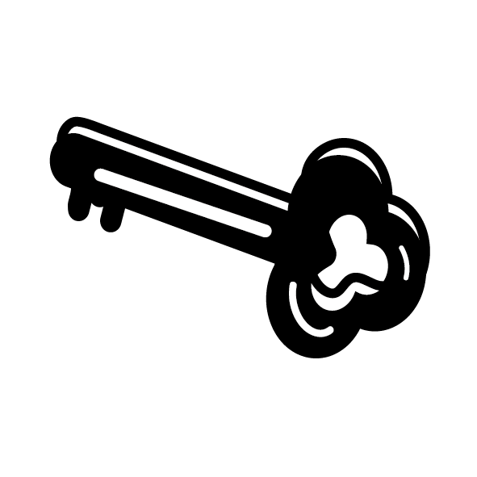

How we will know things are getting better for this recommendation

- A long-term funding plan is agreed with Disabled People’s Organisations and is put in place by the Council

- Disabled People’s Organisations work well, are independent and a real voice of local Disabled residents.

- The Council pays for Disabled People’s Organisations to tell Disabled residents about their rights and support Disabled residents to use them.

- Co-production can show that Disabled residents are leading on ideas and all areas of policy and setting up and running services.

Independent Monitoring and evaluation

Recommendation 8
Carry out monitoring and evaluation of co-production work and how well the recommendations are put into place. This should be done so that information about how
co-production can be used and how this affects people’s lives can be shared outside of Hammersmith and Fulham.



How we will know things are getting better for this recommendation
- Hammersmith and Fulham Council can give information about how using co-production has affected their decision making and policy. This is to show that the experience of co-production can help other communities both locally and nationally.

- Learning is shared in regions and nationally with policy makers and government to show what can be done.

11.2 Hammersmith & Fulham Disabled People’s Commission
What does success look like? Nothing About Disabled People Without Disabled People

- The definition for co-production is agreed in an accessible way that is easy for everyone to understand.

- A co-production strategy where local Disabled people owning everything that the council does is an important part.

- Finishing the agreed work plan and the Terms of Reference.
Terms of Reference: this is a document which tells you what an organisation or document is there to do. It also looks at the limits, this means what it is not there to do.

- The Council shows it is committed to the Disabled People’s Commission and taking on the agreed
Co-production Strategy.
Committed: this means agreeing to do something in a way that you will do everything that you can to make it work.

This should lead to a change in policies and how they are put into place across the Council including the Cabinet and the Leader.
  - What the Council agrees to do should be in the 2018 corporate plan; this is the Councils business plan.
  - Agree to work with Council staff on making sure the co-production strategy is put into place.
  - Put together an agreement to
partnership-working with different areas in the Borough. This is to push for more
co-production with Disabled people.
Partnership-working: this means organisations and people working in different areas, working together.

  - Work in a hands-on way with local Disabled people, communities and partners in planning, carrying out and commissioning local support and services.

- Taking time to hear local Disabled people’s voices. Especially those people who it is hard to include and whose views are not easily heard. This could be done using surveys, public events and by giving information.
11.3 Thank you / acknowledgements

The Commission would like to say a huge thank you to:

The many Disabled residents and Disabled People’s Organisations (DPOs) of Hammersmith and Fulham that gave us their time and information about their lives.

Organisations and people that gave information at Commission meetings. The voluntary and community organisations, health organisations, Hammersmith and Fulham Council, and national organisations.

Hammersmith and Fulham Council staff who gave us the support we needed to make the Commission work. Also, those who shared their advice and information. Especially Kevin Caulfield, Policy and Strategy Officer and the Policy and Strategy Team. Also, the staff who took part in our events and activities.

The Leader and Deputy Leader of Hammersmith and Fulham Council and other Councillors who supported our work.

Also thank you to Stephen Lee Hodgkins and People First (Self Advocacy) for putting together this report and Inclusion London for their ongoing support throughout.

References: this means where we got the information that we have used in this report

This includes services for people with impairments and long term conditions and special educational needs
https://www.lbhf.gov.uk/councillors-and-democracy/resident-led-commissions/Disabled-people-s-commission
https://www.un.org/development/desa/disabilities/convention-on-the-rights-of-persons-with-disabilities.html
http://www.ohchr.org/EN/HRBodies/CRPD/Pages/ConventionRightsPersonsWithDisabilities.aspx
https://www.legislation.gov.uk/ukpga/2010/15/section/149
https://www.gov.uk/government/uploads/system/uploads/attachment_data/file/600465/family-resources-survey-2015-16.pdf
https://www.lbhf.gov.uk/sites/default/files/section_attachments/2011_census_statistics_hammersmith_and_fulham_briefing.pdf
https://www.lbhf.gov.uk/sites/default/files/section_attachments/2011_census_statistics_hammersmith_and_fulham_briefing.pdf
https://www.disabilitynewsservice.com/new-Disabled-mps-pledge-to-fight-for-rights-in-parliament/
https://www.gov.uk/government/uploads/system/uploads/attachment_data/file/600465/family-resources-survey-2015-16.pdf
See ‘Disability data tables’ at: https://www.gov.uk/government/statistics/family-resources-survey-financial-year-201516
https://www.gov.uk/independent-livingfund
https://www.legislation.gov.uk/ukpga/1996/30/contents
http://www.legislation.gov.uk/ukpga/1995/50/contents
http://www.ohchr.org/EN/HRBodies/CRPD/Pages/ConventionRightsPersonsWithDisabilities.aspx
https://www.thinklocalactpersonal.org.uk/Latest/Co-production-The-ladder-of-participation/
http://www.participatorymethods.org/sites/participatorymethods.org/files/Arnstein%20ladder%201969.pdf
http://wecoproduce.com/
http://wecoproduce.com/
http://www.shapingourlives.org.uk/documents/BTUSReport.pdf
http://www.shapingourlives.org.uk/documents/BTUSReport.pdf
http://www.shapingourlives.org.uk/documents/BTUSReport.pdf
http://lx.iriss.org.uk/sites/default/files/resources/beresford.pdf
The Personal Social Services Research Unit? summaries this approach as the effectiveness aim and the aim of cost-effectiveness in their report, The Building community capacity: making an economic case available at: http://www.pssru.ac.uk/pdf/dp2772.pdf The PSSRU defines Cost effectiveness re social care and support as: ‘… a system of care and support that has improved cost-effectiveness – from the available resources – is one that has secured better outcomes for people who use services or people who might otherwise have developed a need for such services’. ? The evidence in the guide meets the requirements for NHS Evidence Accreditation.
https://www.ndti.org.uk/uploads/files/Co-production_Guide51Fin.pdf The evidence in the guide meets the requirements for NHS Evidence Accreditation.
https://www.ndti.org.uk/uploads/files/Co-production_Guide51Fin.pdf
https://www.ndti.org.uk/uploads/files/Co-production_Guide51Fin.pdf
https://www.ndti.org.uk/uploads/files/Co-production_Guide51Fin.pdf
https://www.nesta.org.uk/sites/default/files/the_business_case_for_people_powered_health.pdf

