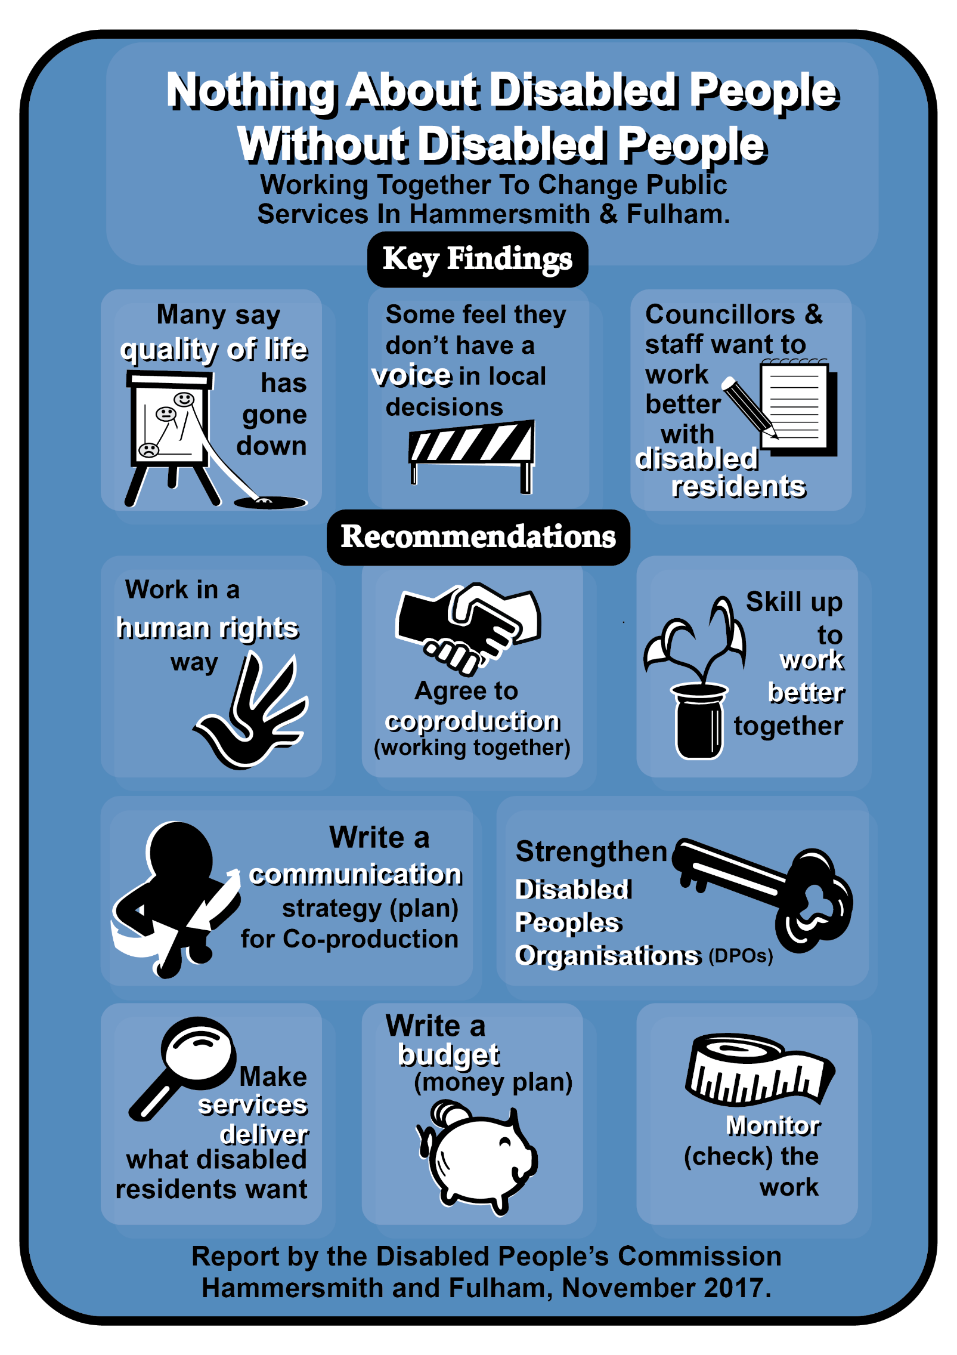
Hammersmith and Fulham Disabled People’s Commission – The Commissioners
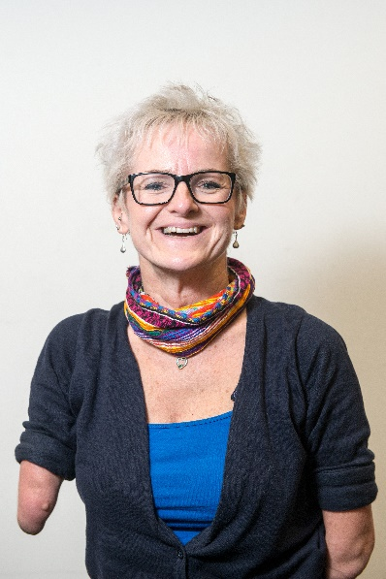
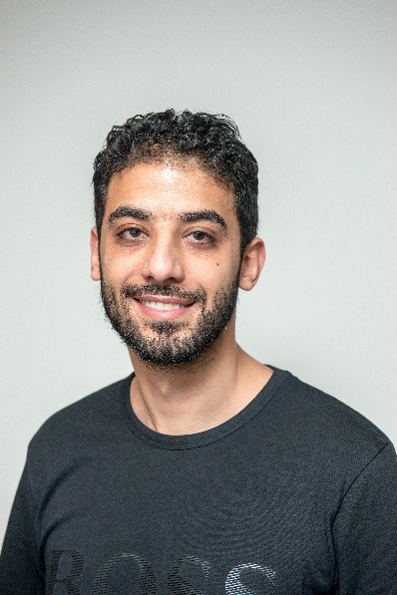
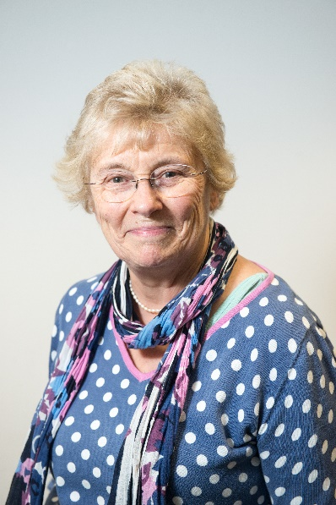
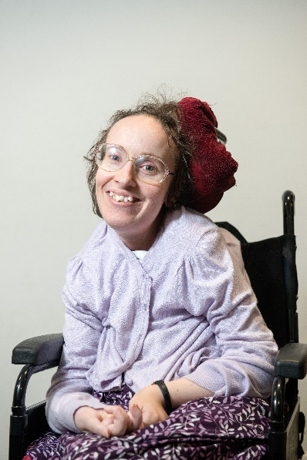
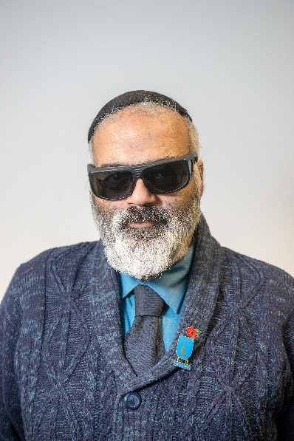
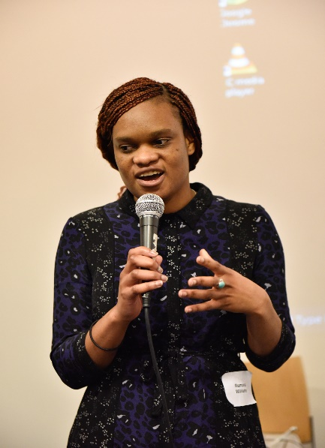
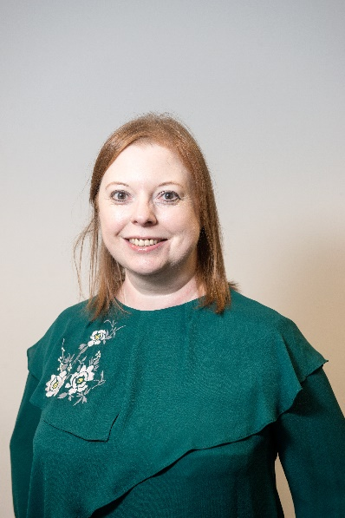
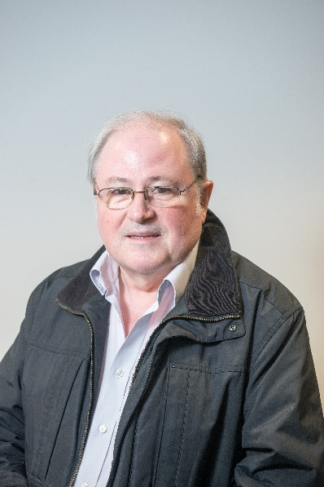
Jane Wilmot
Tara Flood
Ali Buhdeima
Victoria Brignall
Patricia Quigley
David Isaac
Ramona Williams
Kate Betteridge
Martin Doyle
Mike Gannon

For more information about the Disabled People’s Commission Hammersmith and Fulham and its work please go to the link below:
ttps://www.lbhf.gov.uk/councillors-and-democracy/resident-led-commissions/disabled-people-s-commission

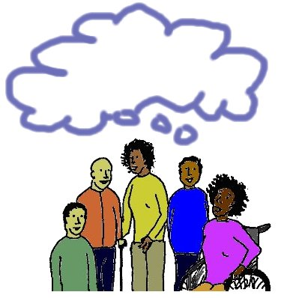
Disabled People’s Commission: Who we are and how we work
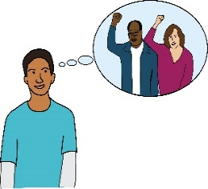
In December 2015 on the International Day of Disabled people, Hammersmith and Fulham Council agreed to work closely with Disabled residents, this means people who live in Hammersmith and Fulham. We took the chance to set up what we believe, is the first local Disabled People’s Commission in the country.
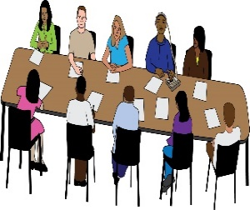
We aim to work together to build a culture that values, respects and pushes for the rights of Disabled people living in Hammersmith and Fulham. "Nothing About Disabled People Without Disabled People”.
All ten Disabled People’s Commission commissioners are Disabled people who face many different barriers in their daily lives. They all live in Hammersmith and Fulham.
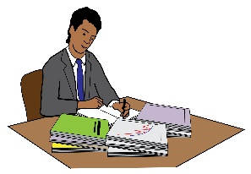
The way we carried out this work:
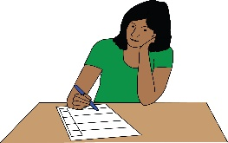
Stage 1: We looked at research and examples of
co-production (working together).
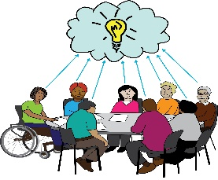
Stage 2: We carried out surveys to find out what Disabled people thought. We also did surveys for Councilors and Council staff.
Stage 3: We ran meetings and events to get information about people’s experience of decision making and
co-production.
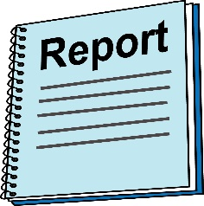
Stage 4: We used the information that we got to write a report with our findings and recommendations, this means what we think should happen.

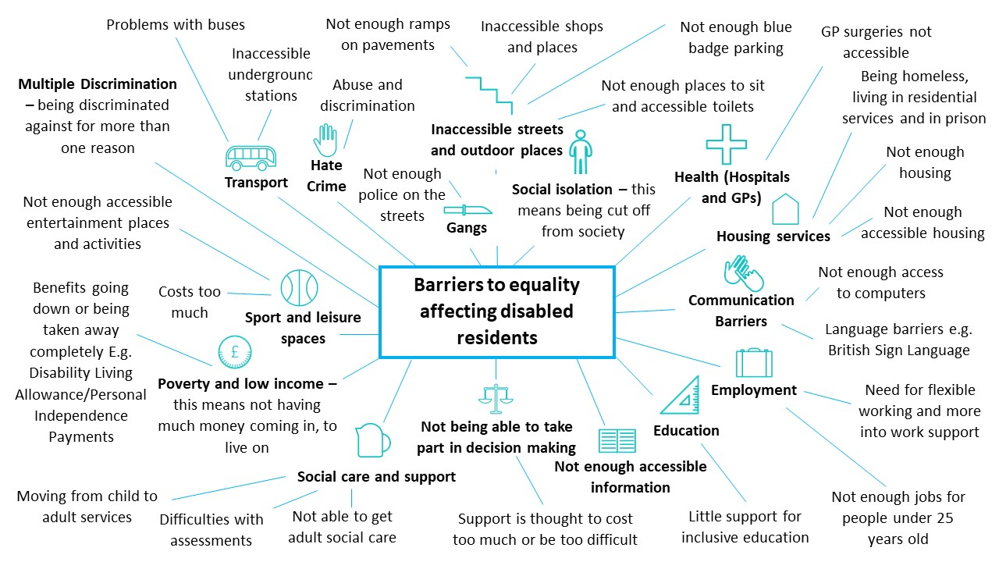
The barriers that disabled residents in Hammersmith and Fulham told the Commission about: The Commission was told about these barriers through a survey for disabled residents and at different events in 2017.
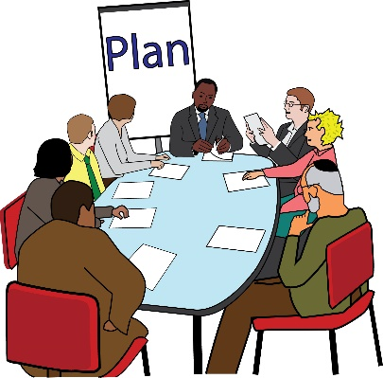
Over the past year the main thing we needed to do as a Commission was to find a way to deal with the barriers experienced by local Disabled people. This needed to be done in a strategic way. It needed to be done in a way that everyone could understand and take part in.
Strategic: this means doing things in line with a plan so that an organisation can meet their big picture goals.

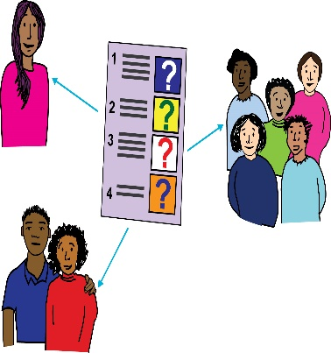
The Commission listened to many Disabled and non-Disabled people telling us about co-production (working together). We have looked at lots of information and examples of co-production. We decided co-production was the best idea to change things.
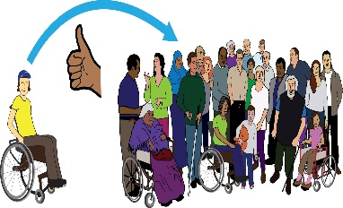
There are different definitions of co-production and explanations of citizen participation; this means how people take part in society.

However, most of the time Disabled people are not given the chance to take part in co-production from the beginning. For this reason, a lot of policy does not affect Disabled residents as much as it could.

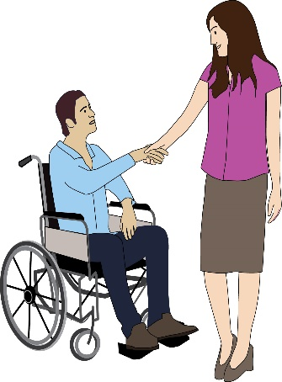
The definition that we are working from for co-production is:

“Co-production (working together) means that Disabled residents and decision makers are working together in an active way to plan, design and review policy and services that affect our lives, to get rid of the barriers we face.
Residents: this means people living in an area.
Decision makers: this means Councillors and people who make decisions about policy.

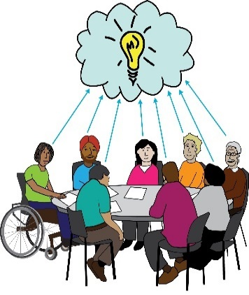
We work together on everything, from how the service is planned to how the service is run. Disabled residents and Disabled People’s Organisations share strategic decision making about policies as well as decisions about the best way to run services.
Strategic decision making: this is where a person or organisation makes decisions in line with the overall goals they have.

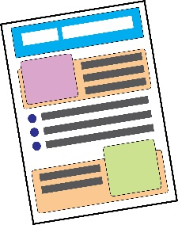
Recommendations: what we think should happen
- Use a human rights way of working, this means working in a way that pushes for people knowing about and using their human rights
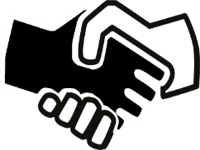

- Agree to co-production (working together)

- Write a plan for how we tell people about
co-production
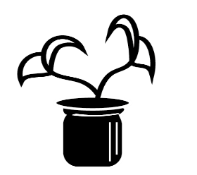

- Give people the skills to work better together

- Make services run in the way that local Disabled people want them to

- Write a budget, this means a money plan

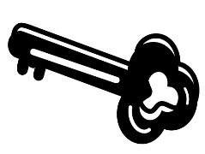
- Support Disabled People’s Organisations (DPOs) to be stronger

- Monitor the work, this mean check how it is going and make changes where needed

Co-Production (working together): What’s next – first steps

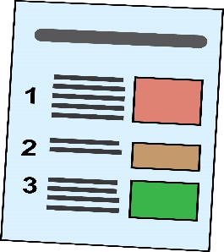
At the same time as working towards a
co-production way of working for all policy that affects Disabled people, we think that there are some areas that need to be looked at first. Below are the three areas that we think need to be looked at first.
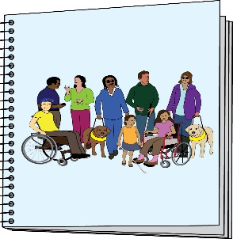
Independent living: We think that a co-produced Independent Living Strategy for Disabled people should be used instead of the Personalisation Strategy now being used. This should be a strategy for Disabled people of all ages.
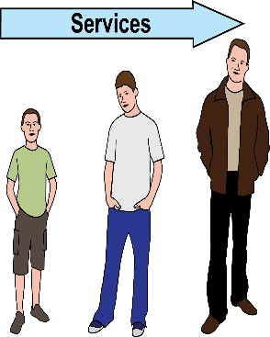
Transition to adulthood: this means moving from being a child to being an adult - There should be a new Preparing for Adulthood Team that brings together Children’s Services and Adult Social Care. This work should be co-produced with young Disabled people, as well as with their families. This work should also be a part of the Independent Living Strategy.
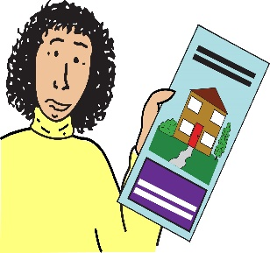
Disabled people’s housing: Work in the Council on better housing for Disabled people has already started. Moving forward, we think that this should be co-produced.
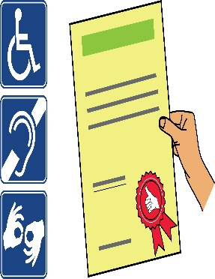
Refurbish Hammersmith Town Hall and the surrounding area: this means giving the place a makeover by redecorating or buying new things: This work will be co-produced with Disabled people to make sure that it has the highest levels of inclusive design; this means making sure that the space is accessible to all.

