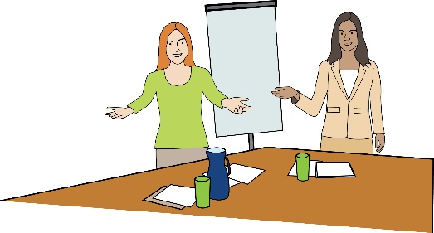 | Co-production group  Co-chair job description template
Background to the group/role
(Insert information about the principles and values of the co-production group, information about the group, it’s remit etc)

The roles & responsibilities of the
- council officer co-chair
- resident co-chair:

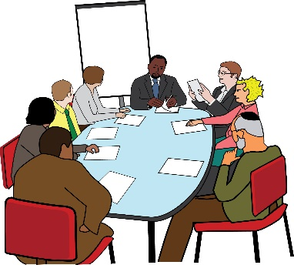 | Co-chairs to think about taking turns to chair the meeting or support members of the group during meetings (very useful to support discussions and the inclusion of everyone).  Officer co-chair to lead on following up on actions with council colleagues between meetings.
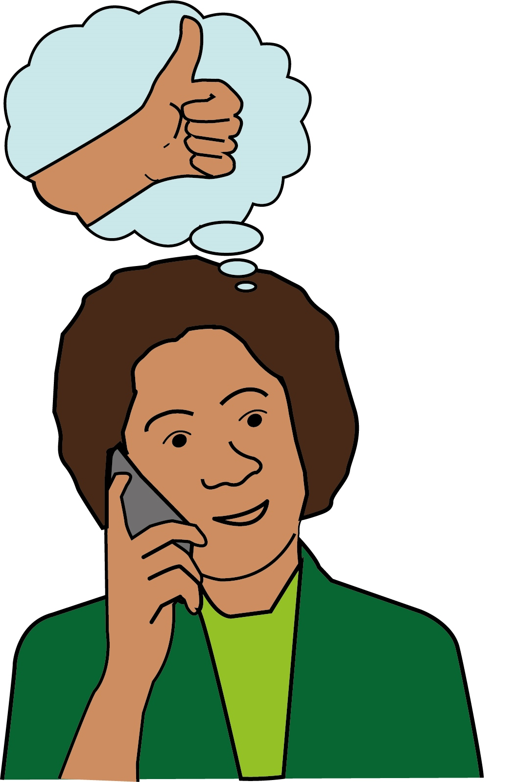 | Make sure co-chairs can be available online between meetings and that all email communications are shared. This will help the co-chairs work well together.
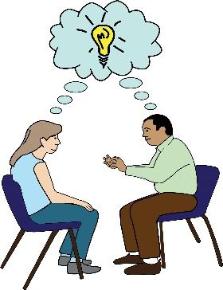 | Be aware of the skills and experience both co-chairs have. Create opportunities for  co-chairs to support each other.
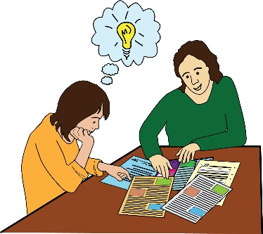 | Make sure the co-chairs share the workload fairly. Each chair to think about what they’re good at and work towards developing a strong co-chair partnership.
 | Co-chairs to know when to decide on behalf of the other, and when it’s important to make decisions together.
 | Co-chairs to recognise that communication, respect and shared values sit at the heart of the relationship being successful.
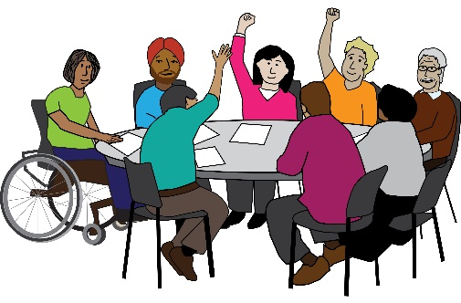 | Make sure that the group has the right mix of members to provide the right ideas and skills needed to deliver the work.
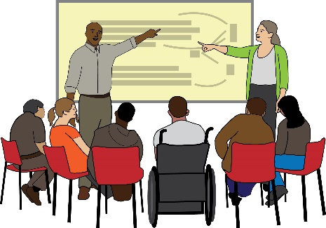 | Make sure all group members receive good induction, training and support to carry out their role well.
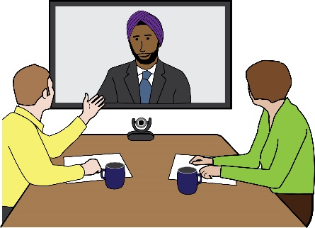 | Regularly check if group members are struggling or need further support.
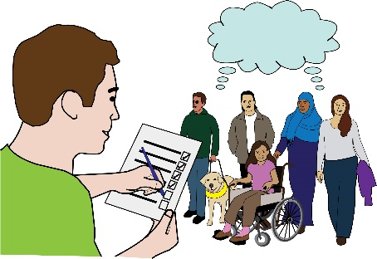 | Make sure the group is doing its job well and take action to improve how the group works if needed.
 | Council officer co-chair to lead on keeping the group updated on progress of the work.
 | Both lead on the recruitment of new members of the group and the annual review of the group.

Person specification for the resident co-chair
The qualities, skills and experience we are looking for in a resident co-chair

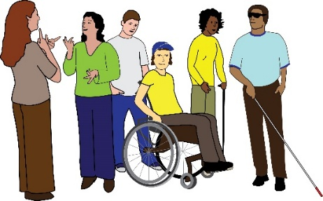  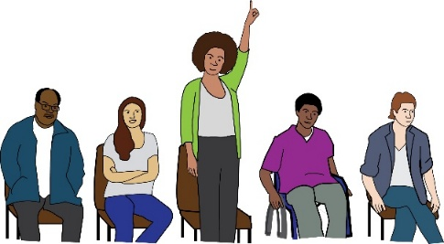     |  | - Resident co-chair must be a resident who identifies as a Disabled person  - An understanding of the Social Model of Disability  - Some experience of a leadership role in a paid or voluntary role  - Some experience of developing plans, direction or a vision  - Experience of different ways of influencing and negotiating  - Networking with a wide range of people and organisations from diverse backgrounds  - Have a positive, professional and a ‘can do’ attitude  - Good communication and people skills


Easy Read produced by People First (Self Advocacy)

LBHF co-production groups generally have a resident co-chair and a senior council officer co-chair. This Job Description covers both roles and how they work together.

