
‘

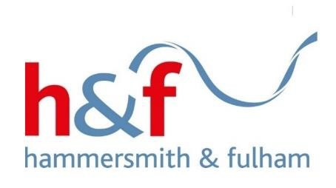
Doing things with residents, not to them’
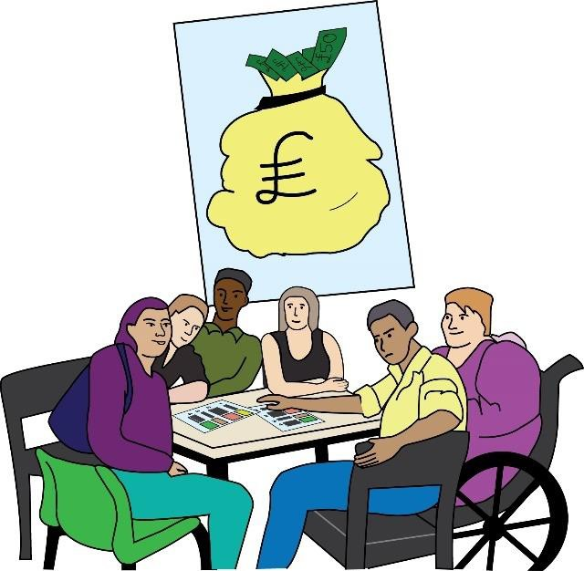

An easy-read guide about payments and expenses for residents who are undertaking co-production activities

Co-production payment and expenses process for residents (who are not employed by the
council)

 | This is a guide for residents who are involved in our work.  It tells you about how we make payments and pay expenses when doing Council Co-production business with us.
Co-production: here, this means Council workers and residents working together to plan, make decisions and deliver support together to improve quality of life for
people and communities in Hammersmith and Fulham.
Introduction

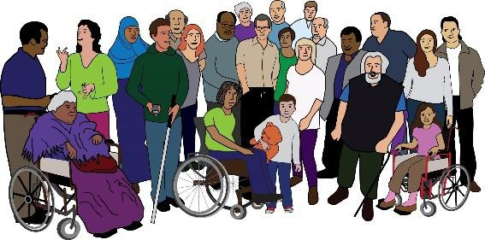   | We really appreciate the residents. We want to ‘Do things with residents, not to them’.  We recognise the time and experience that residents can bring to improving local support and services.  When working with us, residents must not be  financially worse off.

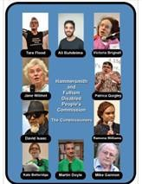   | Our Disabled People’s  Commission found that Disabled residents are less involved in decision making than non-disabled residents.  The Disabled People’s Commission vision was for Disabled residents, the Council and other organisations to build new ways of working that value and respect Disabled  residents.
To see the Disabled People’s Commission Report
click here.
To find our Co-production page click here.

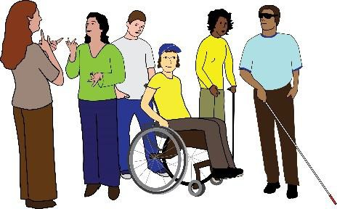
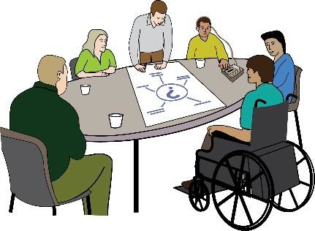
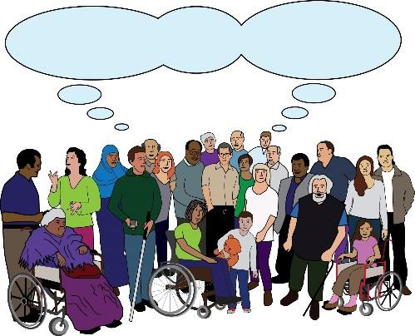
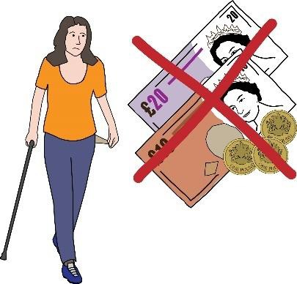


Principles

+

The Council recognises that:
- It needs to increase the number of Disabled residents involved at all levels of decision
making, because currently there are not very many involved.
- It is important to make decisions with residents and do things with them and not to them
- Residents have a lot of knowledge and experience that can help to develop policy, services and support.
- Residents should not be financially worse off because they take part in Co-production
activities.
- Residents should be given the right information at the right time so that they can choose how they want to participate.

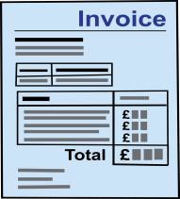 | The Council will reimburse travel and subsistence costs to allow residents to attend meetings comfortably and easily.

Reimburse: to pay someone money that they have
spent and are owed back. For example, you paid for a train ticket to a Council meeting you needed to attend, the Council will then pay you that money back.
Subsistence costs: the cost of food and drink needed when you do business away from home or your usual place of work. For example, you have to go to a meeting far away and you need to buy and eat lunch
on the way there.

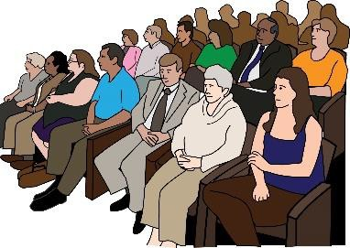 | Residents attending meetings as observers are not allowed to claim expenses.
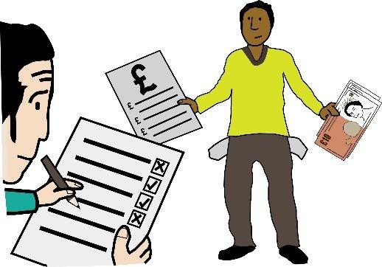 | Sometimes, claiming expenses can affect your benefits so it is important to have up-to-date information about this.  For more information see Appendix 1.

Payments for taking part in Co-production activities

We offer a payment of £20 per hour to co-producers who attend a Co-production meeting either in-person (face-to-face) or via a virtual meeting (Zoom/Teams etc.)
Co-producers: residents who takes part in our Co- production groups/meetings.

 | Also we may sometimes offer a small voucher for ‘one-off’ activities.
 | When we make a payment for Co-production activity, it does not mean the resident has a contract of  employment with the Council or its partner organisations.
 | Payments will be arranged by the Council’s  Co-production lead officer.

We do not offer payments for Co-production work when:
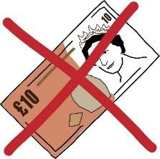  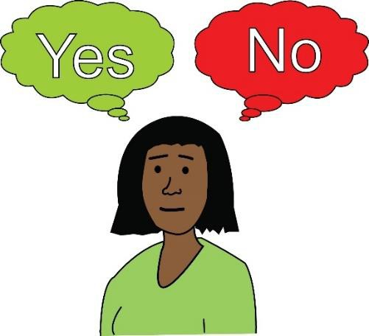 | - The attendance or activity is optional, which means that the resident does not have to attend.  For example:  - Optional training sessions  - Doing or taking part in small pieces of work which are a part of the main work you are  doing, for example, reviewing a document during group work.
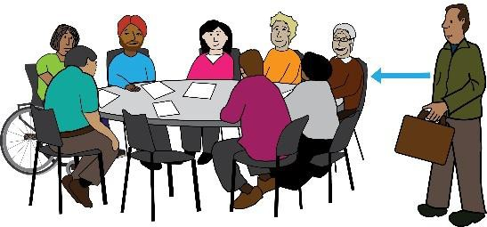 | - A resident does not attend a meeting or only attends part of a meeting (depending on their circumstances).
 | - There are small pieces of work such as reading emails or documents to prepare for meetings.

- Residents attend meetings held in public as
observers, or who take part in consultations,
surveys and other similar activities.
 | - Residents attend meetings as a representative of an organisation rather than as an individual (for example attending a workshop).
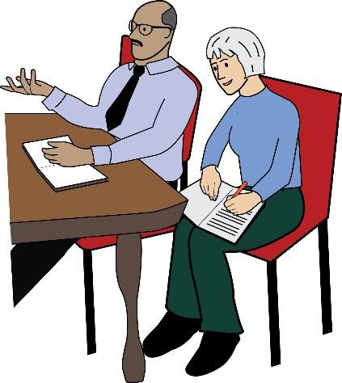 | - Carers, personal assistants or support workers attend a meeting to support a group member, expert or conference speaker. They are paid separately for their work being a support person.

HMRC and effects on paying tax

 | HMRC considers any payments accepted for taking part in the Council’s Co-production work to be income.  Accepting a payment for Co-Production work may  affect your benefits, so it is  important that you get up-to- date information about this. This section explains more about it.
HMRC (His Majesty’s Revenue and Customs): this is the UK’s public authority which is responsible for collecting tax. This tax pays for the UK’s public services which includes things like making benefits
payments.

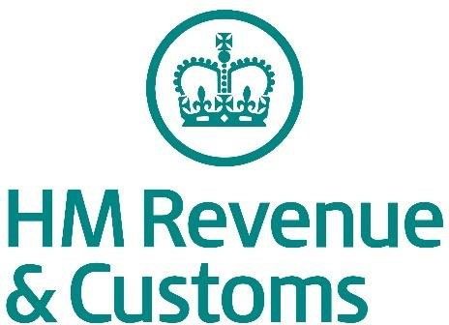   | - Every co-producer is responsible for finding out if they need to tell HMRC about any payments they have accepted from the  Council.  - The Council will pay all individuals directly.

  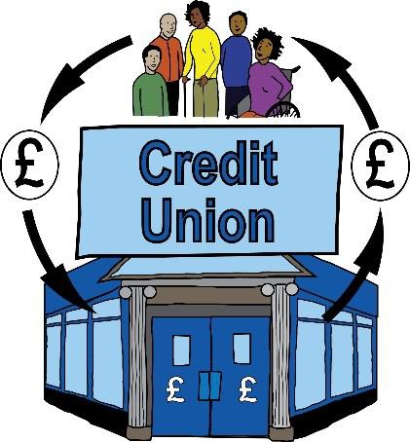    Community Group | - You can decide not to accept a payment if you want to. For example, some people may choose  not to accept a payment as it may affect their benefit.  - The contributor must tell the Council if they are receiving the payment through an intermediary (a company or organisation) because then the Council may need to deduct tax and National Insurance.
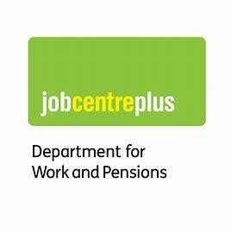 | - Anyone receiving state benefits should talk to the relevant organisations to find out more information, for example Jobcentre Plus
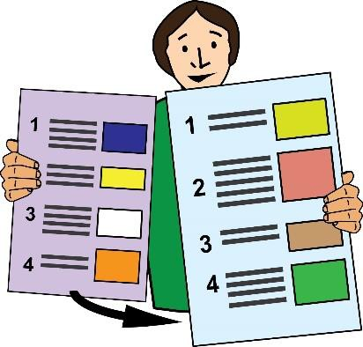 | Please see Appendix 1 for more details.  If you have any questions, please speak with your  Co-production lead officer.

Travel and Expenses

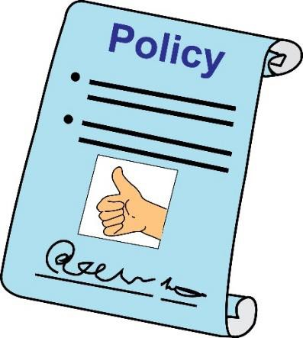 | The Council’s policy covers  travel, subsistence, and other out-of-pocket expenses, as well as  payment for Council business explained above.  Payment of expenses should not affect any state benefits the individual receives.
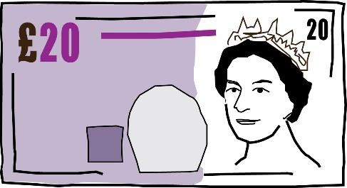 | But if you claim the flat rate fee of £20 per day this may be considered as earnings when calculating benefits.
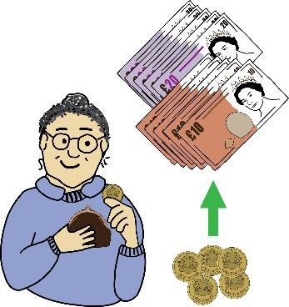 | If expenses are less than  £20, you can claim the exact amount that was spent. A claim for the exact amount will not be considered as  earnings.
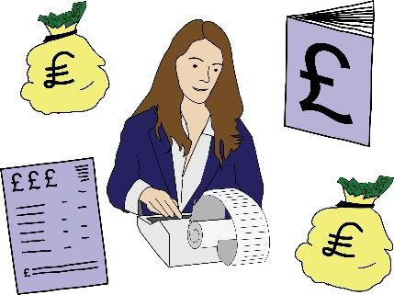 | Expenses that have been paid out by the contributor will be processed and approved by the Council’s Co-production lead officer.  (This does not apply to any travel and  accommodation booked by the Council).

   | If you have any queries about this guidance, please contact the Council’s Co- production lead officer.  Our colleagues in our Human Resources (HR) department can give you extra support:.  Email: dave.rogers@lbhf.gov.uk
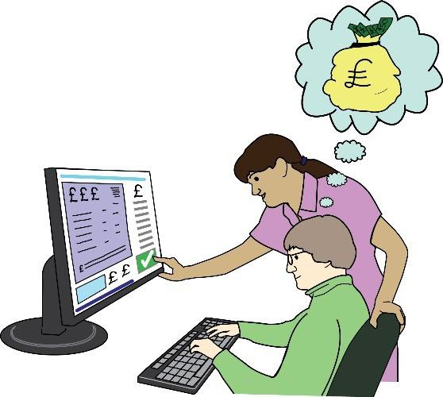 | Everyone involved in  Co-production is responsible for trying to get the cheapest form of accessible travel possible to save the Council money.  Very occasionally, some individuals may need accommodation which must always be agreed in  advance.

Travel and accommodation

 | This section covers the  following:  - Rail travel  - Other public transport  - Taxis  - Flights  - Car use  - Accommodation
   | The Council has a central booking system for train, air travel and accommodation.  We aim to book and pay for all train, air travel and accommodation (if needed) in advance so that our residents are not out of pocket.
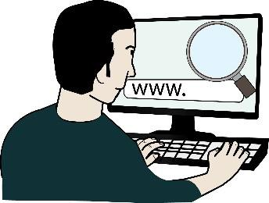 | We know that sometimes individuals may need to book and pay for rail travel and/or accommodation themselves. If so, these guidelines will  apply.

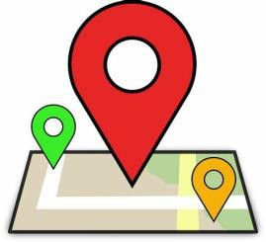 | If this needs to happen, the Council will reimburse the  cost of return travel between the individual’s home, office base or workplace, and the Council’s business location.
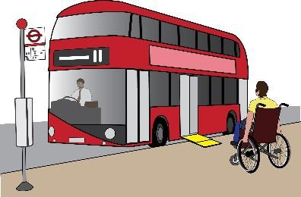  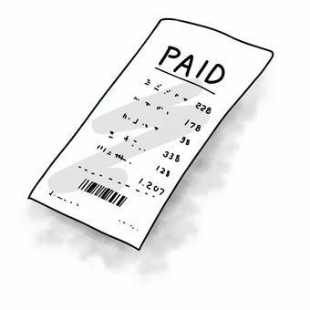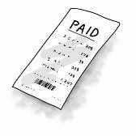 | Where possible, individuals should use public transport rather than using cars or flying.  When an individual makes an expenses claim, they must provide receipts.  When necessary, the Council will reimburse other travel expenses, for example car mileage costs, parking, taxis and flights. But these  must be agreed in advance.
Car mileage costs: this is a flat rate amount paid for each mile you travel in your own car, which mainly covers the fuel costs used for your journey. This rate is
shown in Appendix 2.

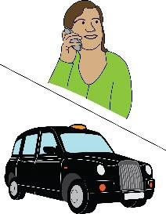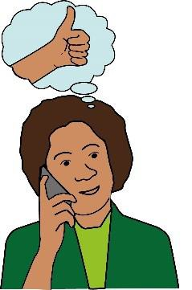 | Please speak to your Council  Co-production lead officer to request travel booking and explore accommodation  requirements.

Rail travel

 | Always buy the cheapest  train tickets. Buying train tickets in advance is often much cheaper.
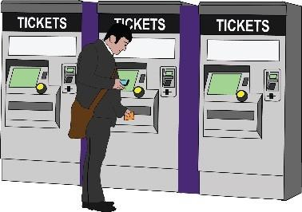 | Give yourself plenty of time to collect the tickets before your journey or on the day. Wait for them if they are arriving by post.
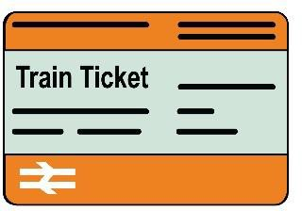  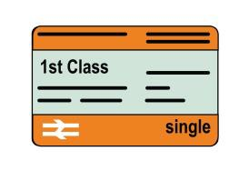    STANDARD    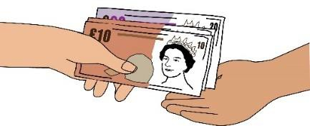 | Always buy standard class train tickets. First-class travel is not allowed. First-class travel will only be agreed if it costs the same or less than a standard class ticket, or as a reasonable adjustment, in line with the Equality Act 2010.  Any access needs must be agreed in advance with the Council’s Co-production lead, who may ask for evidence of your needs.  Refunds for cancellations must be returned to the Council. You can keep  compensation for any delays.

Other public transport (for example tube, tram or bus)

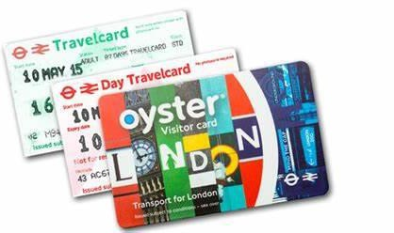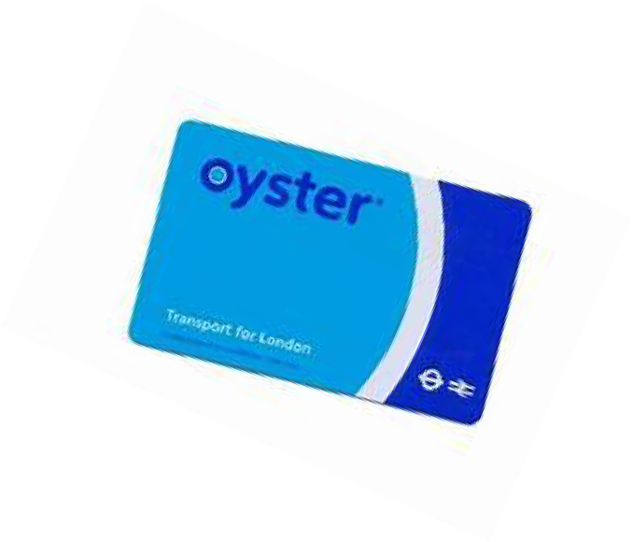 | You should use public  transport services where they are very available and accessible.  You should use travel cards (such as a Freedom Pass or Oyster card) or contactless payment cards (like a debit card) whenever possible.  These types of cards make travelling cheaper.
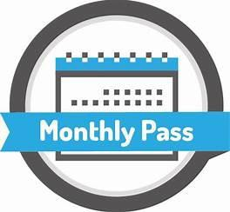 | If you use a bus, tram or tube card pass that allows unlimited travel (such as a monthly season ticket), we will not reimburse you because the cost of the trip will have been included on your card.
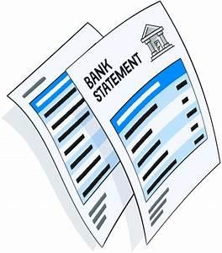 | You should keep tickets, receipts or travel account statement printouts or screenshots (like for an  Oyster card) as proof of the expense.


Taxis
You may use a taxi only if:

      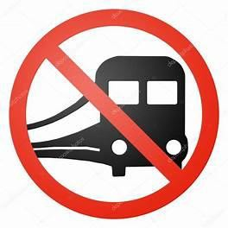 | - It is cheaper because there are a few of you all travelling to the same place together.  - It is safer for you, for example travelling at night.  - You need a Reasonable adjustment under the Equality Act 2010.  - You are travelling with heavy or bulky items of equipment of luggage.  - You are travelling in an area with limited public transport.
 | If you need to travel by taxi, you should discuss this in advance with the relevant Council Co-production lead.
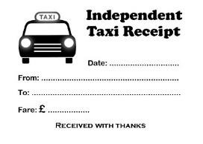 | If you have paid for a taxi  fare, you must get a receipt from the driver.

Air travel

 | Air travel should be  extremely rare.  Also, we must think about its impact on the environment compared to other ways of  travelling.
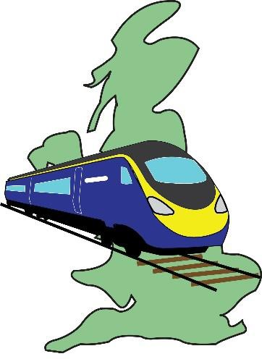 | But there may be times when individuals need to fly, for  example:  - when train travel is not the cheapest or practical option  - when travelling outside the UK to attend conferences and events
 | If you think you will need to travel by plane, you should ask the Council to book it for you using our internal booking system.


Car use

  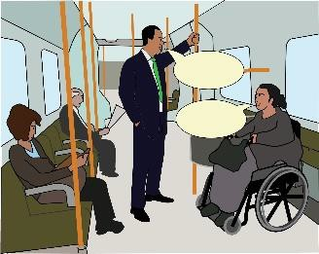 | The Council would prefer you not to travel by car because of the impact on the  environment.  Also, because it is not possible to do other activities while driving (such as preparing for a meeting).
  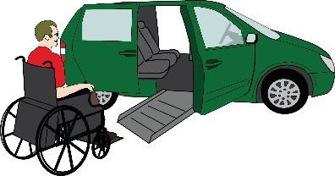 | We usually expect individuals to travel by public transport unless there is a specific need for car use, for example because of:  - disability  - lack of public transport options  - the need to travel to a train or bus station but can only get to there by car
 | If you have to use your car we will cover your mileage expenses. The Council’s mileage rates are shown in  Appendix 2.

       | We will cover reasonable parking fees, congestion charges and tolls.  We encourage individuals to think about their personal safety, especially when travelling at night.  We will not pay parking fines or excessive parking  charges.  We encourage you to car share with other people.

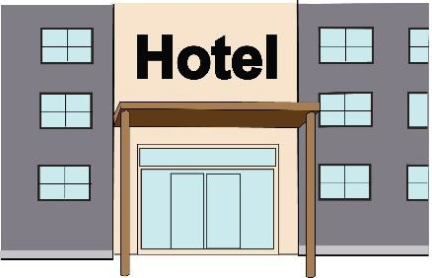
Accommodation

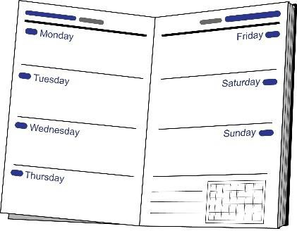 | Sometimes individuals may need to stay away from home to attend early morning meetings or when a meeting runs over several days.
 | In these cases, the Council’s Co-production lead officer will book accommodation using the Council’s central booking system. We will ensure that the accommodation meets any access requirements you may have.
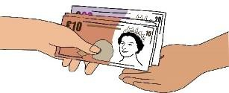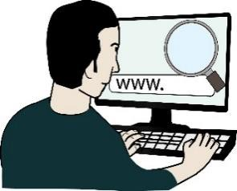 | If the Council cannot book the accommodation and the individual has to book and pay for it themselves, we will reimburse the cost according to this policy.
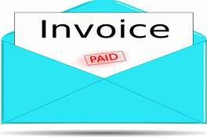 | The individual must keep all their receipts to show proof of purchase.

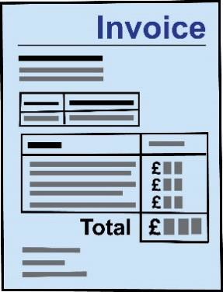 | Costs for overnight bed and breakfast accommodation  should not be more than:  - £135 per night in London  - £100 per night anywhere else in the UK  - £145 per night outside the UK
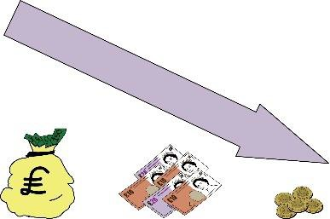 | You should book the lowest rate available in a reasonable standard of  accommodation.
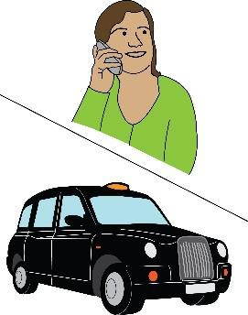 | Sometimes you might have to pay more than these maximum rates for access, location or security reasons. In these cases, you must get approval from the Council’s lead officer.
 | Any extra hotel costs such as room service, mini bar, newspapers etc., will not be covered by the Council.
 | If you choose to stay with relatives, friends or a  colleague instead of a hotel, the Council will pay a rate of  £25 per night.

Subsistence, carers/personal assistants, additional support and other costs
Subsistence

 | If you are away from home  on Council Co-production business, the Council will pay some money towards  the cost of your meals. This is called a subsistence  allowance.
Subsistence costs: the cost of food and drink needed when you do business away from home or your usual place of work. For example, you have to go to a
meeting far away and you need to buy and eat lunch on the way there.
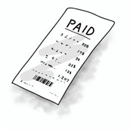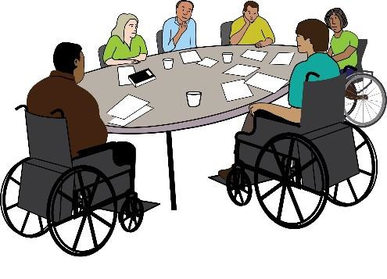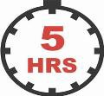 | If you are attending a Council Co-production meeting for 5 hours or more the Council pays money towards your meals.  Because subsistence is an allowance, receipts are not required. The details of subsistence allowances are listed in Appendix 2.

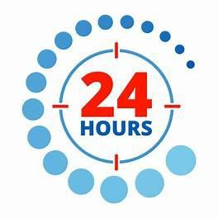  x 1 | You can claim a maximum of one subsistence rate for each 24-hour period.
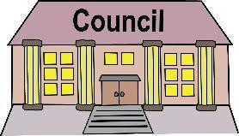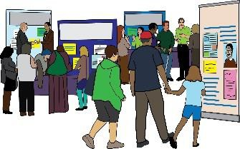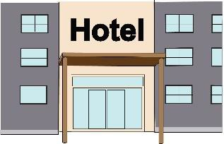   | You cannot claim subsistence allowance if, for example, the meals have been provided by:  - the Council  - a meeting or seminar  - a training course or workshop  - a conference  - the hotel you are staying at, for example if it includes breakfast or an evening meal  Please see Appendix 2 for more details.

Carers, personal assistants or support workers

  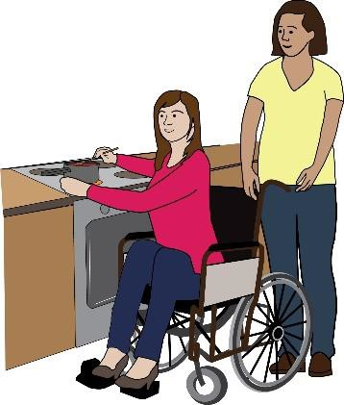 | Sometimes, individuals might need to arrange for a carer, personal assistant or support worker to accompany them to a  meeting.  Or they might need someone to take care of someone they usually care for at home while they are at a meeting.  This includes childcare or care of a disabled family member.
From now on, we will refer to a carer, personal assistant or support worker as a support person.
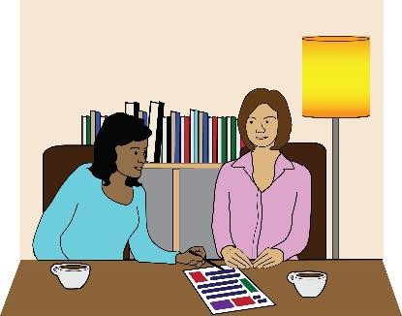 | If you need to employ a  support person, the Council will cover these costs as long as they are reasonable, and you can provide receipts and invoices.  Because these costs can be different depending on the type of care or support needed, we will reimburse the actual costs as there is  no set rate.

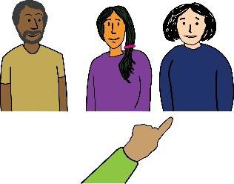 | To be clear, it is your responsibility to hire the support person, not the Council’s.
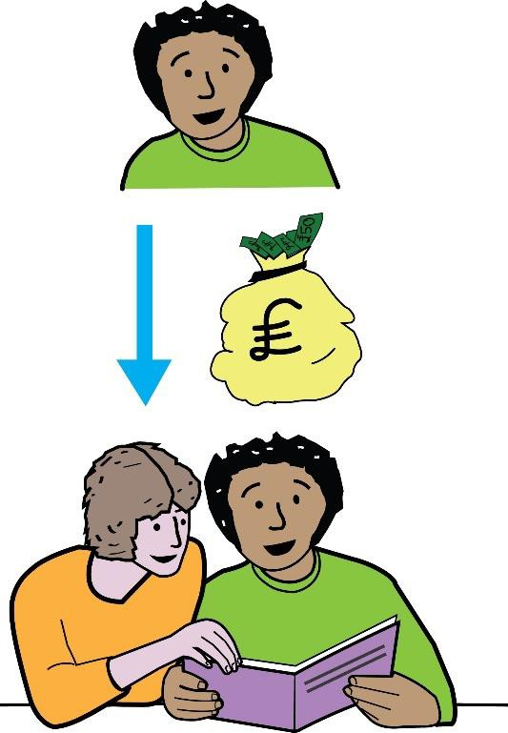 | Under the above guidelines, if you need to hire a support  person the Council will cover:  - Their hourly rate including their travel time to and from a meeting.  - Their travel and subsistence costs (in addition to the hourly rate).  - Their accommodation  - The hourly rate for a professional registered agency for the support person to take over your caring you to attend the meeting.
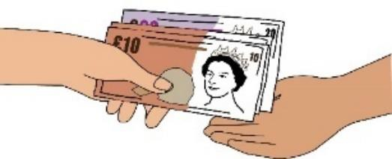 | All these costs will be at the Council’s rate and will be arranged either by the  Council’s booking system or by reimbursing you.

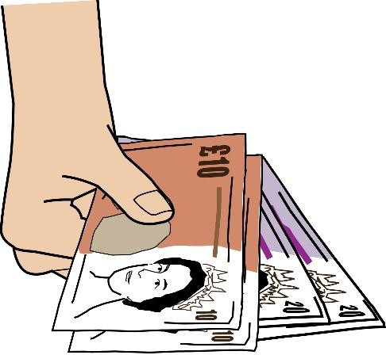 | If an individual uses a friend or family member for  example to take over their caring responsibilities instead of hiring a professional through a registered agency, the Council will make a  contribution of £25 for their out-of-pocket expenses.

Other extra business expenses

 | While doing Council  Co-production business, you may claim reasonable amounts for postage, telephone usage (when not included in their monthly phone contract) and other similar types of extra business costs. You should keep all itemised receipts.
 | If you have other expenses that are not covered in this  policy, then these costs need to be agreed in advance with the Council’s Co-production lead officer.

Additional support, as a reasonable adjustment under the Equality Act 2010

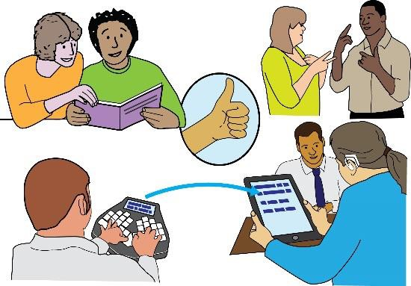 | The Council will make  reasonable adjustments to support you to take part in our committee meetings or groups. This may include things like using a Speech- To-Text typist, note taker or British Sign Language interpreter.
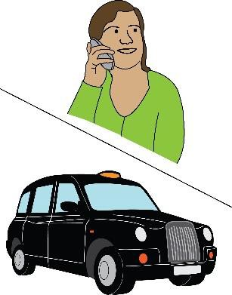 | If additional support is arranged by the individual, it should be agreed in advance with the Council’s  Co-production lead officer. The Council will only reimburse registered businesses who provide these services at current  market rates.

Submitting expense claims

 | All claims must be made    within 3 months of the date the expenses were paid.  You must keep copies of all receipts and any other documentation required.
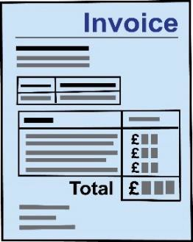   | The Council’s Co-production lead officer will process all  reimbursement claims.  False, exaggerated, or intentionally duplicate expenses claims will be treated as fraud and reported to the Council’s Fraud Team. This may lead to civil or criminal action taken against the individual.
Exaggerated: increased or made larger than something actually is.
Intentionally: done on purpose.
Duplicate: an exact copy of something, something done twice.
Fraud: is the crime of getting money by deceiving people or making false claims about something.

   | All the amounts stated in this policy include VAT.  Individuals need to provide their bank account details so that the Council can reimburse the expenses directly to that bank account.
 | After you make your expenses claim, the Council aims to approve them and reimburse individuals within 3 weeks.  If you have any problems making your claim or lose any receipts you should  contact the Council’s  Co-production lead officer.
 | If you make an expenses claim without a receipt, the Council may not pay it.
The Council has a legal duty to keep records for all claims and receipts for at least 7
years. The Council keeps financial information for
payment and reporting purposes.

Appendix 1: Support for Disabled people receiving welfare benefits
Before agreeing to get involved in Co-production with us, it is important that you get proper advice to see if receiving payment for work from the Council will affect your benefits.

Hammersmith and Fulham Council cannot provide tax or benefits advice, but we know that some benefits do allow for some income from Co-production and user
involvement activities.

Action on Disability offers a free and independent benefits advice service to Disabled residents living in the London Borough of Hammersmith and Fulham. They can help with:
- Disability Living Allowance
- Employment and Support Allowance
- PIP (Personal Independence Payment)
- Universal Credit
- Housing Benefit
- Council Tax
To find out more about the Action on Disability welfare benefits advice service, click here.

We also recommend you look at The Social Care Institute for Excellence (SCIE) website. It has some helpful information about the responsibilities of organisations who pay people who receive benefits for Co-production and participation.

Click here to find out more.
Her Majesty’s Revenue and Customs (HMRC) website lists taxable and non-taxable welfare benefits here:
- Click here for the list of taxable welfare benefits from HMRC
- Click here for the list of non-taxable welfare benefits from HMRC

It is your responsibility to make sure that you meet the conditions of your state benefits. So we strongly advise that you seek independent advice about your personal circumstances before accepting any contract of work.
The Citizen’s Advice Bureau for Hammersmith and Fulham should also be able to provide you with independent advice about benefits queries and tax issues. Please click here to their website to find out more.

Additional Support

- HR Business Partnering Team: email dave.rogers@lbhf.gov.uk

- Strategic Resourcing Team: email lucy.robinson@lbhf.gov.uk

Appendix 2: Subsistence allowances
When a person has to pay extra costs for meals because they are away from their home or place of work (their base), they can claim a subsistence allowance.

Subsistence means food and drink. Subsistence rates are defined by HMRC and do not require receipts where all of the following conditions are met:
- When the person is travelling for Council business where the journey is not a normal commute.
- The payment for the meal (food and drink) was only made after starting the journey.

Subsistence rates are as follows:

Minimum block of time away from base without a meal | Maximum amount of meal allowance (if you paid for a meal)
5 hours | £5
10 hours | £10
24 hours (breakfast provided) | £20
24 hours (breakfast not provided) | £25

The maximum amount you can claim in a 24-hour period is £25.
If you were provided with a meal (for example by the Council or the meeting venue), you cannot claim for this.

Some examples  Situation | Maximum claim (if you paid for a meal)
Away from base between 8am and 6pm  Lunch was provided | £0
Away from base between 8am and 6pm  Lunch was not provided | £5
Away from base between 8am and 8pm  Lunch was provided | £5
Away from base between 8am and 8pm  Lunch was not provided | £10
Away from base between 6am and 9pm  No meals provided. | £5 and £10
Away from base 4pm on day 1 until 8pm on day 2.  Breakfast and lunch provided on day 2. | £10 for day 1  £5 for day 2
Away from base 4pm on day 1 until 7pm on day 2.  Breakfast provided on day 2. | £20
Away from base 4pm on day 1 until 7pm on day 2.  No meals or refreshments provided | £25

Rates payable for using your own vehicle

- Motor Vehicles 28p per mile
- Motor Cycles 28p per mile
- Passenger Allowances: 5p per mile
(you can claim this if you allow a colleague to go with you to a meeting in your private vehicle)

Appendix 2: Setting up payments for supporting co-production

Step 1
- Lead manager/People & Talent (HR)
- Lead manager contacts Head of HR Operations to arrange for the set up of a casual position in IBC (Integrated Business Centre) self-service – see appendix A

Step 2
- IBC Action
- Issue lead manager with a link to complete with the resident and provide signposting re. benefits.

Step 3
- Lead manager
- Arranges in person meeting to set resident up on IBC system, check right to work documents Right to Work verification form
- Complete payroll form Bank details form

Step 4
- Resident
- Attends a meeting in-person to set up on IBC, complete forms.
- Has a meeting in-person with Lead Manager.
- Provide the right to work documentation as well as (passport or birth certificate or share code)

Step 5
- H&F Action (HR & Lead manager)
- Issue paper copies of letter of engagement, code of conduct, confidentiality agreement, declaration of interests at the in person meeting.
- Lead manager delivers local induction
- Uploads signed copies to EPF

Step 6
- IBC action
- Add resident to payroll.

Step 7
- Lead manager
- Processes payments in IBC self-service (see appendix C for processing payments guidance)

Step 8
- IBC action
- Send payslip via post

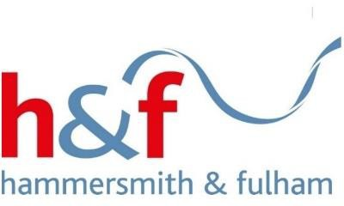
© London Borough of Hammersmith and Fulham 2024

This document was put into Easy Read by the Empower Team at People First. www.peoplefirstltd.com

Information is Power!
